Steps for Lexia Log In
How to get there??
How to Log in and Play!!
- Type in the web address: www.philasd.org
- Go to “Login”.................
- Type in his User name:
User name is your child’s student ID number
- Type in his password “”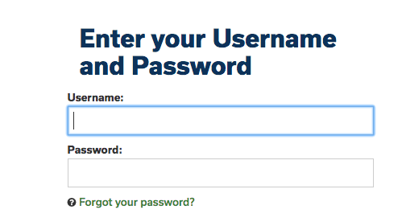
- Click on 3 Horizontal lines
- Go to and Click on “Message Center”
- Scroll down to Lexia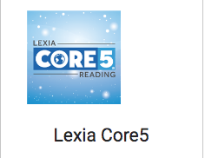
- Click on Arrow to start
Enjoy, Learn and have Fun!!!!!!

