Steps to Trouble Shooting your Chrome Book
My Chrome book is not connecting to the Internet.
Here is a Possible solution:
Your computer has lost its connection.
Solution:
Move your mouse to the bottom right corner of your screen.
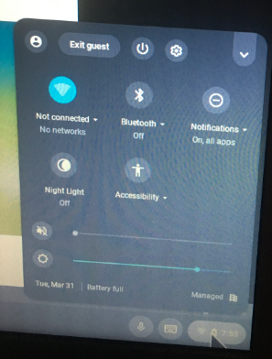

Click on bottom right and go to “not connected” circle.
Click on it and select your home wifi

