Steps to Log Into Google Classroom!!
How to get there??
How to Log in and get your Assignments!!
- Type in the web address: www.philasd.org
- Go to “Login”.................
- Type in their User name:
User name is your child’s student ID number
- Type in their password (If not sure, ask teacher)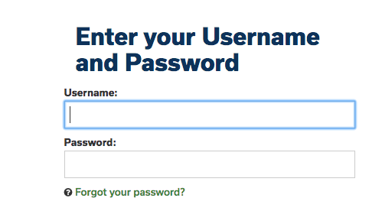
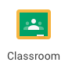
- Click on 3 Horizontal lines
- Go to and Click on “Message Center”
- Scroll down to Google Classroom
- Now Click onto class of choice.
- Your assignment will be there.
Check back often for new Assignments!!
Try them and do the best job you can.

Just make an effort!

