Students and teachers will use their school district user names and passwords to access Renaissance Star on the Launchpad by logging into the district's website.

When logging in to the District’s website (philasd.org/login), students have quick access to an overview of assignments and important dates, grades, and class schedules. The Student Launchpad includes adaptive online learning resources, interventions and curricular materials.

To access the Launchpad, students log in to their portal account and select “Message Center” from the navigation menu on the left-hand side of the screen. By clicking “Show More”, students will see an array of applications to choose from.

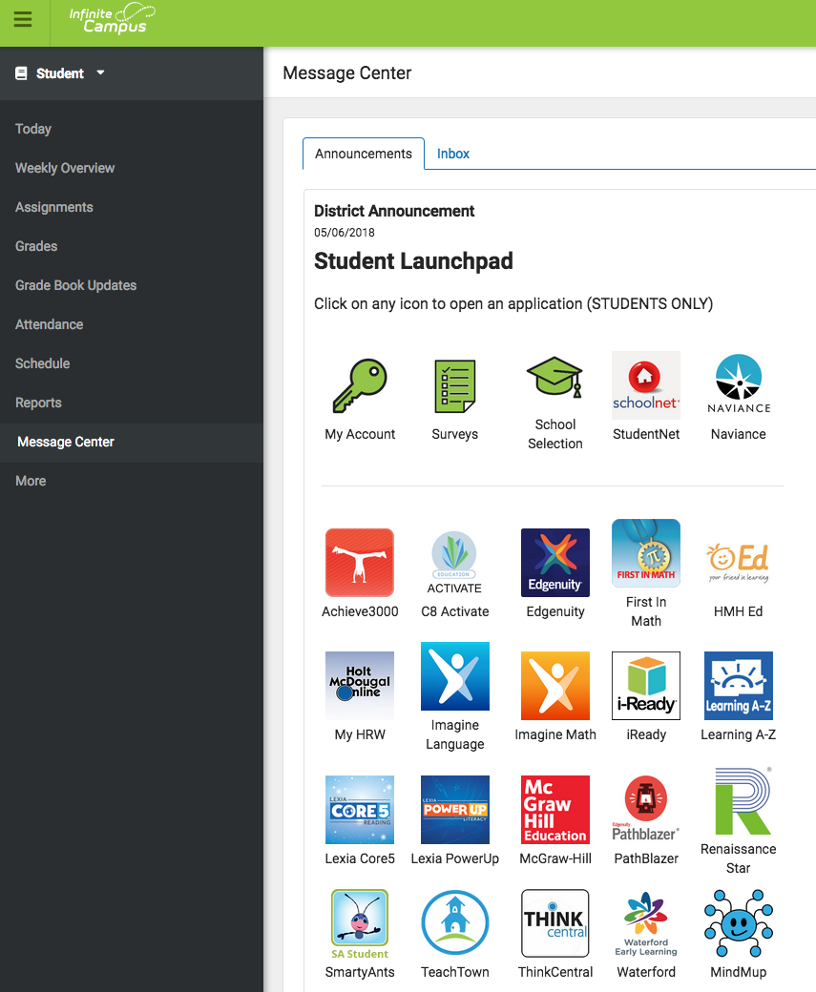
Click on icon to access
Renaissance Star

Teachers and instructional staff also have access to these tools through the Employee Portal.

To access these resources, you should login to employee portal at philasd.org/login. Here you will see icons for programs used in the District. You will only have access to programs purchased for or by your school. You simply need to click on the program icon to access the program.
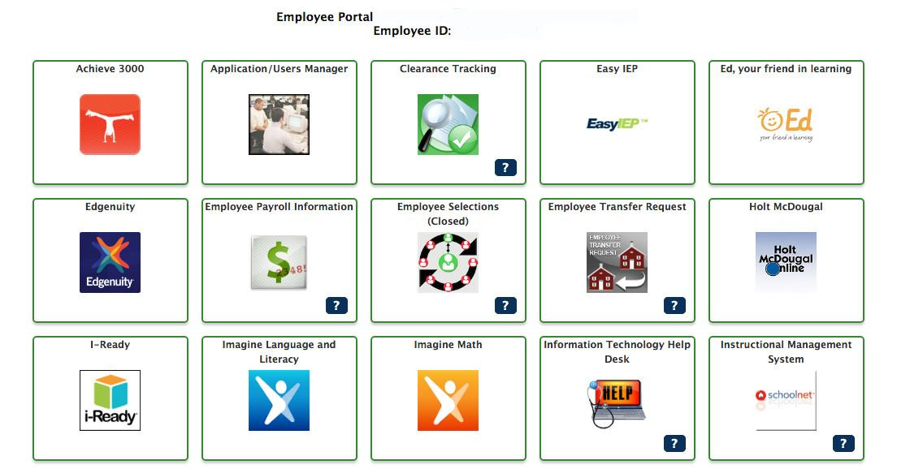
PASSWORD RESET

If a student needs assistance in resetting his/her password, he/she can follow the steps below:

STUDENTS

- Click the Forget Password? prompt on log-in screen to reset password.

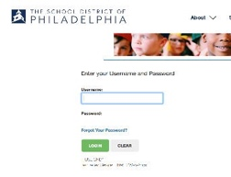

- If student cannot remember answers to security questions, teacher or counselor can reset the password through Password Lookup.

TEACHERS

Using Password Look Up

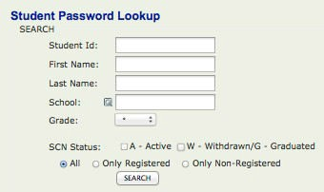
- Login to the district portal and select the Student Password Lookup application.

- Enter the student ID of the student.

- . For grades 6-12: click Reset Password and continue with step 4.

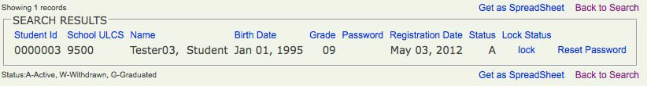

- Enter any Temporary Password for the students that has six characters with at least one numeric.

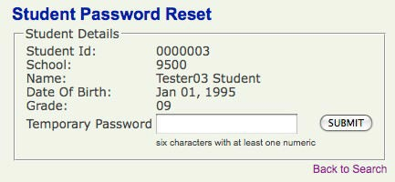

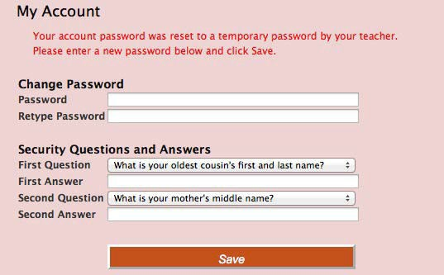
The student will now be able to log in with this password. Upon logging in, they will be directed to change the password.

Please remind students to write down their passwords and keep them somewhere safe!

