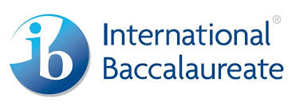
Bodine High School for International Affairs
International Baccalaureate Program

Where are they now?
Universities / Colleges Attended by Bodine IB Students

Albright Spelman
Arcadia St. Joseph’s
Barry (FL) Swarthmore
Bryn Mawr Temple
Carnegie Mellon University of Hawaii
Drexel (Liberty Scholars) University of Miami
Eastern University of Pennsylvania
Fisk University of Pittsburgh
Fordham University of the Sciences
Gettysburg Ursinus
Hampton Villanova
Harvard
Haverford
Indiana University of PA
Ithaca
Kalamazoo
La Salle
Lycoming
McDaniel (MD)
McGill (Canada)
Middlebury
Millersville
Mount Holyoke
Penn State (Main Campus and Abington)
Princeton
Rochester Institute of Technology
Rosemont
Rutgers

