A. Phillip Randolph Technical High School
3101 Henry Ave, Philadelphia, PA 19129

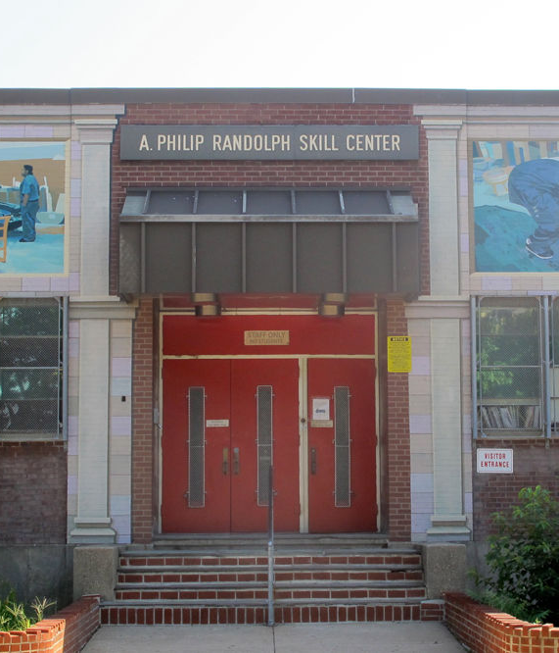
Scope Determination Report:
CTE Improvements

April 5, 2018

Prepared by:
Amanda Brown, RA
G.P.Lamina, Jr., P.E., MBA
Charles Li, PE, LEED AP BD+C

School District of Philadelphia
Office of Capital Programs
440 N. Broad Street, 3rd Floor
Philadelphia, PA 19130

Introduction

This report outlines the scope of work for the CTE Improvement project at the A. Phillip Randolph Technical High School. This school serves 9th through 12th grade students, and the current enrollment is 496 students.
Randolph Technical High School offers CTE programs in nine occupational areas including Auto Body, Auto Mechanics, Construction, Culinary Arts, Fire Academy, Health Related Technology, Oral Health, Vending Machine Repair and Electronics, and Welding. These programs allow students to gain both hands-on technical experience and traditional academic skills.

The scope work for this projects includes creating a new classroom area and upgrading the welding booths and the mechanical exhaust system in the welding Shop area. A review of the welding shop area was conducted by several members of the SDP Capital programs team and it has been determined that these renovations are necessary for daily operation.

Randolph Technical High School is located at 3101 Henry Avenue in the Northwest Philadelphia. The main entrance faces West and is located off of Henry Avenue. The building site is bound by Roberts Avenue to the North, a Restaurant Depot warehouse building to the East, and a small wooded area to the South. The one-story,
121, 579 square foot building was constructed in 1975 and was originally known as the A. Phillip Career Academy. This rectangular shaped, concrete and steel framed building has a brick masonry façade.

Context Maps

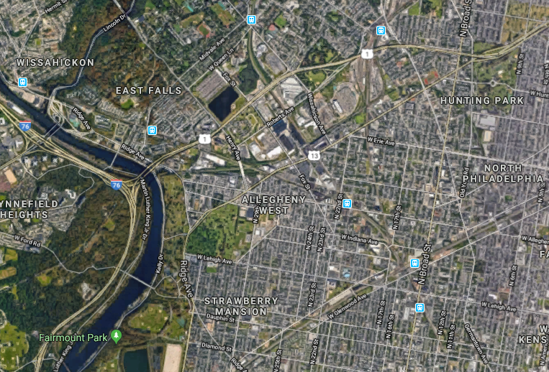
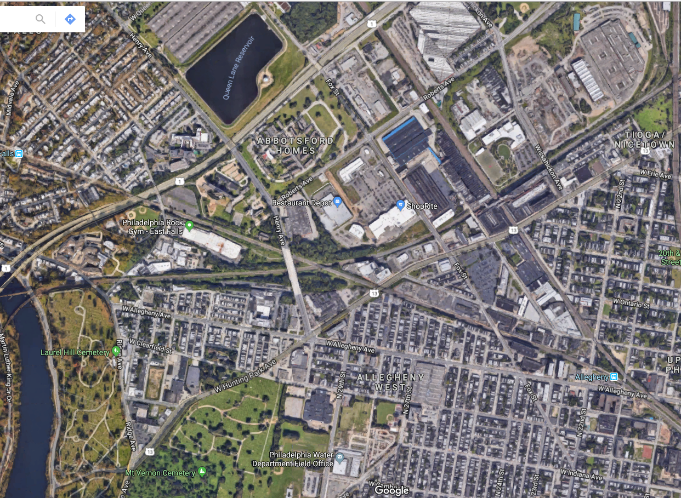

Scope of Work

Proposed scope is outlined below. Final scope to be determined by SDP and Design Consultant during the Schematic Design Phase. See Appendix A for floor plans, Appendix B for photographs of existing conditions, and Appendix C for Ideal Technology Requirements.

The design consultant is responsible for verifying and documenting all existing conditions and confirming all scope. The design consultant shall take extra care to survey and accurately document all existing conditions and provide appropriate, cost-effective design solutions. The design consultant shall conduct a code analysis at the outset of the design process.

Classroom | Create a theory classroom area within the welding shop area. Design consultant to survey the existing welding shop and propose a location for this classroom.  Classroom requirements include:  - Area: 800 sf minimum  - Walls: CMU  - Flooring: VCT  - Ceiling: Ceiling construction to mitigate sound from adjacent shop area  - Accessories: Interactive Panel board, markerboard (16’-0” min.), tackboard (12’-0” min.)  - Furniture: Provide furniture for a CTE classroom per SDP’s standards  - Other: Provide visual connection from classroom to shop area  - Provide new welding booths to replace existing.
Mechanical | Upgrade welding shop exhaust system:  - Remove and Replace 2 welding hood ventilator exhaust fans with 2 new 1000 CFM fans. Remove and replace the existing metal duct manifold with 2 new 24" diameter galvanized spiral duct manifold headers from each of the ventilator hoods to the newly installed exhaust fan  - Remove and replace 1 new central exhaust fan and grille with a new 2000 CFM in-line exhaust fan.  - Furnish and install a new 3000 CFM Variable speed exhaust fan for the automotive shop. Installation shall include 24" diameter galvanized ductwork and a CO2 sensor located within the duct interior walls for both units.  - All Fans shall be equipped with T stats and VFD's to automatically control the flow capacity  - Testing and balancing of all equipment should occur at substantial completion.  Classroom:  - Furnish and install a 3 ton HVAC- Heating, cooling and ventilation unit to condition the new 800 sf classroom space.  - 200 LF of 24” x 24” galvanized steel ductwork with 24” x 24” supply diffusers and two 24” x 24” return air grilles.
Electrical | - Provide electrical disconnects, branch circuits in EMT and overcurrent protection for the new welding booths and welding exhaust system described under the Mechanical Scope of Work.  - Provide classroom with electrical HVAC branch circuit in EMT and overcurrent protection for the classroom HVAC system described under the Mechanical Scope of Work.  - Provide classroom with power receptacles, data receptacles, phone, clock, fire alarm, public announcement speaker and lighting per School District guideline.

Budget
The construction budget as established is $2,000,000.

Appendix A – Floor Plan

Automotive and Welding Shop at Randolph Technical HS

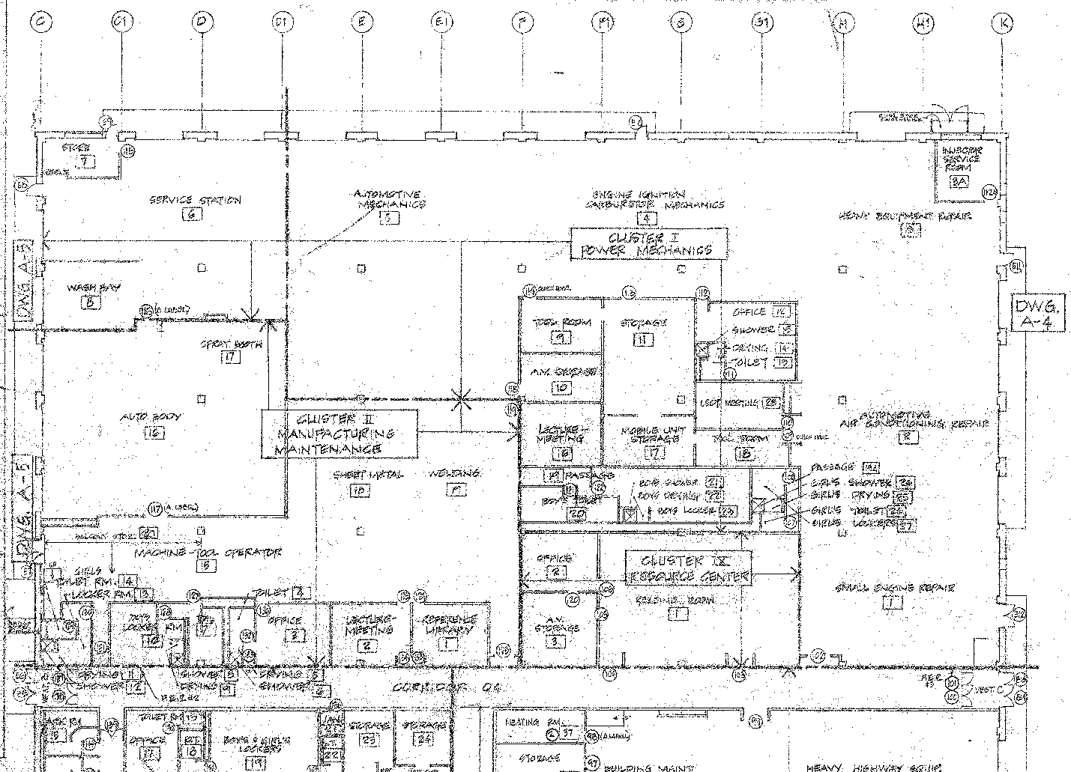

Appendix B – Existing Conditions
Automotive &  Welding Shop | Existing mechanical/exhaust system
 | 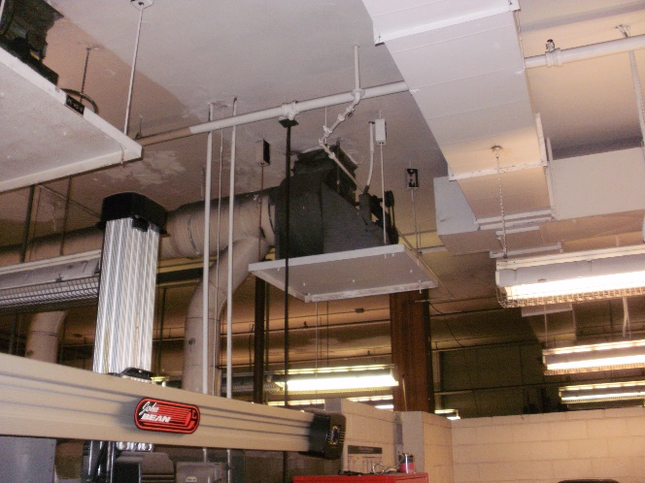
 | 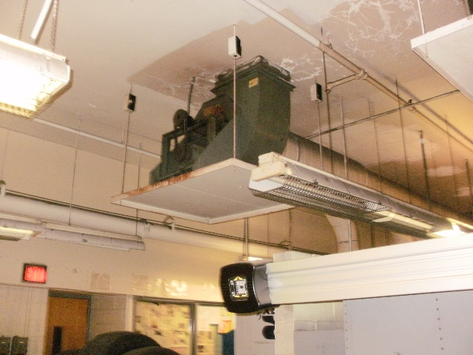
 | 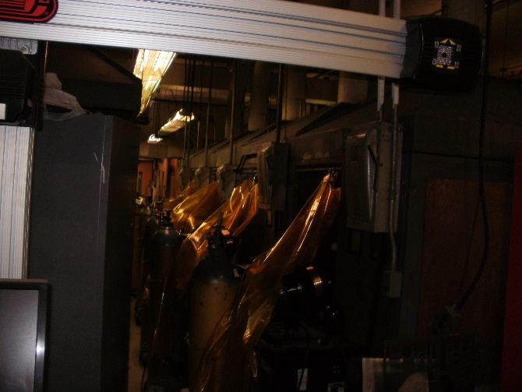

Appendix C – Ideal Technology Requirements

