January 8, 2021

Dear Laura H. Carnell Elementary School Community,

This letter is to provide an update around environmental safety work taking place at Laura H. Carnell Elementary School. During a routine lead paint inspection on Tuesday, December 22, 2020, an imminent hazard -- damaged pipe insulation -- was discovered in the fan room.

Abatement work is now being performed in the area by licensed asbestos abatement contractors and monitored by independent asbestos project inspectors. As you are aware, there are no students in our schools since we are engaging in 100 percent digital learning due to the pandemic. However, no staff are permitted in this space until the repair work is completed and the appropriate testing is done to determine if the area is suitable for re-occupancy.

The health and well-being of our students and staff remains our top priority and we are committed to ensuring that all buildings are safe environments for instruction and learning. To learn more about asbestos and what the District is doing to improve environmental safety, please visit our website at www.philasd.org/healthyschools. If you have any additional questions or concerns, please email environmental@philasd.org.

Sincerely,
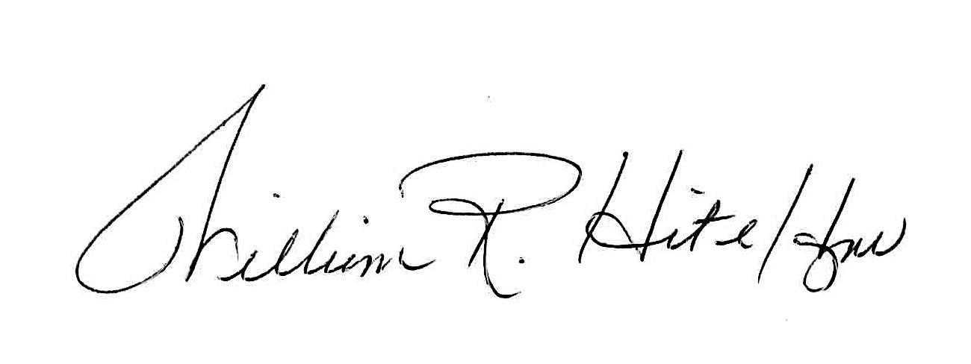
William R. Hite, Jr., Ed.D.

