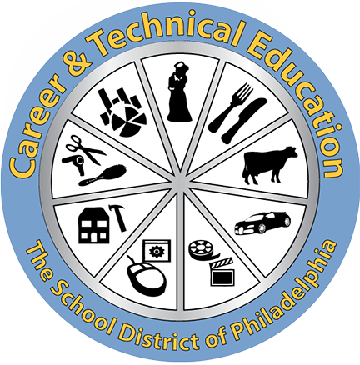
Career & Technical Education Makes A Difference!
The "TOP 10" Reasons for Enrolling in Career & Technical Education Programs

- Students can earn industry certifications and credentials.
While enrolled in CTE programs, students can earn industry recognized certifications and credentials that enable them to be employed directly from high school or obtain college credit in some programs by earning these certifications. The School District pays the costs of the certification exams which run from $25.00 to $450.00 per exam.

- Students can qualify for college credits.
Students who successfully complete their CTE program may be awarded up to 15 college credits at no cost, which can be used towards their associate or bachelor's degrees.

- The NOCTI test taken by graduating seniors is a nationally recognized exam.
The NOCTI exam results may be used to gain entry into technical training programs, apprenticeships, and can qualify students for additional college credits at no cost, which can be used towards their associate or bachelor's degrees.

- CTE teachers are professionals from the industry.
In addition to being certified as high school teachers they must also demonstrate their experience and skills before they can teach their career skills to our students.

- Students participate in career-related activities, internships and summer work ready experiences that may lead to permanent positions upon graduation.
Important job-ready skills are acquired that boost classroom learning and help in their future careers.
- Each CTE Program must be supported by a team of industry professionals.
They advise the teachers and the school principals on current industry trends, equipment and post high school opportunities for graduates to evaluate and ensure the programs are high quality.

- CTE Programs are taught in state of the art facilities in schools that mirror real industry.
The School District spends millions of dollars annually to keep CTE program facilities updated and outfitted with the latest industry-standard equipment and materials for students to learn.

- Students enrolled in CTE Programs are taught by the same teacher for 3 years.
This permits the teacher to become a mentor and supporter for each of the students in the CTE classes.

- CTE students obtain leadership, public speaking and career planning skills.
CTE students participate in national organizations that are affiliated with their career pathways, which include regional, state and national competitions and conferences.

- CTE students have higher graduation, attendance, and college going rates than the School District citywide average.
CTE students have an 84% on-time graduation rate, over 90% average daily attendance and have a college entrance rate of over 40%.

Accounting and Financial Services
Locations: Furness, Lincoln, and Washington

Animal Sciences
Location: Saul

Architectural Drafting
Location: West Philadelphia

Autobody Collision Repair
Locations: Edison, Randolph, Swenson, and Workshop

Automotive Technology
Locations: Edison, Mastbaum, Randolph, Swenson and Workshop

Baking and Pastry Arts
Location: Swenson

Barbering
Location: Dobbins

Biotechnology
Locations: Dobbins and Roxborough

Business Administration
Locations: Dobbins, Franklin Learning Center, King, Lincoln, Mastbaum and Roxborough

Carpentry
Locations: Mastbaum and Swenson

Computer Aided Drafting and Design (CADD)
Location: Ben Franklin

Computer Supports Systems Technology
Locations: Kensington and South Philadelphia

Computer Systems Networking
Locations: Dobbins, Swenson and West Philadelphia

Construction Technologies
Location: Randolph

Cosmetology
Locations: Dobbins and Edison

Culinary Arts
Locations: Ben Franklin, Dobbins, Edison, Frankford, King, Mastbaum, Randolph, South Philadelphia, Strawberry Mansion, Swenson and Washington

Dental Assisting
Locations: Kensington Health Sciences and Randolph

Digital Media Production
Locations: CAPA, Dobbins, Kensington CAPA, Northeast, Overbrook, Roxborough, Swenson and West Philadelphia

Early Childhood Education and Childcare
Location: Parkway West

Electrical and Power Transmission Installation
Locations: Edison, Mastbaum, and Swenson

Electronics Technology/ Automated Systems
Location: Randolph

Emergency Medical Technician
Location: Randolph

Engineering Technologies
Locations: Carver, Kensington, South Philadelphia, Science Leadership Academy, Science Leadership Academy at Beeber and Swenson

Facility and Property Maintenance
Locations: Dobbins and Ben Franklin

Fashion Design
Location: Dobbins

Film & Video Production
Locations: Edison, Fels and Science Leadership Academy

Food Processing Science
Location: Saul

Graphic Design
Locations: Dobbins, Edison, Mastbaum and South Philadelphia

Health Information Records Technology
Location: Mastbaum

Health Related Technologies
Locations: Edison, South Philadelphia, Kensington Health Sciences, King, Lincoln, Mastbaum, Overbrook, Paul Robeson, Randolph, Sayre and Swenson

Horticulture
Locations: Lincoln and Saul

Logistics, Materials and Supply Chain Management
Location: Edison

Medical/ Clinical Assistant
Location: Franklin Learning Center

Natural Resource Management
Location: Saul

Plumbing Technology
Location: Edison and Mastbaum

Precision Machine Tool Technology
Location: Ben Franklin

Sports Marketing and Management
Locations: Dobbins, Kensington, Lincoln, Northeast, Roxborough and Washington

Welding Technology
Locations: Edison, Ben Franklin, Mastbaum and Randolph

