 | Chromebooks:  Basic Setup & Features | 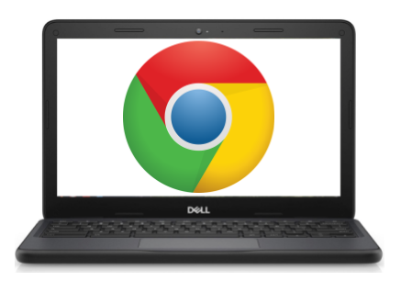
Anatomy of a Chromebook:
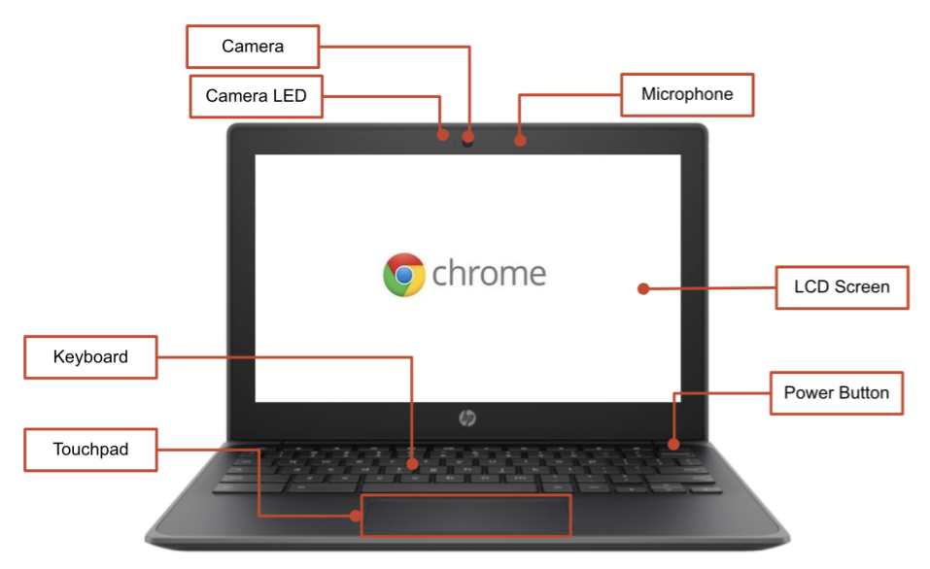 | 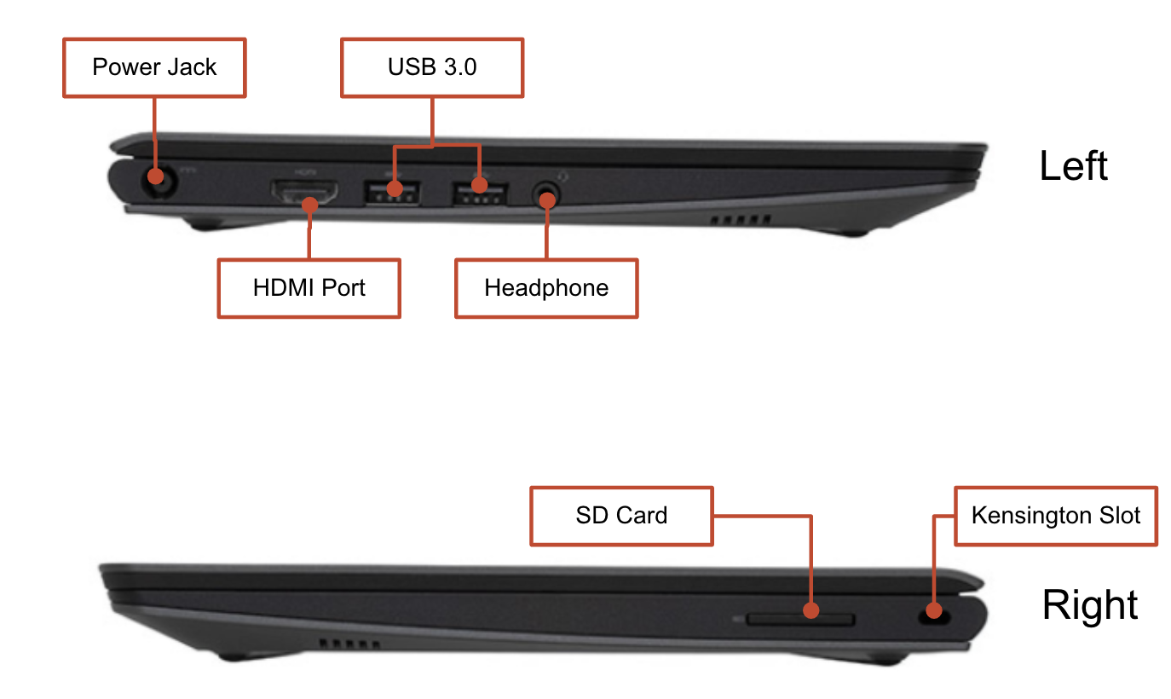
Important Keys:
These keys can be found across the top of the keyboard:

Key | Function |  | Key | Function
 | Go to the previous page in your browser history |  |  | Decrease screen brightness
 | Go to the next page in your browser history |  |  | Increase screen brightness
 | Reload your current page |  |  | Mutes sound  *
 | Open your page in full-screen mode |  |  | Decrease the Volume
 | Switch to your next window |  |  | Increase the volume  (*Press to cancel mute mode)

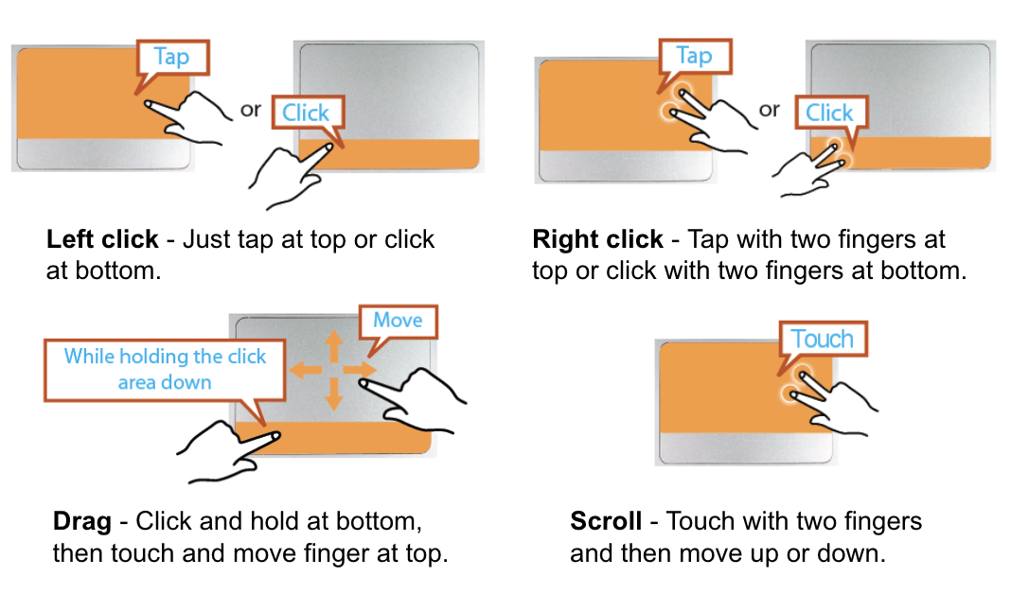
Using the Touchpad:

Adjusting Language Settings
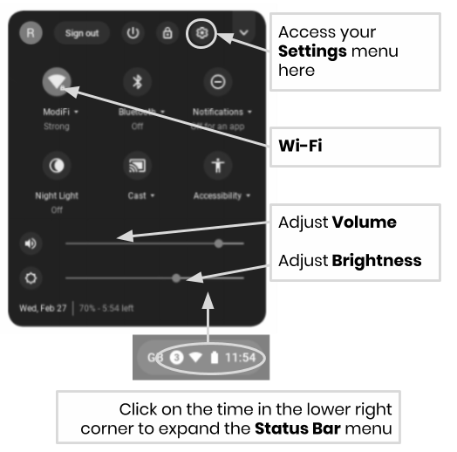
To change the language settings on a Chromebook, open the “Status Bar” on the bottom right corner of the desktop. The expanded view of this window will show a settings (gear) icon..

Step 1 → Select “Advanced”

Step 2 → Access the “Languages and input” section, and select “Language”

Step 3 → Choose the language you would like to use

....if your language is not included in the list
- Select “Add languages”
- Select the language you want and press “Add”.

Once you have selected your language, select the more button ( ) and you will be given the opportunity to specify how you want to use the language. Your options include:
- “Show menus in this language”
  - Select “Show system text in this language”
  - Restart the device

- “Show webpages in this language”
  - Select “Move to the top” to prioritize this language at the top of the list.
  - If you would like Google Chrome to translate the webpages also, select “Offer to translate pages in this language”

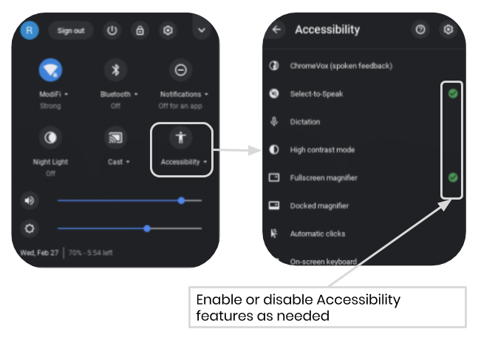
Accessibility
You can enable the Accessibility features by opening the “Status Bar” menu and selecting “Accessibility”. This will open a menu of available accessibility features, select features as needed.

Features include: ChromeVox (spoken feedback), Select to Sleep, Dictation, High contrast mode, Fullscreen magnifier, Docked magnifier, Automatic clicks, and On-screen keyboard.

 | Chromebook Cheat Sheet:  Basic Use & Troubleshooting | 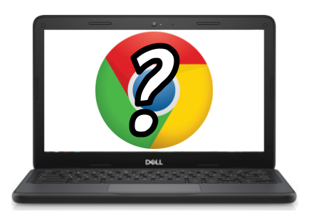

Tips & Tricks for Chromebook Users
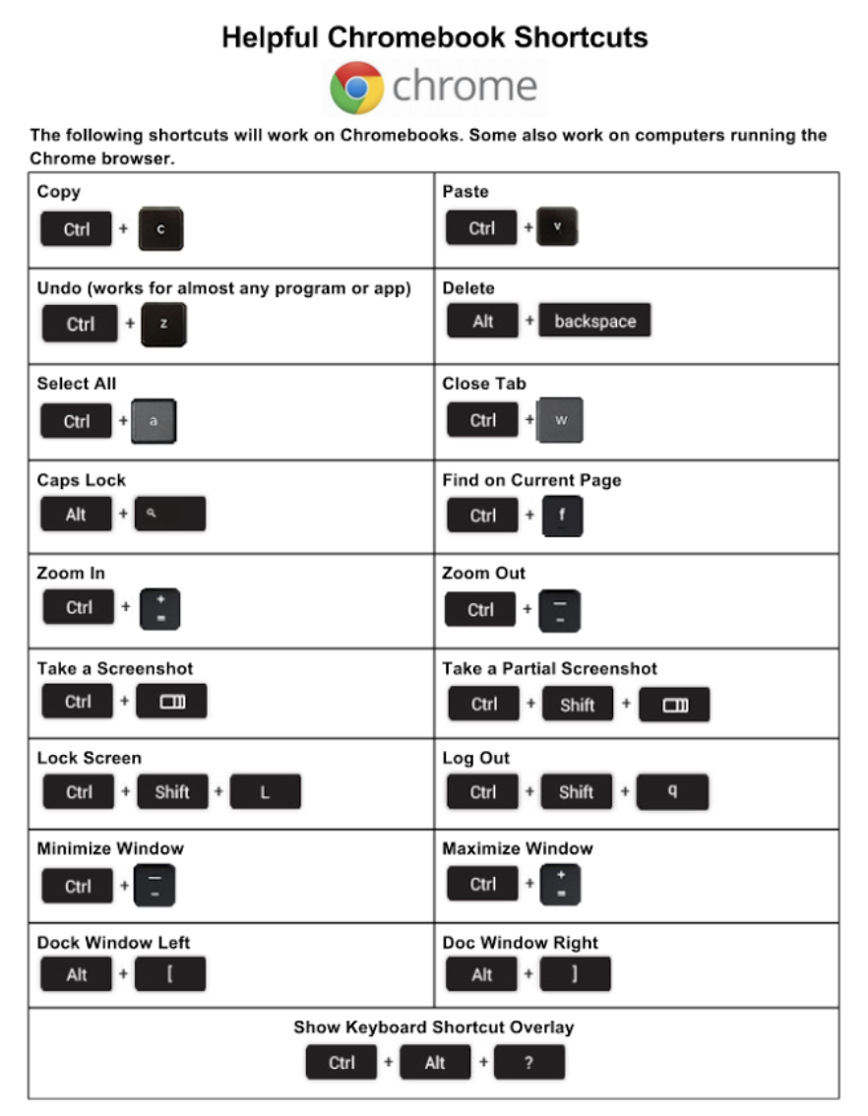

Basic Troubleshooting

Issue: | Key Commands
The Chromebook has crashed or the screen is frozen | Turn the machine off and on again by holding the Power button.
The screen isn’t powering on | Reset the machine by pressing:  RELOAD/REFRESH + POWER
The Chromebook is sluggish | Reset the machine by pressing:  RELOAD/REFRESH + POWER
The keyboard is not responding | Reset the keyboard by holding the following keys:  Click + SHIFT + ALT
The touchpad is not responding | Reset the machine by pressing:  RELOAD/REFRESH + POWER
The power button won’t work | Sometimes the Power Button will not wake up the machine, even when you know the battery is fully charged. Wake up your machine, by following these steps:  - Close the lid of your Chromebook  - Plug your power cord in and connect to your Chromebook  - Open the lid of your Chromebook without pressing any keys  This should reactivate the Power button.
The home screen image is rotated or upside down | Hold the following keys:  CTRL + SHIFT + RELOAD  *This will rotate the entire screen by 90 degrees each time it is pressed
There is no sound when headphones are plugged in | Follow these steps to troubleshoot your audio settings:  - Make sure headphones are plugged in fully and properly and there isn’t any debris blocking the port.  - Make sure the Chromebook is not in “Mute Mode” by pressing the  - Clear the cache and reboot:  - Open Chrome  - At the top right, click More ( )  - Click More tools > Clear browsing data  - Choose a time range, like Last hour or All time  - Select the types of information you want to remove  - Do all  - Click Clear data  - Restart the Machine
Websites aren’t loading | Clear the cache and reboot:  - Open Chrome  - At the top right, click More ( )  - Click More tools > Clear browsing data  - Choose a time range, like Last hour or All time  - Select the types of information you want to remove  - Do all  - Click Clear data  - Restart the Machine

