4th GRADE SUPPLY LIST
FOR IN-PERSON LEARNING
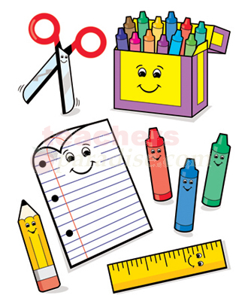
- 7 Black and White Composition Books
- 1 Pack of 24 pencils
- 2 red pens
- 1 black pen 1 blue pen
- 1 pencil sharpener with plastic cover
- 3 packs of loose-leaf paper
- 1 pack of colored pencils
- 1 pack of Crayola markers
- 2 boxes of 24 Crayola crayons
- 1 pencil case
- 4 sturdy (PLASTIC FOLDERS) 1 red 1 blue 1 green 1 yellow
- 2 dry erase markers
- 2 glue sticks
- 2 packs of Copy Paper
- 1 box of tissues
- 1 bottle of hand sanitizer
- 1 pack of post-its
- (Calculator (Model TI-15) (if you do not have you can get this at Emlen on the 31st)

4TH GRADE SUPPLY LIST
FOR REMOTE LEARNING

- Headphones
- 4 black and white composition books
- 4 pencils
- 1 plastic sharpener
- 1 box of crayons
- 1 pack of colored pencils
- 1 pack of markers
- Whiteboard
- 2 Dry Erase markers
- Whiteboard eraser or sock
- (Calculator (Model TI-15) (if you do not have you can get this at Emlen on the 31st)

