LOUIS H. FARRELL ELEMENTARY SCHOOL

2020-21
STUDENT/PARENT HANDBOOK

NICHOLAS J. CIRULLI, JR
PRINCIPAL

DEL N. JONES
ASSISTANT PRINCIPAL

Dr. William R. Hite, Jr.
SUPERINTENDENT

“Together We Can Make A Difference”

Dear Parents and Students,

This booklet contains an overview of policies and procedures at Louis H. Farrell School. It addresses the issues of greatest importance to students and parents, and serves as a convenient reference. It is not intended as a comprehensive digest of our school policies, and you may have questions not answered here, but can be found in School District's Parent Handbook.

Any text in RED are protocols and procedures to support the current
SDP Remote Learning Program

Please feel free to contact the school at any time if you need more information. We value your interest and your inquiries. All students will sign for acceptance of this handbook and it will be their responsibility for bringing it home. Failure to read this document will not exempt students from consequences stated within.
We have found that students experience success if they meet three fundamental expectations. Therefore, we require that students attend school regularly, complete their in-school work as well as their homework, and treat peers and staff with respect. Our school focus is on being Responsible, being Courteous, being Respectful, being Honest, and being the Best one can be.
Each student should expect a comprehensive instructional program in a safe and supportive environment. Parents and students will be treated with respect, and parents' inquiries will receive a timely response.
We welcome everyone to the 2020-2021 school year, and we encourage parents to become active members of the Home and School Association and/or the Student Advisory Council (SAC), as well as other school functions. We will spend the first week of school working with your children and preparing them properly for school admission and dismissal, in an effort to keep a safe and orderly environment. We will also be required to complete a fire drill within the first ten days of the start of school. As always, please visit us, become a volunteer, and become active in our learning community. Thank you for your strong commitment to your child’s education and your involvement and continued support.

Sincerely,

Nicholas J. Cirulli, Jr.

Nicholas J. Cirulli, Jr.
Principal

Del N. Jones

Del N. Jones
Assistant Principal

VISION STATEMENT

LOUIS H. FARRELL ELEMENTARY SCHOOL will provide every student with an environment in which they will become successful citizens and reach their full potential. To achieve this, the School Community will:
- provide standards-based and rigorous instruction.
- foster a life-long love of learning.
- accept and embrace all cultures.
- create a learning environment that includes high expectations, fosters confidence and encourages growth.

Instruction
- Daily Schedule: It is the expectation that students will stay logged in and participate in all activities throughout the day assigned by their teachers until the end of the instructional day at 3:09pm. Each Friday afternoon, students will participate in asynchronous (independent) learning activities.
- Daily Assignments: Students are expected to complete all assignments and submit them by the due dates teachers give them. All assignments must be neatly typed and headed appropriately. A properly headed paper includes the date typed in the upper left-hand margin, and the student’s full name typed in the upper right-hand margin. The subject title and grade level are written below the name. Students must complete assignments independently and without parent intervention so that teachers can accurately identify the academic strengths and areas in which the child needs additional support.
- Assessments/Tests/Quizzes : Teachers will assign various modes of assessments/tests/quizzes to students during the course of virtual learning. It is the responsibility of the students to complete the assessments/tests/quizzes given the expectations set forth by the teacher. Assessments will measure what teachers need to know in order to effectively instruct students on a daily basis. We ask parents to refrain from assisting students with assessments/tests/quizzes that will be given.
- Cheating: Plagiarism is defined as the unauthorized use of digital content and/or claiming another student’s work as one’s own, or taking credit for work without properly crediting the creator. In order to maintain the academic integrity of our online programming, cheating and plagiarism is strictly prohibited.

Attendance
Please see the below guidance from the School District of Philadelphia regarding virtual attendance:
The Pennsylvania Department of Education (PDE) has published guidance for SY 2020-21 that includes the following:

“Any school entity that includes time spent in a remote learning environment toward instructional time requirements must implement a system that accurately tracks out of school instructional time similar to attendance in the school building.”

Consistent with this guidance, it is critical that the School District of Philadelphia implement attendance procedures that facilitate the ability to document and report true and meaningful attendance information for all students, including those engaging in remote learning. The attendance protocols for the School District of Philadelphia for SY 2020-21 are:

STUDENTS:
Students are expected to:
- Attend school daily, whether remotely or in-person.
- Be prepared each day and be ready to learn and engage in instruction.
- Complete assignments on time each day for each digital and in-person class.
- Adhere to the Student Code of Conduct at all times while engaged in both digital and in-person instruction.

PARENTS:
- Parents are expected to: Have their child(ren)ready to engage every day in learning.
- Assist their child(ren) in logging into the system if necessary, to ensure their child’s attendance is marked on remote learning days.
- Assist with reaching out for support from teachers if their child is struggling or has barriers to attending school each day.
- Ensure their child attends in-person instruction on that child’s scheduled days.
- Reach out to the professional school counselor for support if there are barriers to regular attendance.

COMMUNICATION
(Due to COVID-19 all communication must be through emails or phone calls with staff)

Parents are considered full partners in the educational process at Farrell. We encourage your active participation in all school activities, and you are welcome at the school at any time. Please proceed to the Main Office anytime you enter the school. In order to insure meaningful communications please follow the steps listed below.

A. Advising School of Problems
It is essential that we know about problems as they arise. All students are directed to report issues to the following authorities:

- The adult closest to the situation. This would be the teacher, yard aide, crossing guard,
bus driver, etc.
and/or
- The Dean, Mr. Mackin, the Assistant Principal, Mr. Jones, and/or the Principal, Mr. Cirulli.
and/or
- Parent(s). Parents are then asked to complete a Parent Concern Form making the school aware of the problem and allowing the school time to investigate and develop a plan to solve the problem or concern (24 - 48hrs).

B. General Questions
Contact the office for proper referral, 215-400-3230. Office personnel will be glad to help you and direct your call.

C. Teacher Questions - Three Ways to Contact a Teacher
• E-mail- utilizing the teacher’s SDP email (…@philasd.org).
• Call the school office (215-400-3230) and leave a message.
• Send in a written note to the teacher.

All parent inquiries are to be responded to within 24-48 hours. If you fail to get a response within this time frame, please contact the main office.

Please do not engage in conversations with teachers during arrival time. It is important that the teachers get their classes inside as quickly as possible.

PARKING

It is illegal to park around the perimeter of the school on the roads adjacent to Farrell School during school hours. Warning signs are posted and you may be ticketed by the Philadelphia Police Department. Farrell School will assume no responsibility regarding parking or traffic tickets received when visiting the school or dropping off/picking up children. We will open the schoolyard for parking during many of our parent events. Our school buses utilize the side entrance of our building on Fox Chase Road and we ask that you do not park there. We also ask that you do not block the intersections at Hoffnagle and Alma as well as Fox Chase and Alma. Please do not double park in front of the school building on Castor Avenue as doing so creates a dangerous situation for you and our students. Also, be courteous to our Farrell neighbors and refrain from parking in front of their driveways. Finally, Dunkin Donuts has notified Farrell Administration that their employees will call to have cars ticketed and/or towed should they be parked in their lot while visiting Farrell.

SCHOOL INFORMATION

A. After School Detentions
After school detentions run from 3:09 – 3:39 or 3:09 – 4:09 PM. A Detention notice will be sent home before the detention is to be served. Failure to return the notice signed will not exempt the student from serving the detention.
B. Attendance
All students are expected to attend school every day. If a child is absent for any reason, THE STATE REQUIRES that a PARENT PROVIDE A WRITTEN EXCUSE. Please send the excuse note to the classroom teacher with your child on the day that he or she returns to school or feel free to drop it off in the Main Office yourself. Failure to provide a written excuse within three (3) days will result in the absence being counted permanently as unexcused. All absences of three (3) or more consecutive days must be supported by a written excuse note provided by a licensed health care provider. Absences over 10 days will result in the student being dropped from our roll. If students arrive in school after 10 AM without a valid note or leave before 1PM without a valid note they will be marked as a half-day unexcused absence. The half-day unexcused absences will accrue to full days. The following reasons are not excused absences and will be marked as unexcused should the child not return to school:
- Doctor, Dentist, routine visit (should not require a full day)
- Overseas trips or Family vacations
- Inclement weather
- Illness of a family member
The trigger for a truancy referral remains 10 unexcused days. After a third unexcused absence, a C-31 will be mailed home. After eight (8) cumulative absences for illness the parent/caregiver must secure a doctor's note for any future absences for illness.
Lateness: A phone call will be made each time your child is late for school and excessive lateness can result in the loss of Honors or for 8th grade students, loss of 8th grade privileges.

C. Extracurricular Activities
A variety of sports and special interest programs are available to students. The programs run before school or after school. Information will be sent home later in the Fall.

D. Inclement Weather
On inclement weather days, the school doors will open at 8:20 AM and children will go to the following areas to wait for their teachers:

- Kindergarten students in rooms A2, 100, 101, & 103 will enter through the side Annex doors and will report to the library.
- Grade 1-5 students will enter through the auditorium doors and remain there.
- Grade 6-8 students will enter through the cafeteria doors and move to the gymnasium.

*Please note that the school will NOT open until 8:20 in the event of bad weather. Children should not arrive at school before that time, as staff will not be available to receive and supervise them. Students will not be permitted to enter through the main doors of the school until after 8:35.

E. Picking Up Students before Dismissal Time
Parents who wish to pick their children up before dismissal time must come to the Main Office and sign them out. Please be prepared to show some form of picture identification. Students are called down to the office upon a parent or guardian’s arrival. At no time should a parent or guardian go to their child’s classroom. Students returning from an early dismissal MUST REPORT to the Main Office for an admit-to-class slip along with a note from doctor/dentist to present to the teacher.

Students may not be picked up for early dismissal after 2:30 PM.

F. School Closings Due to Severe Weather Conditions
All school closings are announced on KYW-1060 A.M. radio station and on the School District of Philadelphia’s Website- www.philasd.org. Please listen during periods of inclement weather. DO NOT CALL THE SCHOOL. A calendar is issued at the beginning of each month and special half-days or days off are indicated. Please let the school know when there are changes to your contact or emergency number, so that the changes can be made in the SCN.

SCHOOL DISTRICT OF PHILADELPHIA
SNOW HOTLINE and INFO NUMBER
215-400-INFO (4636)

G. School Day
Students are expected to login to their learning platforms each morning by 8:30AM. Students will engage in activities each day from 8:30-9:00AM centered on Social Emotional Learning and then will follow their schedule for the remainder of the day. It is the expectation that students will stay logged in and participate in all activities throughout the day assigned by their teachers until the end of the instructional day at 3:09pm. Each Friday afternoon, students will participate in asynchronous (independent) learning activities.
School starts promptly at 8:30 a.m. for all students, grades K - 8. All children must be in line in the yard at that time. Kindergarten children will lineup in the schoolyard with the other children. If your child will be arriving late, please send in a note. All school rules apply to students from the time they leave home to come to school until the time they return home. This allows us to provide an extended protective environment to all students. This applies to walkers as well as to students who ride the bus. All late students must report to the Late Desk located in the front hall or to the main office when arriving after 8:36 a.m.

H. School Hours
8:20 - Yard Opens (There is no supervision for children before 8:20)
8:30 - School starts
3:09 - School is dismissed (3:00 for kindergarten students)

OFFICE HOURS – 8:45 – 2:45
(Remote details forthcoming)

Lunch Periods
(ALL STUDENTS IN GRADES K-8 WILL HAVE THEIR LUNCH PERIOD FROM 12:05-12:50PM)
10:35 - 11:20 – Grades 4 & 5
11:20 -12:00 – Kindergarten & Grade 1
12:05 - 12:50 – Grades 2, 3, & 6
12:50 - 1:35 – Grades 7 & 8

* LUNCH is free for all students.

SCHOOL RULES
It is the responsibility of the school stakeholders to provide a safe and secure environment. Discipline is a key element for the safety of all our children. Discipline keeps students accountable through active engagement. Good habits and appropriate behavior are learned early in a child’s development. It is also at this time, when parental involvement is at its highest. It is important for school staff and parents to work together to achieve and maintain a school atmosphere conducive to learning.
Discipline is a way of reaching that goal. Parents, as an important part of the Farrell team, can assist by teaching their children appropriate and proper behavior, respect, and responsibility. It is a continuous process. What your child learns at home, can and will be carried into the school day. All students are expected to behave in an acceptable and responsible manner while learning remotely. Positive behavior, courtesy and cooperation are essential to learning. Farrell adheres to the School District of Philadelphia Student Code of Conduct. Please review it with your child. The Student Code of Conduct will be referred to when circumstances arise for any disciplinary action involving your child. The district’s Student of Code of Conduct in on the main website (philasd.org)

A. Acceptable Use Policy
The School District of Philadelphia has committed to ensuring our students use technology in an appropriate manner. Guidelines for responsible use thwart unlawful plagiarism, copyright violations and network criminal behavior. The Acceptable Use Policy (AUP) governs student, employee and guest usage and behavior, tempered by legal, institutional and practical management concerns. Use is defined as a privilege, not a right. AUP rules define proper use of the district network. Unacceptable use, its penalties, and liabilities forewarn users that Internet privileges can, and will, be revoked. The AUP also addresses safety concerns and risks of inappropriate use. Parents have an important role in the implementation of the AUP. It is not enough that guidelines and responsibilities of School District personnel and students control Internet usage. Parental authorization is required for student SchoolNet use. Parents may deny student’s access to SchoolNet or revoke SchoolNet privileges upon request. Students given written parental permission to use SchoolNet must also sign an acceptable use agreement. This agreement incorporates the terms and conditions of the AUP.

B. Accommodation Room (In-School Suspension)
The Accommodation Room serves the purpose of providing an educational alternative site for students who consistently fail to follow school rules. Students who do not follow the School District Student Code of Conduct and receive disciplinary referrals may be assigned to the Accommodation Room. Parents will be contacted when their child is assigned to the Accommodation Room.

C. Anti-Discrimination & Anti-Harassment Policy
The School District of Philadelphia maintains a firm policy prohibiting all forms of discrimination and harassment. Below is brief summary of the Code. The complete policy can be found at www.philasd.org.

Students have a right to learn in an environment free from harassment and discrimination. Harassment is defined as a demand for sexual favor or any conduct which harasses, threatens, intimidates or otherwise creates a hostile school environment because of someone's gender, age, race, color, sexual orientation (known or perceived), gender identity expression (known or perceived, national origin, religion, disability, socioeconomic status and/or political beliefs. Discrimination is defined as treating an individual differently because of someone's gender, age, race, color, sexual orientation (known or perceived), gender identity expression (known or perceived), national origin, religion, disability, socioeconomic status and/ or political beliefs. This list is in itself not all-inclusive.

If a student feels as though he or she is a victim of discrimination or harassment, he or she shall report such conduct as described in the "Code of Student Conduct" handbook.
Upon such complaint, the District shall investigate the complaint thoroughly and completely. To the extent possible and allowed by law, the District will maintain confidentiality within the confines of the investigation or the alleged prohibited behavior. All parties will be treated with dignity and the District will not retaliate against anyone making a report.

Nothing contained in this policy prevents a student from contacting the police if the matter involves an alleged criminal offense.

D. Birthday Celebrations
Birthday celebrations involving cupcake, donut, and/or cake deliveries to classrooms are not permitted. Acknowledgement of individual student birthdays will take place over the loud speaker each morning and children may sing or celebrate in other ways during their lunch recess; however, birthday food items will not be allowed in school. Students or parents are also not permitted to bring birthday balloons or other paraphernalia to school.

E. Bullying Policy
Bullying is characterized by the following three (3) criteria:
• It is aggressive behavior or intentional harm doing.
• It is carried out repeatedly over time.
• It occurs within an interpersonal relationship where there is an imbalance
of power (e.g. one (1) person is physically larger, stronger, mentally quicker
or socially more powerful).

Bullying, may be direct or indirect action, which may include but is not limited to:
• Physical: hitting, kicking, pushing, shoving, and getting another person to hurt
someone
• Verbal: racial slurs, name-calling, teasing, taunting, verbal or sexual
harassment, gossiping, spreading rumors
• Non-Verbal: threatening or obscene gestures, cyber-bullying (bullying that occurs by use of
electronic or communication devices through means of email, instant messaging, text messages, blogs,
photo and video sharing, chat rooms, bash boards, websites, etc.), isolation, exclusion, or stalking
A student or an adult can report bullying and we ask that a Parent Concern Form or Incident Statement be filled out so an investigation may be performed.

Consequences for Violations:
Students who violate the bullying policy will be subject to the following disciplinary procedures:
• First Offense: Documented warning and parent notification
• Second Offense: Parent conference, loss of school privileges, exclusion from school-sponsored activities, detention, and/or counseling within the school
• Third Offense: Suspension or transfer to another classroom, school building or school bus.

* If the first offense is notably severe, a student may immediately be disciplined in accordance to the Code of Student Conduct. This could result in a long-term suspension (4-10 days), a lateral transfer to another school, referral for placement in an alternative education program, and/or expulsion.

F. Care of School Books/Textbook Policy
Students are responsible for the care, maintenance and timely return of all textbooks and borrowed classroom library books. Students and/or their parents will be assessed penalties for lost or damaged books. Imposition of one or more of the following penalties is permitted:
- a charge for replacement of the textbook or library book
- delayed receipt of a report card
- loss of privileges such as participation in sports or other extracurricular activities, school dances and other special events or commencement-related activities
G. Cell Phones
Cell Phones are not permitted in school. Cell phones will be confiscated and returned after school or at a later time upon a first offense. Repeat offenders will have their cell phones returned to their parents and/or may have their phones returned at the end of the school year. Farrell School will assume no responsibility regarding damaged, lost or stolen cell phones. Special circumstances may arise throughout the year requiring the school to adjust its cell phone policy – confiscating phone and not returning it until the last day of school. Information will always be sent home prior to any adjustments.

H. ChildLine
All staff members at Farrell Elementary School are mandated reporters of any suspected forms of child abuse or neglect.

I. Demerits/Behavior Notices
Demerits may be issued for various offenses in grades 4 through 8 and Behavior Notices in grades K through 3. One copy goes to the student (parent), one copy remains with the teacher, and one copy is to be returned to the Dean. Any accumulation of 5 demerits/behavior notices may result in a 60-minute or 30-minute detention administered by the teacher. Students will be issued demerits/behavior notices for being out of uniform and will receive an afterschool detention with administration after accumulating 5.
The accumulation of 20 demerits or behavior notices may result in an In-School suspension.

J. Destruction of School Property
Any student who defaces or vandalizes school property will be disciplined, possibly arrested, and charged the full price for the repair or replacement of damaged items. It should be understood that even small areas of graffiti are a costly expense. Parents are required to reimburse the School District for damages.

K. Detentions
Detentions are permitted before school, after school, and/or during lunch periods. Twenty-four (24) hour notice will be given for attending a formal before/after school detention. Failure to return the signed detention notice will not void a detention.
- Any student receiving five (5) demerits or behavior notices may receive a 60-minute or 30-minute after-school detention with their teacher.
- The accrual of 20 demerits may result in an In-School-Suspension.
- Failure to attend detentions will lead to further disciplinary actions.

L. Drugs
Students who possess, sell, or distribute any drugs, including alcohol, will be referred for a disciplinary transfer and turned over to the police. All schools are "Drug Free" Zones.

M. Fighting
A fight is defined as a physical confrontation between two students in which one student hits another student, and the student who has been attacked hits back. Students involved in fighting may be suspended and parents will be notified and will be required to attend a reinstatement conference. Farrell School has "Zero" tolerance for physical violence.

N. Homework Policy
Every elementary classroom teacher will require regularly assigned homework based upon classroom instruction no less than four times a week. Because homework is an important part of the instructional program, failure to submit homework will be reflected in the student's grade. Students should review their daily lessons every night as a vital part of homework. Reading should be taking place each night.

O. Positive Behavior Intervention System (PBIS)
There are five rules of conduct the students and staff follow on a daily basis. They are known as The Farrell Five:
BE RESPECTFUL
BE COURTEOUS
BE RESPONSIBLE
BE HONEST
BE YOUR BEST

We expect our students to behave appropriately in school so that learning can take place. Students are expected to follow the rules of the classroom and the school, and respect each other and all adults. No student has the right to disrupt the learning day and prevent others from learning. Nor do students have the right to threaten, bully or physically harm other students. We expect good citizenship and look to the parents/caregivers and the home for support. The Power of 3 will continue for the 2020-2021 school year and will remain as our school-wide classroom rules. There are three rules included in this concept: We Take Care Of Ourselves, We Take Care Of Others, and We Take Care Of The Classroom. These rules will be discussed and expanded upon within each grade and the hope and expectations are that between our Farrell Five and the Power of 3 the students and staff of Louis H. Farrell Elementary School remains a safe environment for all.

The Farrell Five Matrix will be distributed to each staff member and all staff is expected to teach and model appropriate behaviors. The matrix will also be posted in various areas throughout the school. Starting with the first day of school and all throughout the school year it is expected that staff members will discuss, explain, demonstrate, and model proper behaviors and revisit them on a frequent basis. There will be various assemblies throughout the year in which the students will be reminded of the positive way we act and behave at Farrell. The Power of 3 will be displayed in each classroom.

Caught Being Good coins will be distributed to all staff members and these coins will be given to children upon witnessing appropriate modeling of The Farrell Five and a reason will be provided to the student for why they are receiving the coin. Each month students will be called to the office and allowed to trade their coins for small prizes. Pillars of Character will also be celebrated on a monthly basis. This involves teachers selecting a student of the month for each month of the school year. We celebrate these eight characteristics: KINDNESS, RESPECT, TRUSTWORTHINESS, RESPONSIBILITY, CITIZENSHIP, CARING, FAIRNESS, and TOLERANCE. Chosen students are rewarded with a luncheon.

P. Racial / Ethnic Intimidation
The School District of Philadelphia has a firm policy regarding race, gender, religious and political tolerance (Policy 102). Offensive expressions concerning other students race, sex, ethnic background, national origin, religion or disability are prohibited. Any action of this type will result in a suspension and a review by the School District.

Q. Sexual Harassment
Sexual harassment includes a course of conduct involving unwelcome sexual advances, propositions or sexual comments such as sexually-oriented gestures, sounds, remarks or comments about a student, staff member or visitor's sexuality or sexual experiences and will not be tolerated. Any action of this type may result in a suspension and a review by the School District or other consequences.

R. Sports Equipment
Sports equipment should not be brought from home as Socialized Recess replaces the need for any of these items. Farrell School will assume no responsibility regarding lost or stolen items. Children should not be running around recklessly in the schoolyard before the start or end of school, as this will increase the risk of unnecessary injury.

S. Suspensions
Demerits (grades 4-8), behavior notices (grades K-3), detentions (all grades), loss of trip privileges, Office Discipline Referral, Behavior & Attendance Contracts, Suspensions and Community Service are all viable consequences for students choosing to disregard the Code of Student Conduct and Farrell school rules.

Suspensions are typically our last resort and may be In-School (ISS) or Out-of-School (OSS), and the procedure follows what is presented in the Code of Student Conduct. Also:
• Three (3) out-of-school suspensions may result in a student being excluded
from all extracurricular activities including sports and trips and/or a Behavior
Contract.
• The accumulation of three (3) in-school suspensions may result in a Behavior Contract or Out-of-
School Suspension.
• Disruptive behavior exhibited by a student while in the in-school suspension room may result in that
student being issued an out-of-school suspension.

T. Transportation
Transportation is a privilege that continues as long as eligible students behave responsibly. Bus rules will be reviewed for students who ride the yellow school buses. Students who ride SEPTA must listen to the driver and must cross the street at a corner with a crossing guard. Students who fail to follow these directions will lose bus privileges, and parents will assume responsibility for transporting their children.

U. Trespassing
Students are always assigned to areas under adult supervision. At no time is a student permitted in an unauthorized area without permission. This includes before and after school as well as lunch and recess periods. Failure to follow this rule will result in a detention or possible suspension. Suspended students are not permitted on school property while serving their suspension and will be arrested for trespassing.

V. Trips
Students may attend trips throughout the school year and clear instructions and deadlines will be provided. Parents & Caregivers will be expected to adhere to these instructions and deadlines. No child will be permitted to attend a trip without providing a signed permission slip. Children should not be kept from attending a trip due to financial hardships. Should finances be an issue, reach out to a school counselor or the principal to discuss this matter. Parents & Caregivers may be asked to accompany their own child on a trip due to disciplinary issues and the parent will have to pay accordingly.

The school-wide PSSA trip is a school-wide (grades 3-8) reward for all students who complete all portions of the PSSA tests. Any student who is unable to complete the test or has opted-out from taking the test is ineligible for this reward.

W. Uniform Policy
The District maintains a uniform dress code for all schools, however, during remote learning, we are relaxing the District guidelines. While students participate in remote learning, students are expected to wear appropriate attire for school.
The School District of Philadelphia approved a mandatory school uniform policy for all students as follows: The uniform shall be defined as clothing of the same style and or color; each school will be responsible for determining its uniform program within the guidelines of the district wide uniform policy. Non- compliance with the uniform policy is addressed in the School District Code of Student Conduct. Please send a note in with your child if they are ever unable to come to school in their uniform. The note should give a reasonable explanation and whether this is a one-day event or more.

The school uniform for the 2020-2021 school year continues to be as follows:

Solid Hunter Green short sleeve, collared polo style shirt with the Farrell logo. Shirts will be available for purchase throughout the school year.

Tan/Beige Khaki pants, shorts or skirts – pants must be straight-legged or boot cut and may be full-length pants, cropped pants, or straight-legged Capri pants and shorts and skirts must reach the knee.

Walking shorts (straight-legged shorts that are to the knee) will be permitted only during the summer/fall and spring seasons. Last day for shorts is the Monday following Thanksgiving recess and then it starts again on the first day of Spring.
- Shoes: Sneakers or sensible, comfortable shoes. No sandals, shower shoes, flip-flops or other open-toe or open-heel shoes, and no "heelies".
- No hats should be worn while in the building.

Gym uniform: Farrell grey gym shirt and solid grey or black sweatpants or shorts. Gym uniforms may be worn to school only on scheduled gym days. A solid grey shirt may replace the Farrell gym shirt.

Large hoop or dangling earrings are not permitted, as they create a safety hazard.

Hoodies are not to be worn in the building unless it is the school-approved zippered one.

Failure to wear the school uniform will result in progressive disciplinary action starting with a demerit or behavior notice.

X. Valuables/Electronic Devices
Students are not to bring items such as fidget spinners, silly string, trading cards, video games, iPods, fine jewelry, cash, etc. to school. Wireless speakers are not permitted in school. They will be confiscated and returned as described in the Cell Phone section. Farrell School will assume no responsibility for the loss, theft, or damage of any of these items.

Y. Weapons (Act 26)
Any student bringing a weapon to school voluntarily or involuntarily will be immediately suspended for up to ten (10) days and referred for the EH-21 process, including a disciplinary transfer and possible expulsion, as well as the notification of the Philadelphia Police Department. As per the School District of Philadelphia’s Code of Student Conduct: Any object, device, or instrument, which, in its inherent and functional purpose is intended to be a weapon, including any firearms, whether loaded or not, cap guns, pellet guns, BB guns, knives, box cutters, cutting instruments, nunchaku, or mace. This does not include ordinary objects such as pencils.
There are no exceptions. (See "Act 26" policy)

School District of Philadelphia Discipline Policy - Please refer to the 2019-2020 Student Code of Conduct Handbook.

SCHOOL SAFETY

The School District of Philadelphia is committed to protecting the safety of all our students and staff members. Here at Farrell we are continually assessing and improving our safety procedures and programs to respond to safety concerns. Cameras have been recently installed in and outside our school and are monitored throughout the day. Administration has the technology to investigate incidents and complaints through the review of past or present video.
We have plans in place to deal effectively with emergency situations that could occur in and around our school and our goal is to be as proactive and as prepared as possible for any potential situation. We practice three types of drills throughout the school year:
(COVID-19 health and safety protocols forthcoming when necessary)

- EVACUATION: This action moves students and staff out of the building to escape a threat or danger inside (fire drill).
- LOCKDOWN, LOCK-IN, LOCK-OUT: This action protects students and staff from a threat inside or outside the building. This response involves students and staff remaining in a secure location in the building, locking the doors and remaining quiet and out of sight.
- SHELTER-IN-PLACE: This action occurs during a weather event, natural disaster or other situations when it is not safe to go outside the building. The specific meeting location within the building is determined by the event.

It is not possible to practice every situation in which a serious threat may occur, but we do try to run a minimum of two lockdown and shelter-in-place drills per year and a fire drill each month. Our school safety team reviews the drill experiences to refine our responses and procedures if needed.

Evacuation of Building Reunification Procedure
In the event of an immediate off-site evacuation of the building, the following schools are designated as an emergency evacuation sites:

- Northeast High School, Cottman Avenue & Algon Avenue – grades 4-8
- Rhawnhurst Elementary School – Castor Avenue & Rhawn Street – grades K-3, AS, and LSS classes.

School auditoriums will be the Student Areas where Farrell students will be housed until picked up by parent/caregiver.

Del Jones, Fran Mackin, Robin Hoyt, Ed Cox, Samantha Hartz, Kathleen Tomczuk, Nikki Wong Shing, and Christina Lee will be site coordinators.

Upon entering Northeast High School/Rhawnhurst School parents/caregivers will be escorted to the auditorium area where they will follow the reunification procedure:
- Sign in at the Check-In tables. Parents will need to show a picture I.D. in order to pick up their child.
- Parents will receive a signature form and move to the auditorium where they will sign the release form.
- Their child will be escorted to the reunification area and after staff have crosschecked the child’s name/I.D.# with our alpha list, they will be permitted to leave the area with their parent/caregiver.
- The process continues until all children have been safely released.
SCHOOL SERVICES

A. Extracurricular Activities
1. Instrumental Music
Instrumental musical lessons (string and wind) are provided to children in grades 4-8 who demonstrate a talent. Lessons are provided by Instrumental Music teachers at the school on specific days of the week. Students must audition for this program. Auditions are completed during the first few weeks of school.

2. Extracurricular / Extended Day Program
(Remote details forthcoming)
A variety of activities are offered during the Fall and the Spring:
- EC Programs run for 6-8 weeks and provide enrichment and remediation opportunities in areas such as homework club, art, sports, drama, dance, chess, and computer. These programs run after or before school hours and arrangements must be made for prompt pickup. You will be notified if a club must be canceled for any reason. Additional information will be sent home in late September or early October.
- Paley & Methodist - After school enrichment and support programs. Programs run from dismissal time to 6:00 PM (both programs are not affiliated with Farrell School).

3. Home & School Association & SAC
(Remote details forthcoming)
Farrell has a very active Home and School Association. This group gives parents a vehicle
for meaningful input into the operation of the school. Messages can be left for H & S at 215-400-
3230. There are Home & School representatives in the school during the morning hours on most
days.

B. Food Services
(Remote details forthcoming)
1. Breakfast
The breakfast program operates from 8:00 - 8:30 AM for ALL students in grades K
through 8 and is FREE to all students. Students must cooperate by demonstrating positive behavior and cleaning up after themselves as there is limited help available. Those who do not cooperate will be removed from the program.

2. Breakfast and Lunch Costs
Farrell participates in the Federal Lunch Program and all breakfasts and lunches will be free for
the 2020-2021 school year.

3. Lost or Forgotten Lunches
No child will be denied a lunch. If a student forgets his/her lunch, they must inform the lunch
staff and a lunch will be provided. All school lunches are free of cost. Please make sure your
child understands that lunch will be provided if they ask. Parents may call, Food Services
Manager, at 215-783-1544 if there are any questions.

4. Lunch Program
Lunch is served daily during regularly assigned periods and is free. Farrell offers freshly prepared meals every day. A monthly food calendar will be posted on our school’s website - https://farrell.philasd.org
- Socialized Recess is a safe and fun program utilized during lunch recess

C. Student Support
(Remote details forthcoming)
1. Bilingual Counseling Assistants are available to assist parents with translating for counseling
issues.

2. Counseling - Two full-time counselors, Nikki Wong Shing (last names from A-J) and Christina Green (last names from K-Z), are available to assist and support students and families. Both counselors will oversee the High School admission process for grade 8 students. Parents and students with questions may contact them by calling the school, 215-400-3230.

3. Homebound Services - Students who will be out for medical reasons for a
period of 4 weeks or longer are eligible for home teaching. Contact the School Nurse and/or
Counselors for further information.

4. Honor Roll – students in grades 4 through 8 will have the opportunity to achieve Distinguished Honors and Meritorious Honors. Distinguished Honors is achieved when a student earns A’s in all subjects and Meritorious Honors is achieved when a student earns all A’s & a maximum of two (2) B’s in all subjects.

No 3’s in behavior are allowed or more than four days lateness or three days of unexcused absences in a Cycle.

5. Lost and Found - All lost and found items are to be turned into the office.
Parents are encouraged to label everything that is sent to school (lunch boxes, clothes, eyeglass
cases, gloves, books, etc.). Parents can call the office (215-400-3230) with inquiries about lost
items. The "Lost & Found Bin" is located outside the cafeteria.

6. Nursing Services - Ms. Samantha Hartz, our school nurse, is assigned to Farrell five
days a week. She provides medical attention to students who become ill at school, as well as
providing routine vision and hearing screenings. If your child has a specific medical condition that
we should be aware of, please call the nurse at 215-400-3230. Parents must also contact the
nurse prior to sending any medication to school.

7. MTSS – Multi-Tiered System of Support (otherwise known as RtII- Response to
Instruction & Intervention)
(Remote details forthcoming)
The MTSS process provides support to students experiencing academic, behavioral, or
attendance-related difficulties. Short-term interventions are developed by the team in
conjunction with the student's parents and teachers to ensure success in the classroom.

Thank you for your cooperation in reviewing this information with your child or children. We will work closely with all parents or caregivers, faculty, and students to create an environment that is safe, supportive, disciplined, and responsive.
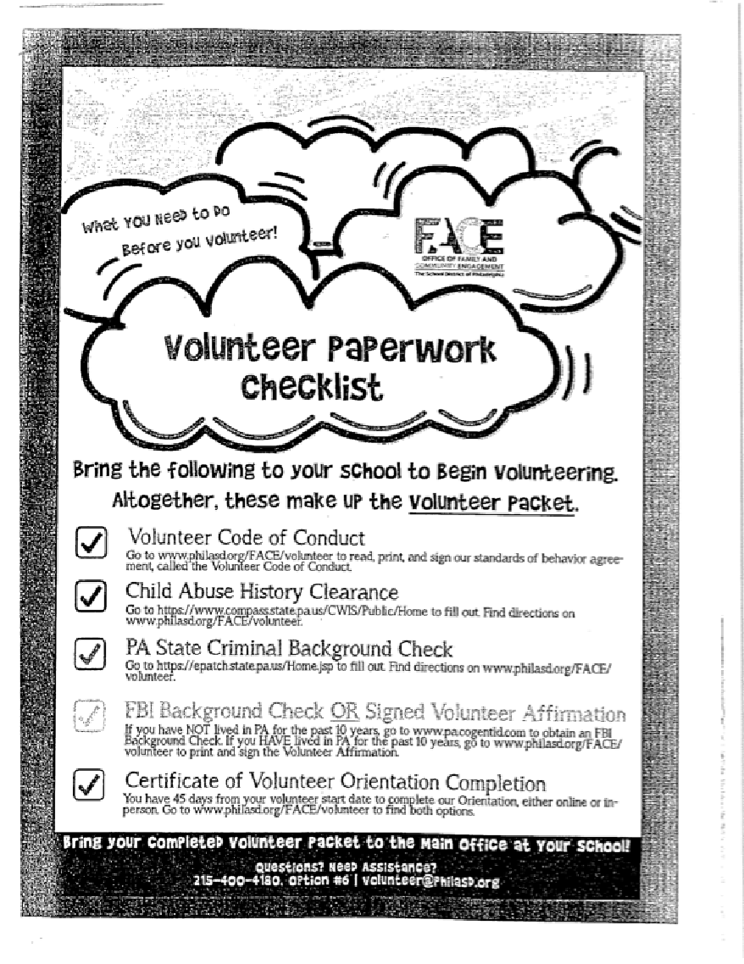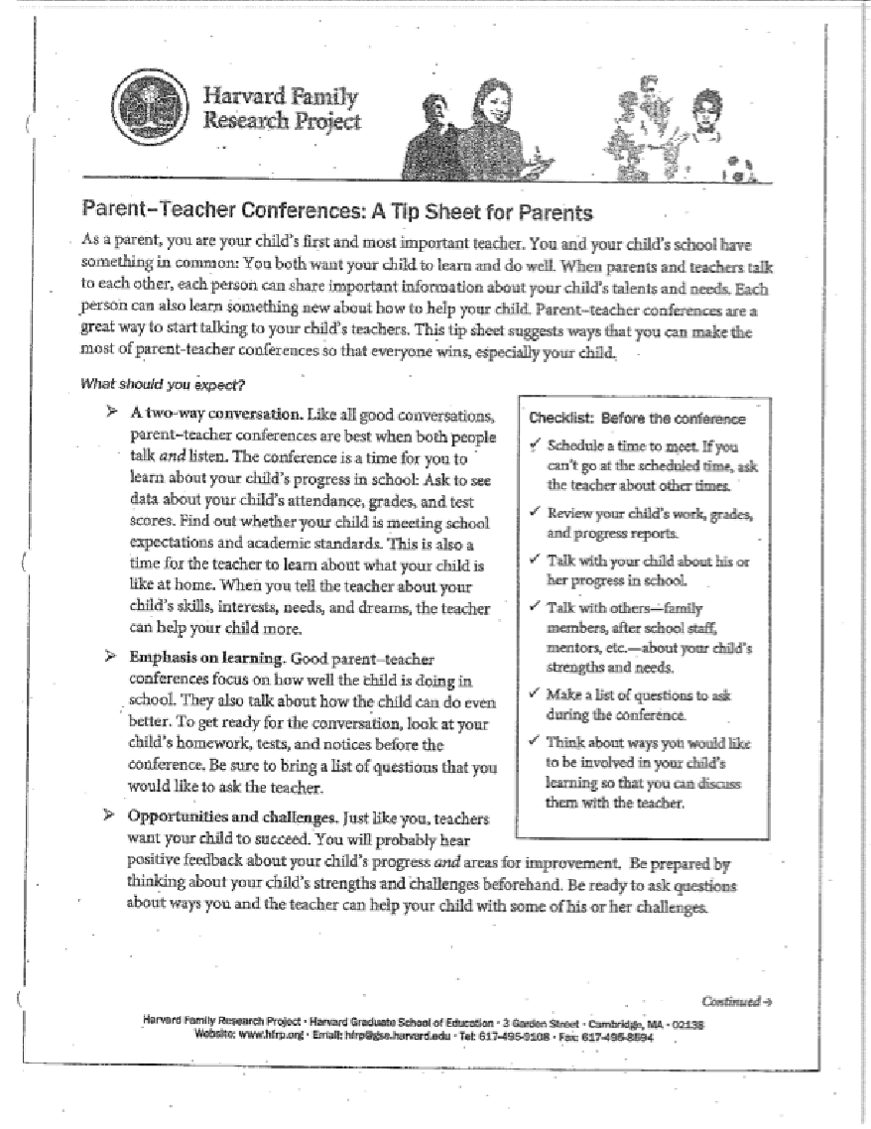
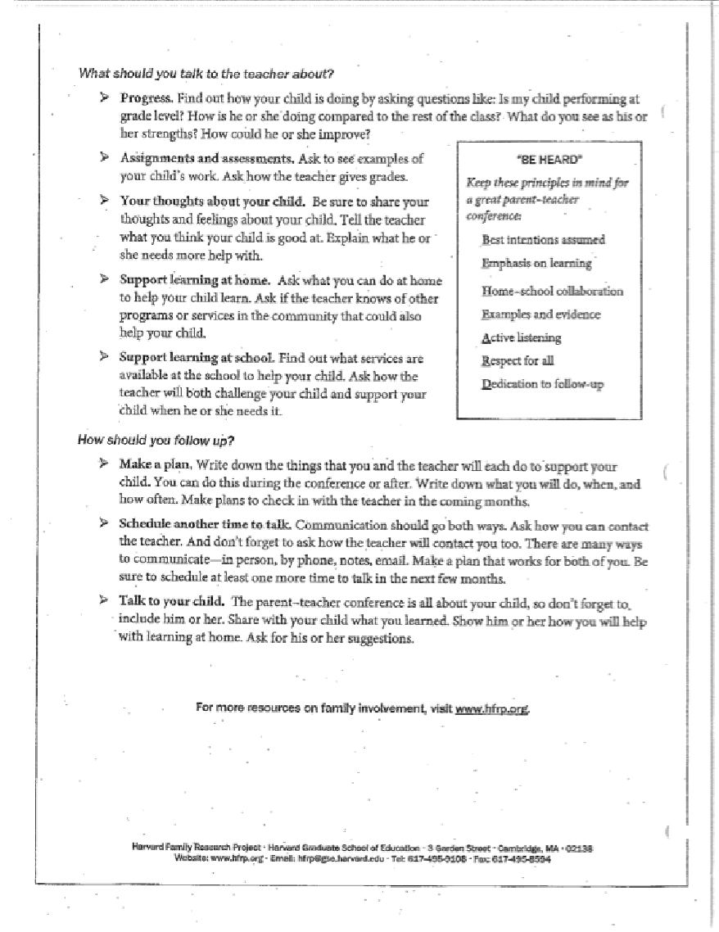

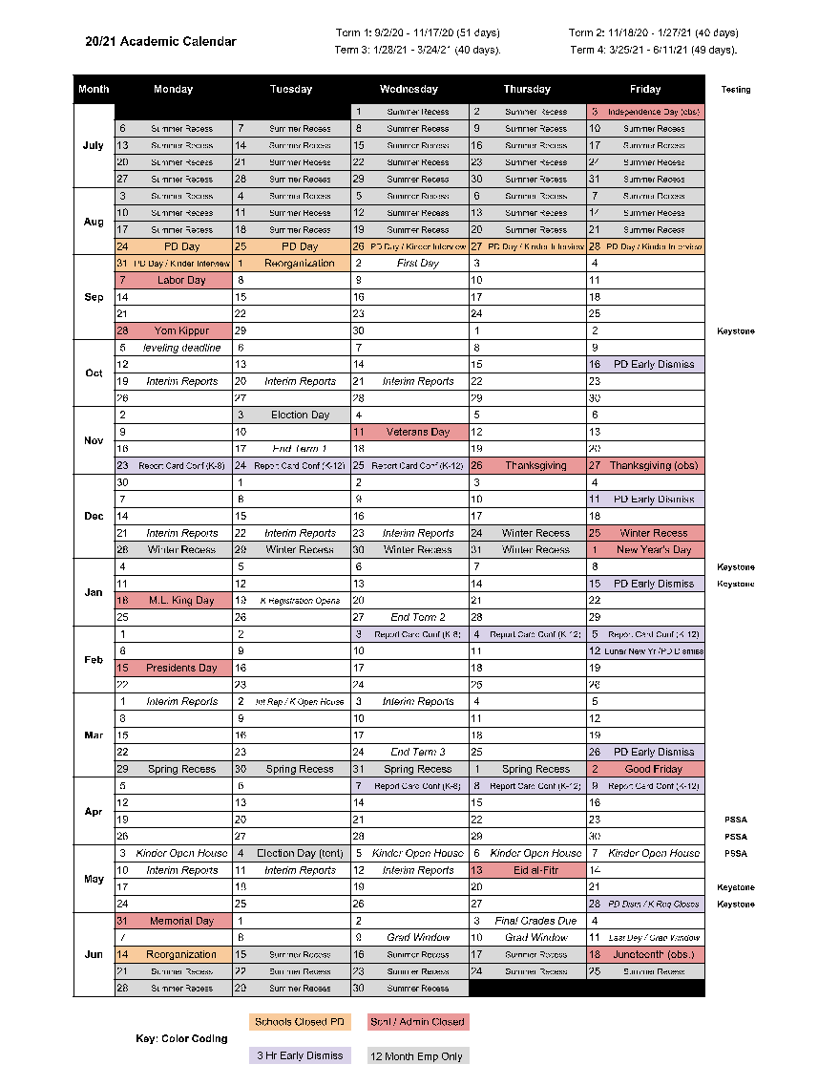

The School District of Philadelphia

LOUIS H. FARRELL ELEMENTARY SCHOOL

8300 Castor Avenue

Philadelphia, Pennsylvania 19152

Main Office (215) 400-3230

Fax (215) 400-3231

School-Parent Compact

2020-2021 School Year
Revision Date: 04/13/2020

Dear Parent/Guardian,

JOINTLY DEVELOPED

The Louis H. Farrell School and the parents of the students participating in activities, services, and programs funded by Title I, Part A of the Elementary and Secondary Education Act (ESEA) agree that this compact outlines how the parents, the entire school staff, and the students will share the responsibility for improved student academic achievement and the means by which the school and parents will build and develop a partnership that will help children achieve the State’s high standards.
This school-parent compact is in effect during the school year of 2020-2021.

To understand how working together can benefit your child, it is first important to understand the District’s and school’s goals for student academic achievement.

To understand how working together can benefit your child, it is first important to understand the district’s and school’s goals for student academic achievement.

THE SCHOOL DISTRICT OF PHILADELPHIA ANCHOR GOALS:
- 100% of students will graduate, ready for college and career.
- 100% of 8-year-olds will read on grade level.
- 100% of schools will have great principals and teachers.
- SDP will have 100% of the funding we need for great schools, and zero deficit.

LOUIS H. FARRELL SCHOOL GOALS:

- At least 35% of 3rd grade students will score at Proficient or Advanced on the ELA PSSA (includes PASA) (use AIMsweb Plus to monitor). 32.2% of students scored P/A in 2018-19, 37.7% of students scored P/A in 2017-18, 34.4% of students scored P/A in 2016-17
- At least 55% of 3rd grade students will score at Proficient or Advanced on the Math PSSA (includes PASA). (use AIMsweb Plus to monitor). 50.4% of students scored P/A in 2018-19, 40.4% of students scored P/A in 2017-18, 30.3% of students scored P/A in 2016-17
- At least 45% of students in grades 4-8 will score at Proficient or Advanced on the ELA PSSA (includes PASA). (use STAR to monitor). 41.8% of students scored P/A in 2018-19, 42.3% of students scored P/A in 2017-18, 44.2% of students scored P/A in 2016-17

- At least 35% of students in grades 4-8 will score at Proficient or Advanced on the Math PSSA (includes PASA). (use STAR to monitor). 31.0% of students scored P/A in 2018-19, 27.4% of students scored P/A in 2017-18, 28.2% of students scored P/A in 2016-17

- No more than 20% of 3rd grade students will score at Below Basic on the ELA PSSA (includes PASA). (use AIMsweb Plus to monitor). 21.6% of students scored BB in 2018-19, 27.2% of students scored BB in 2017-18, 32.0% of students scored BB in 2016-17

- At least 99% of students will have zero out-of-school suspensions (100% of K-2 will have zero-out-of-school suspensions). 98.8% of students had zero out-of-school suspensions in 2018-19, 97.5% of students had zero out-of-school suspensions in 2017-18 , 97.9% of students had zero out-of-school suspensions in 2016-17

To help your child meet the district and school goals, the school, you, and your child will work together:

SCHOOL/TEACHER RESPONSIBILITIES:
The Louis H. Farrell School will:

- Provide high-quality curriculum and instruction in a supportive and effective learning environment that enables the participating children to meet the State’s student academic achievement standards as follows:

All students will receive instruction based on the School District of Philadelphia’s Common Core Curriculum and supporting materials. Students will be assessed regularly and every effort will be made to meet the needs of individual students through differentiated instruction, small group instruction, and specialized programs where appropriate.
- Hold parent-teacher conferences (at least annually in elementary schools) during which this compact will be discussed as it relates to the individual child’s achievement. Specifically, those conferences will be held:

1st Report Conferences - November 23-25, 2020
2nd Report Conferences - February 3-5, 2021
3rd Report Conferences – April 7-9, 2021
Final Report Cards will be sent home on the final day of school.
3. Provide parents with frequent reports on their children’s progress. Specifically, the school will provide reports as follows:
Teachers will communicate with parents on an ongoing basis. Parents will receive interim reports halfway between report card conferences. These reports will be distributed to all students in danger of failing and to any other student at the discretion of the teacher. For parents who do not attend Report Conferences, telephone conferences will be arranged and/or reports will be sent home.
Parents will be a part of the MTSS/RTII process and will be kept updated on students’ academic, behavioral, and attendance progress. Parents will be invited to the MTSS/RTII meeting when appropriate to garner their input into planning for student progress.
4. Provide parents reasonable access to staff. Specifically, staff will be available for consultation with parents as follows:
Staff will make themselves available to speak with parents at a time that does not unduly impact the instructional program.
Appointments can be made during the following non-instructional times:
- Before and after school with teacher by prior agreement.
- During preparation time by prior agreement.

5. Provide parents opportunities to volunteer and participate in their child’s class, and to observe classroom activities, as follows:
Parents are encouraged to volunteer and participate through many venues including Home and School Association activities.
Volunteers for classrooms are encouraged and are arranged through the School Office in collaboration with teachers.

PARENT RESPONSIBILITIES:
We, as parents, will support our children's learning in the following ways:

- Monitor attendance.
- Make sure that homework is completed.
- Monitor the amount of television my child watches.
- Volunteer in my children’s school.
- Participate, as appropriate, in decisions relating to my child’s education.
- Promote positive use of my child’s extracurricular activities.
- Stay informed about my child’s education and communicate with the school by promptly reading all notices from the school or the school district either received by my child or by mail and responding, as appropriate.
- Serve, to the extent possible, on policy advisory groups, such as but not limited to, being a Title I, Part A parent representative on the school’s School Improvement Team, the Title I Policy Advisory Council, the State’s Committee of Practitioners, the School Support Team, or school advisory or policy groups.

STUDENT RESPONSIBILITIES:

We, as students, will share the responsibility to improve our academic achievement and
achieve the State’s high standards. Specifically, we will:
- Take appropriate responsibility for my academic success.
- Do my homework every day and ask for help when I need it.
- Read at least 30 minutes every day outside of school.
- Give to my parents or the adults responsible for my welfare all notices and information received by me from my school.

COMMUNICATION ABOUT STUDENT LEARNING:

Louis H. Farrell School is committed to frequent two-way communication with families about children’s learning. Some of the ways you can expect us to reach you are:

- Involve parents in the planning, review, and improvement of the school’s parental involvement policy, in an organized, ongoing, and timely way.

- Involve parents in the joint development of any school-wide program plan, in an organized, ongoing, and timely way.

- Hold an annual meeting to inform parents of the school’s participation in Title I, Part A programs, and to explain the Title I, Part A requirements, and the right of parents to be involved in Title I, Part A programs. The school will convene the meeting at a convenient time to parents, and will offer a flexible number of additional parental involvement meetings, such as in the morning or evening, so that as many parents as possible are able to attend. The school will invite to this meeting all parents of children participating in Title I, Part A programs (participating students), and will encourage them to attend.

- Provide information to parents of participating students in an understandable and uniform format, including alternative formats upon the request of parents with disabilities, and, to the extent practicable, in a language that parents can understand.

- Provide parents of participating children information in a timely manner about Title I, Part A programs that includes a description and explanation of the school’s curriculum, the forms of academic assessment used to measure children’s progress, and the proficiency levels students are expected to meet.
- On the request of parents, provide opportunities for regular meetings for parents to formulate suggestions, and to participate, as appropriate, in decisions about the education of their children. The school will respond to any such suggestions as soon as practicably possible.

- Provide to each parent an individual student report about the performance of their child on the State assessment in at least math, language arts and reading.

- Provide each parent timely notice when their child has been assigned or has been taught for four (4) or more consecutive weeks by a teacher who is not highly qualified within the meaning of the term in section 200.56 of the Title I Final Regulations (67 Fed. Reg. 71710, December 2, 2002).

ACTIVITIES TO BUILD PARTNERSHIPS:
Louis H. Farrell offers ongoing events and programs to build partnerships with families.

- Recommend to the Regional No Child Left Behind District Liaison, the names of parents of participating children of Title I, Part A programs who are interested in serving on the State’s Committee of Practitioners and School Support Teams.

- Notify parents of the school’s participation in Early Reading First, Reading First and Even Start Family Literacy Programs operating within the school, the district and the contact information.

- Work with the School District of Philadelphia in addressing problems, if any, in implementing parental involvement activities in section 1118 of Title I, Part A.

- Work with the School District of Philadelphia to ensure that a copy of the State Education Agency’s written complaint procedures for resolving any issue of violation(s) of a Federal statute or regulation of Title I, Part A programs is provided to parents of students and to appropriate private school officials or representatives.

The School District of Philadelphia

LOUIS H. FARRELL ELEMENTARY SCHOOL

8300 Castor Avenue

Philadelphia, Pennsylvania 19152

Main Office (215) 400-3230

Fax (215) 400-3231

Parent and Family Engagement Policy

School Year 2020-2021
Revision Date: 04/13/20

In support of strengthening student academic achievement, Louis H. Farrell School receives Title I, Part A funds and therefore must jointly develop with, agree on with, and distribute to parents and family members of participating children a written parent and family engagement policy that contains information required by section 1116(b) and (c) of the Every Student Succeeds Act (ESSA). The policy establishes the school’s expectations for parent and family engagement and describes how the school will implement a number of specific parent and family engagement activities, and it is incorporated into the school’s plan submitted to the local educational agency (LEA).

The Louis H. Farrell School agrees to implement the following requirements as outlined by Section 1116:
- Involve parents, in an organized, ongoing, and timely way, in the planning, review, and improvement of programs under Title I, Part A, including the planning, review, and improvement of the school parent and family engagement policy and the joint development of the schoolwide program plan under Section 1114(b) of the Every Student Succeeds Act (ESSA).
- Update the school parent and family engagement policy periodically to meet the changing needs of parents and the school, distribute it to the parents of participating children, and make the parent and family engagement policy available to the local community.
- Provide full opportunities, to the extent practicable, for the participation of parents with limited English proficiency, parents with disabilities, and parents of migratory children, including providing information and school reports required under Section 1111 of the ESSA in an understandable and uniform format, including alternative formats upon request and, to the extent practicable, in a language parents understand.
- If the schoolwide program plan under Section 1114(b) of the ESSA is not satisfactory to the parents of participating children, submit any parent comments on the plan when the school makes the plan available to the local educational agency.
- Be governed by the following statutory definition of parent and family engagement and will carry out programs, activities, and procedures in accordance with this definition:

Parent and Family Engagement means the participation of parents in regular, two-way, and meaningful communication involving student academic learning and other school activities, including ensuring:
(A) Parents play an integral role in assisting their child’s learning
(B) Parents are encouraged to be actively involved in their child’s education at school
(C) Parents are full partners in their child’s education and are included, as appropriate, in decision-making and on advisory committees to assist in the education of their child
(D) Other activities are carried out, such as those described in Section 1116 of the ESSA

DESCRIPTION OF HOW THE SCHOOL WILL IMPLEMENT
REQUIRED SCHOOL PARENT AND FAMILY ENGAGEMENT POLICY COMPONENTS

Section A: JOINTLY DEVELOPED
Louis H. Farrell School will take the following actions to involve parents in an organized, ongoing, and timely manner in the planning, review, and improvement of Title I programs, including opportunities for regular meetings, if requested by parents, to formulate suggestions and to participate, as appropriate, in decisions relating to the education of their child and respond to any such suggestions as soon as practicably possible.
- Parents are members of our Home & School Association/SAC, which assists in the coordinating and planning of all activities. Parents are invited to attend monthly Home & School/SAC meetings where input is garnered and school status and upcoming events are discussed. We have Winter and Spring Title I Parental input meetings for assistance in the Parent and Family Engagement Policy and the School Parent Compact.

Section B: ANNUAL TITLE I MEETING
Louis H. Farrell School will take the following actions to conduct an annual meeting, at a convenient time, and encourage and invite all parents of participating children to attend to inform them about the school’s Title I program, the nature of the Title I program, the parents’ requirements, the school parent and family engagement policy, the schoolwide plan, and the school-parent compact.
- The Principal and School-based Teacher Leader will present information (How Title I works, how to monitor a child’s progress, curriculum, the School Wide Plan, Title I Budget, Teacher Qualifications, as well as Academic Standards and Assessments) to parents and will support the school as needed at our annual Back to School Nights (September 8, 2020 & September 10, 2020) and at a monthly parent workshops relating to Title I.

Section C: COMMUNICATIONS
Louis H. Farrell School will take the following actions to provide parents of participating children with (1) Timely information about the Title I programs, (2) Flexible number of meetings, such as meetings in the morning or evening, (3) transportation, child care or home visits, as such services relate to parent and family engagement and may use Title I funds and (4) Information related to the school and parent programs, meetings, and other activities, is sent to the parents of participating children in an understandable and uniform format, including alternative formats upon request and, to the extent practicable, in a language the parents can understand.
- The Parent and Family Engagement Policy will be in the Parent Handbook that is distributed in September and posted on the Farrell School Website.
- We have alternating AM and PM meetings throughout the year.
- Childcare is provided during PM meetings.
- Each Tuesday parents will receive flyers and newsletters, with translations where possible, that inform them of important events and concerns. A parent information desk is present in the front hall along with a “PAD” bulletin board. Arabic, Chinese (Cantonese & Mandarin), Russian, Albanian, Portuguese, Pashto, Spanish, Ukrainian and Uzbek Bi-lingual Counseling Assistants are available and meet with parents and administration to further school/parent communication. School staff also utilizes Language Line when BCAs are unavailable. Parent Workshops will be held monthly and parents will be invited to participate in professional development opportunities at the school and network level.

Section D: SCHOOL-PARENT COMPACT
Louis H. Farrell School will take the following actions to jointly develop with parents of participating children a school-parent compact that outlines how parents, the entire school staff, and students will share the responsibility for improved student academic achievement and the means by which the school and parents will build and develop a partnership to help children achieve the state’s high standards.
- The Leadership Team will annually evaluate our Parent and Family Engagement Program and revise it as necessary based on feedback from parents and staff. The Parent and Family Engagement Policy is sent home to each family in the first month of school, giving all parents the opportunity to review, request a different format, and/ or discuss with school staff. Parents are invited to share their suggestions for plan revisions at the Winter and Spring Title I parental input meetings, as well as updates to the school parent compact.
- A parent involvement survey will be distributed to all families and the information collected will be reviewed to help update the Parent and Family Engagement Policy and Compact.
- The Leadership Team, along with the Home and School Association, plan a parent and family engagement calendar of activities based on parental input.

Section E: RESERVATION OF FUNDS
Louis H. Farrell School will take the following actions to involve the parents of children served in Title I, Part A schools in decisions about how the 1 percent of Title I, Part A funds reserved for parent and family engagement is spent by:
- Principal will share the budget with parents at the Spring Title I parental input meeting and the Winter Title I parental input meeting. During this meeting, parents will review the previous budget as well as the upcoming budget. Then parents will give their input for how the funds should be spent, including the 1% parent set-aside.

Section F: COORDINATION OF SERVICES
[Louis H. Farrell School will, to the extent feasible and appropriate, coordinate and integrate parent and family engagement programs and activities with other Federal, State, and local programs, including public preschool programs, and conduct other activities, such as parent resource centers, that encourage and support parents in more fully participating in the education of their children by:
- Principal’s attendance at meetings at a local pre-school and greeting pre-school parents.
- Distributing Kindergarten registration information.
- Inviting teachers at neighborhood pre-schools to attend kindergarten instructional planning sessions.
- Having a Kindergarten teacher act as a liaison between our school and local pre-schools.
- Arranging Open Houses and site visits for incoming kindergarteners.
- Guiding parents toward after school care provided by Pelbano, Paley and Methodist.
- Guiding parents to Cora Services through the MTSS process.
- SBTL membership and attendance at 7th Police District Advisory Council monthly meetings to discuss neighborhood concerns and school initiatives.

Section G: BUILDING CAPACITY OF PARENTS
Louis H. Farrell School will build the parents’ capacity for strong parent and family engagement to ensure effective involvement of parents and to support a partnership among the school and the community to improve student academic achievement through the following:
- Providing parents with a description and explanation of the curriculum in use at the school, the forms of academic assessments used to measure student progress, and the achievement levels of the challenging State academic standards; and
- Materials and training to help parents to work with their child to improve their child’s achievement, such as literacy training and using technology (including education about the harms of copyright piracy), as appropriate, to foster parent and family engagement
- Providing assistance to parents of participating children, as appropriate, in understanding topics such as the following:
    - The challenging State’s academic standards
    - The State and local academic assessments including alternate assessments
    - The requirements of Title I, Part A
    - How to monitor their child’s progress
    - How to work with educators to improve the achievement of their child
- Workshops and events, such as Learning how to access the Parent Portal, Literacy and Math workshop, Preparing for High School, and Standardized Test Information, will be held during the monthly Home and School/SAC meetings and/or scheduled as needed. The monthly Home and School/SAC meetings will alternate between day and evening in an effort to accommodate a greater number of parents based on their schedules. Bi-lingual Counseling Assistants will hold meetings with parents of their designated language groups to further enhance their involvement. Our annual Special Title I Meetings will be held on our Back To School Nights on September 8, 2020 and September 10, 2020, at our Winter Home & School/SAC meeting (Date TBA), and at the Spring Title I Parental Input Meeting (Date TBA).
- The Principal and School-based Teacher Leader will present information (How Title I works, how to monitor a child’s progress, curriculum, the School Wide Plan, Title I Budget, Teacher Qualifications, as well as Academic Standards and Assessments) to parents and will support the school as needed at our annual Back to School Nights (September 8, 2020 and September 10, 2020) and at a monthly parent workshops relating to Title I.
- Students will have access at home to materials used for instruction, and web-based activities in reading and mathematics, through Pearson, that can be accessed from home. This will give parents the opportunity to explore these materials with their children. Written documents that support the academic process, such as booklets and pamphlets, will be distributed to parents in various languages when feasible.

Section H: BUILDING CAPACITY OF SCHOOL STAFF
Louis H. Farrell School will provide training to educate teachers, specialized instructional support personnel, principals, and other school leaders, and other staff, with the assistance of parents, in the value and utility of contributions of parents, and in how to reach out to, communicate with, and work with parents as equal partners, implement and coordinate parent programs, and build ties between parents and the school by:
- Contributions from parents on effective teacher-parent communication are always welcome. A specific time for input is designated at the Fall Home and School Association/SAC meeting and other meetings that follow and the information is passed on to teachers and staff through the Principal Chat and Chews and on Professional Development days. Professional Development sessions will be held, and information will be sent by the Principal through email and a Weekly Gram, including articles focusing on “tips” for parent meetings, parent access to teachers’ email and parent portal. Specifically, one professional development day in the fall, is focused on working with parents as equal partners in the educational process. Staff will review parent survey results and incorporate parent suggestions into their parent and family engagement program.

- A Professional Learning Community has been established to address the collaborative and educational needs of classroom and support teachers. A School-based Teacher Leader (Instructional Support Leader) is available for support on an individual or group basis. Farrell will continue to have an Early Literacy Specialist assigned to the school providing daily professional development to all Early Literacy teachers as well as a Reading Specialist on site.

Louis H. Farrell School will provide other reasonable support for parent and family engagement activities under Section 1116 as parents may request by:
- “Farrell Five” & “Power of 3” School-wide Behavioral Support
- “Student of the Month” Pillars of Character Program
- “Caught Being Good” Coin Positive Behavior Incentive Program
- “Grow Your Stamina” Reading Program
- Instrumental Music Program – Winter and Spring Concerts
- Honor Roll for grades 4-8
- Student Council
- Muffins with Mom Day
- Donuts with Dad Day
- Graham Crackers with Grandparents Day
- Workshops for Parents
- Project Pride Prevention Services
- Second Step
- RSVP Volunteer Program
- Parent and Family Portal through Infinite Campus
- Sports Clubs
- School-wide academic interventions supporting math (Imagine Math) and literacy (Lexia)
- Imagine Language Intervention Program for EL students
- After School Academic Support and Enrichment for Math and Reading (iReady)
- After School Extracurricular Activities
- After School “Methodist Services” Program and Paley Daycare Program

PARENT AND FAMILY ENGAGEMENT POLICY DISCRETIONARY COMPONENTS

- Involve parents in the development of training for teachers, principals, and other educators to improve the effectiveness of that training.
- Provide necessary literacy training for parents from Title I, Part A funds, if the school district has exhausted all other reasonably available sources of funding for that training.
- Pay reasonable and necessary expenses associated with parental involvement activities, including transportation to enable parents to participate in school-related meetings and training sessions.
- Train parents to enhance the involvement of other parents.
- Arrange school meetings at a variety of times, or offering in-home conferences between teachers or other educators, who work directly with participating children, with parents who are unable to attend those conferences at school, in order to maximize parental involvement and participation in their children’s education.
- Adopt and implement model approaches to improving parental involvement.
- Establish a district wide Parent Advisory Council to provide advice on all matters related to parental involvement in Title I, Part A programs.
- Develop appropriate roles for community-based organizations and businesses, including faith-based organizations, in parental involvement activities; and provide other reasonable support for parental involvement activities under section 1118 as parents may request.

Nicholas J. Cirulli, Jr.
Principal

April 29, 2020
Date

