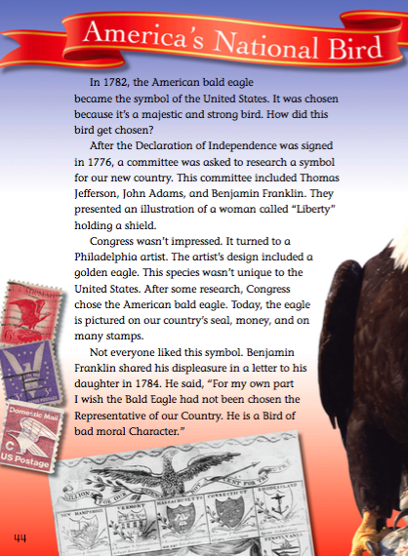

Part A. Make a sentence with each word in the right column:
 | Vocabulary word | Explanation/Definition | Make YOUR sentence with the word
1 | majestic | having or showing impressive beauty or dignity.
2 | committee | a group of people appointed for a specific function, typically consisting of members of a larger group.
3 | liberty | the state of being free/freedom
4 | country’s seal | a nation with its own government, occupying a particular territory.
5 | displeasure | a feeling of annoyance or disapproval.
6 | coward | a person who lacks the courage to do or endure dangerous or unpleasant things.
7 | appropriate | suitable or proper in the circumstances.
8 | courageous | not deterred by danger or pain; brave.
9 | symbolize | represent with symbols
10 | Founding  Fathers | a group of leaders who signed the Declaration of Independence
Part B. Answer the following questions using text evidence:
1) How long has the American bald eagle been the symbol of the U. S.?
-
2) Why was the American bald eagle chosen as the symbol of the U. S.?
-
3) Who was in charge of researching a symbol for the U.S. after the Declaration of Independence was signed? What was their idea?
-
4) Did Congress like the committee’s idea? No, they did not like the idea.
-
5) Where is the eagle pictured as our country’s symbol? Name 2 things (from the text)
-
6) Explain what Benjamin Franklin did not like about the Bald Eagle as the U.S. symbol.
-
7) Explain what Benjamin Franklin liked about the Bald Eagle as the U.S. symbol.
-
8) What was president’s John F. Kennedy’s opinion about the Bald Eagle?
-
9) What do you think about the Bald Eagle as the symbol of U.S.?
-
10) If you were in charge of creating a symbol for U.S., what would you pick? Why?
-
Part C. Use the graphic organizer to type 3 details
that support the main idea of the passage.

MAIN IDEA: America’s National Bird
(What is the passage mainly/mostly about?)

DETAIL 1  Committee’s idea | DETAIL 2  Philadelphia artist’s idea | DETAIL 3  Positive comments and opinions about the bald eagle.

Part D. Write a 3-paragraph essay. Explain the main idea of the passage and provide 3 details from the graphic organizer to support the main idea.

Introduction

Body
Conclusion

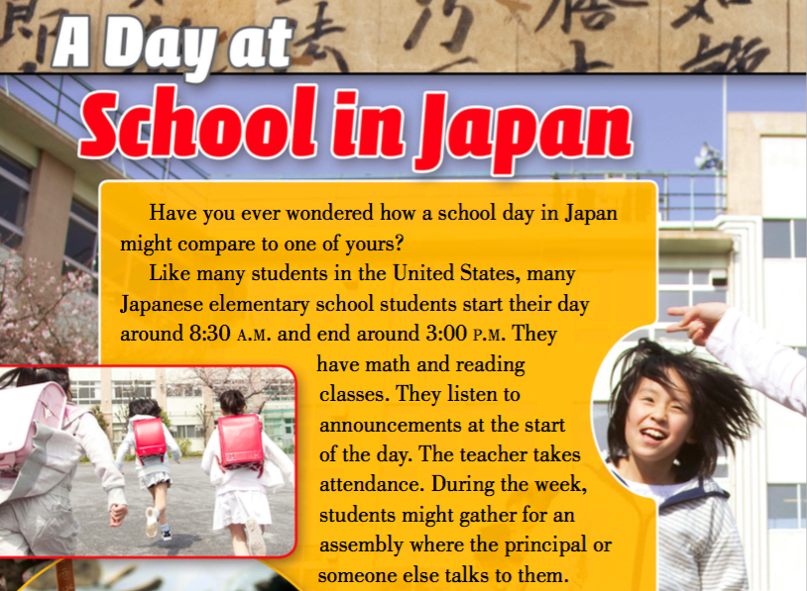

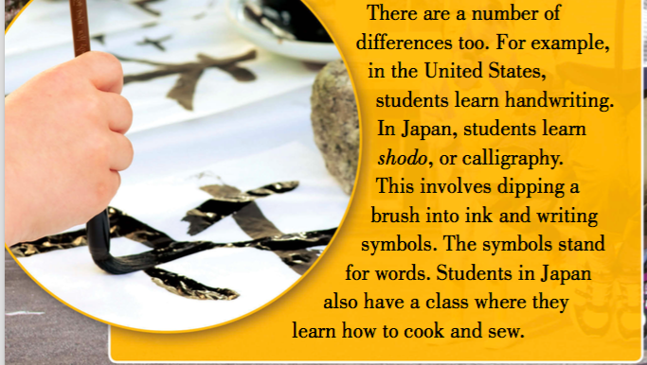
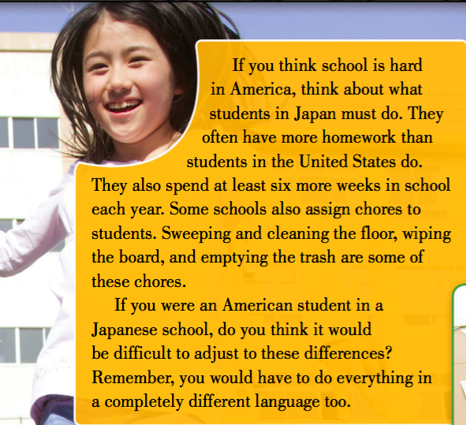
Part A. Type the explanation/definition of each word and make a sentence with it.
 | Vocabulary word | Explanation/Definition | Make YOUR sentence with the word
1 | wonder
2 | gather
3 | assembly
4 | calligraphy
5 | sew
6 | assign
7 | chores
8 | adjust

Part B. Answer the following questions using examples from the text:
- Write 2-3 things you like about schools in Japan.
-
- Write 2-3 things you do not like about schools in Japan.
-

Part C. Compare and Contrast schools in Japan and the U.S.:

Schools in the U.S. American schools | In both countries | Schools in Japan  Japanese schools
Differences | Similarities | Differences
1. | 1. | 1.
2. | 2. | 2.
3. | 3. | 3.

Part D. Write a 3-paragraph essay. ComparE and contrast schools in the U.S. and Japan. Use transition words from the right column.

Introduction
Similarities
like
both
also
too
same
as well as
Differences
unlike
but, however whereas, yet different,
on the other hand

Conclusion
In conclusion
To conclude

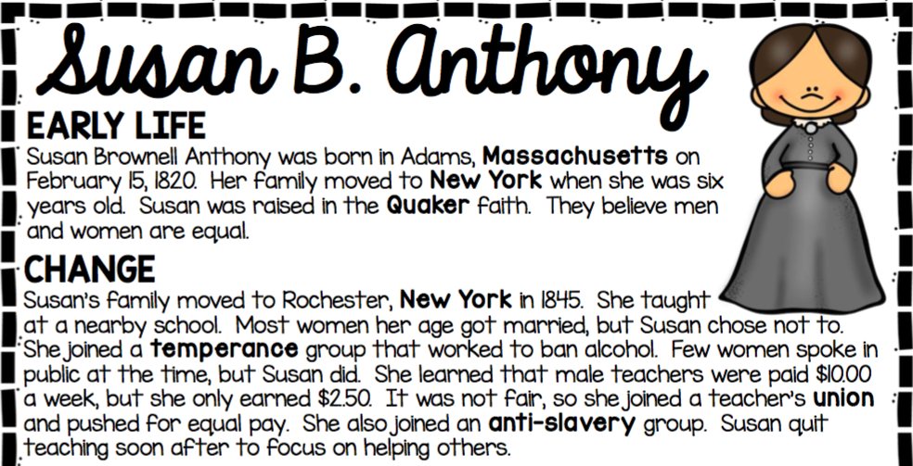

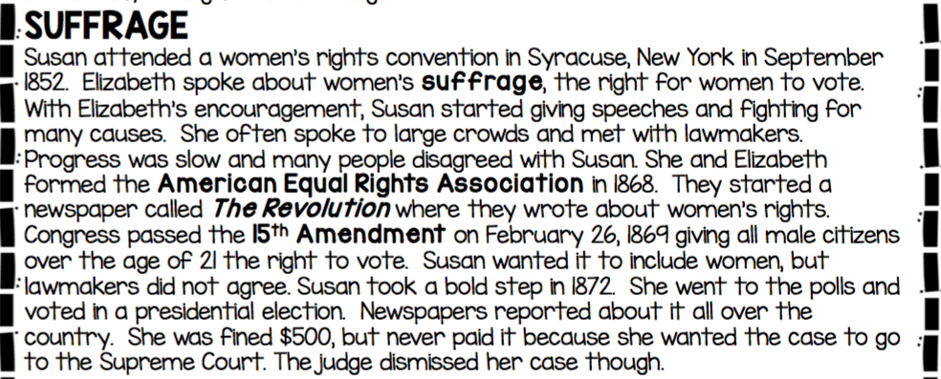
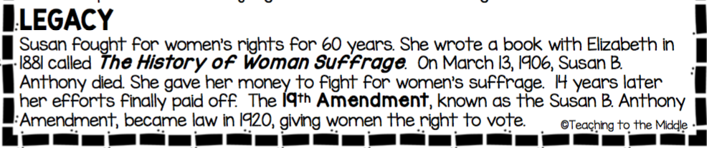
Vocabulary
Quakers faith - a belief that each person is unique, all people are equal
temperance group - people who think alcohol is bad and should not be allowed
ban - not to allow, to prohibit anti-slavery - against slavery vow - promise
union - is a group of people that have similar jobs and support each other
convention - a big important meeting suffrage - the right for women to vote
give speech - talk about an important topic in front of people
cause - important ideas and things that help people lawmakers - people who make laws
association - a group of people with the same goal
amendment - a small part added to the constitution bold step - brave action
polls - a place where you vote case - legal action law - rule you need to follow
to be fined - to pay money when you broke the law dismiss - cancel/stop
efforts paid off- hard work gave results

Part A. Choose any 5 words from the vocabulary list.
Make 1 sentence with each word (5 sentences total)
1.
2.
3.
4.
5.
Part B: Answer the following questions using text evidence:
1. What faith was Susan raised in?

2. Why did Susan join a teacher’s union?

3. Why did Susan quit teaching?

4. What was Seneca Falls Convention?

5. What did Susan promise herself to do after a temperance convention in Rochester?

6. What did Susan do at a women’s rights convention in 1852?

7. What organization did Susan form with her friend?

8. What did Susan do in 1872? Why did she do it?

9. What is “The History of Woman Suffrage”?

10. Give an example of how Susan’s efforts in women’s voting rights paid off after her death?

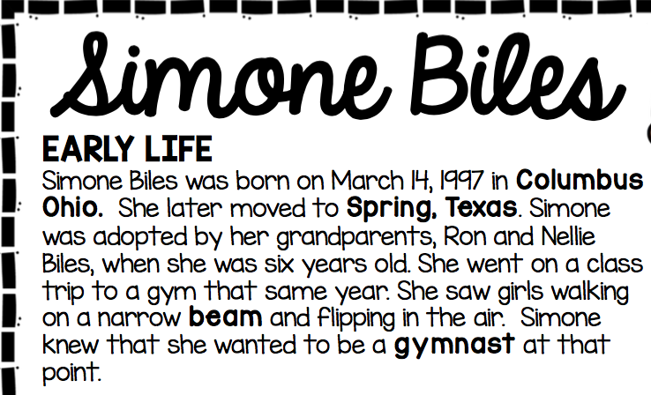
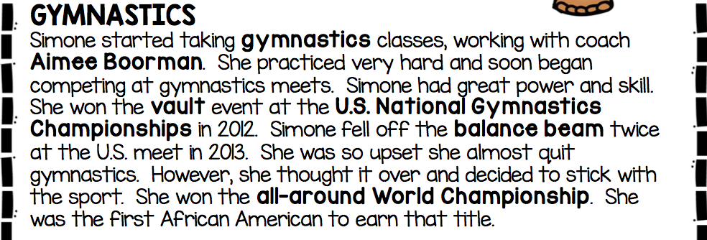
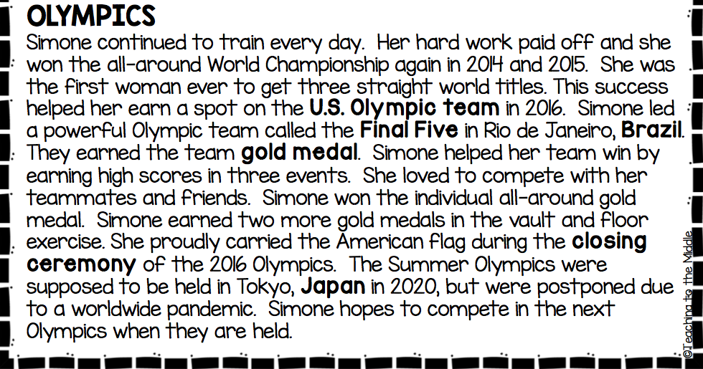
Vocabulary
was adopted - was taken by a new family at that point - at that time
gymnastics - a type of sports quit - stop trying
compete - participate to win meets - contest, sporting event
U.S. National Championship - a competition to be the best in the U.S.
all-around World Championship- a competition to be the best in the world
paid off - gave results, was successful due to - because of
word title - the champion of the world (#1)
a spot- place led (past of “lead”) - was the leader of
earning - getting teammates - people from the same team
closing ceremony - celebration at the end of a competition
to be held - to take place were postponed - were canceled for a later date
pandemic - a dangerous disease/illness all over the country or all over the world

Part A. Choose any 5 words from the vocabulary list.
Make 1 sentence with each word (5 sentences total)
1.
2.
3.
4.
5.
Part B: Answer the following questions using text evidence:
1. What happened to Simone when she was 6 years old?

2. When did Simone know that she wanted to be a gymnast?

3. What did Simone start doing after she knew she wanted to be a gymnast?

4. When and what was her first victory?

5. What happened in 2013 that made Simone upset?

6. What happened after she was upset?

7. What helped Simone get a spot on the U.S. Olympic team in 2016?

8.How did Simone help her team win the gold medal in the Olympic games in 2016?

9. List all the medal and titles Simone won in gymnastics?

10. What happened to the Summer Olympics in 2020?
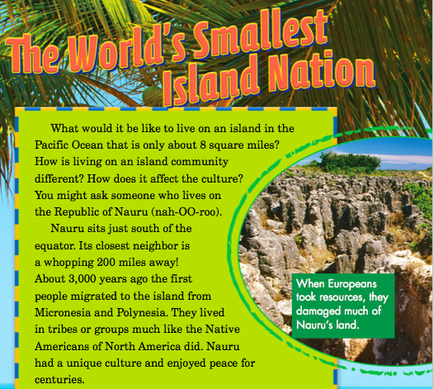
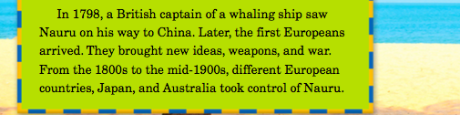

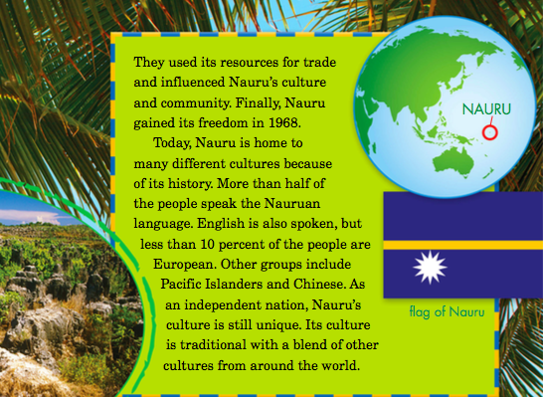
Part 1: Vocabulary
- Read the definitions of these 20 vocabulary words from the passage.
- Study them for your Vocabulary Quiz.
 | Vocabulary Word/Phrase | Definition
1 | island | a piece of land surrounded by water
2 | community | a group of people living in the same area
3 | affect | make a difference to
4 | equator | an imaginary line dividing the earth into north and south
5 | migrated | moved from one place to another
6 | tribes | a group of people living together and having the same culture and origin living
7 | unique | very special
8 | peace | when people don’t fight (opposite of war)
9 | captain | the person in charge of a ship (the boss of the ship)
10 | weapons | guns, things used to kill people and animals
11 | war | when people fight and kill
12 | took control | became in charge of (became the boss of)
13 | resources | things we need to live
14 | trade | selling or buying things
15 | influenced | had an effect, made a difference to
16 | gained freedom | became free
17 | independent | free from others
18 | nation | a large group of people living in the same country
19 | traditional | things that people and their families do for a long time
20 | centuries | plural of “century” (a century is 100 years)

PART 2: Vocabulary Practice
- Choose any 10 words from the table above and make 1 sentence with each word
1.
2.
3.
4.
5.
6.
7.
8.
9.
10.

PART 3: Vocabulary Quiz
- Choose a word from the WORD BOX that goes in the blank. Type that word in the column.
- Remember that some of these sentences are taken directly from the passage.

WORD BOX
island | tribes | war | trade | nation | migrated | influence
community | centuries | peace | freedom | traditional | weapons | resources
unique | independent

 | Sentence
 | Example: My mom _drove __ me to school.
1 | An __________ is surrounded by water.
2 | ______ means “many hundreds of years”.
3 | Native Americans lived in ________ .
4 | A group of people living in the same area is a _____ .
5 | A large group of people living in the same country is a ___ .
6 | Many people ____________ when they found a new land.
7 | Soldiers use ______________ when there is a war.
8 | People need many different __________ to live.
9 | As an _________ nation, Nauru’s culture is unique.
10 | Nauru gained its ________ in 1968.
11 | Nauru had a ______ culture.
12 | Families made ________ meals for a long time.
13 | The opposite is of war is ___________ .
14 | When you have an effect on or make a difference to something, you _______ it.
15 | _______ is when you sell or buy things.
16 | A ________ is when people fight and kill one another.

PART 4: Writing
Use the graphic organizer to type 3 details that support the main idea.

MAIN IDEA

Detail 1 | Detail 2 | Detail 3

Write a 3-paragraph essay. Explain the main idea of the passage and provide 3 details from the graphic organizer to support the main idea.

Introduction (main idea) 2-3 sentences

Body (3 supporting details) 6-7 sentences

Conclusion (restate the main idea) 2-3 sentences

First / Then / Next / Finally / Another example / Also / In addition / In conclusion /

PART C: Checklist:

- Indent paragraphs (move the first word of the beginning of the paragraph to the right)
- Capital letter at the beginning of my sentences. (My friend and I played a game.)
- Period at the end of my sentences (My friend and I played a game.)
- Space between the words. (My friend and I played a game.)
- Signal words (first, then, next, finally, in conclusion, also, in addition, moreover, according to the passage, according to the text)
- Correct spelling

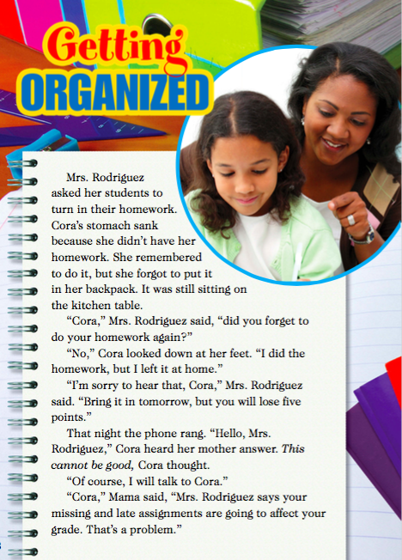
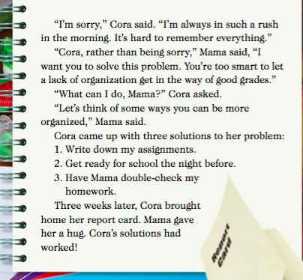
1. Gather Evidence
- What is the problem in the story?
- Write two details that let you know about this problem.
2. Ask Questions
- What questions might the teacher have asked Cora to help understand why Cora’s homework wasn’t turned in on time?
- Write two questions.
3. Make Your Case
- How do you think Cora’s decision to change her habits changes what happens in the rest of story?

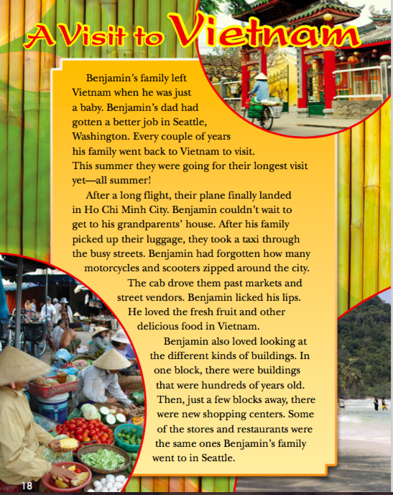

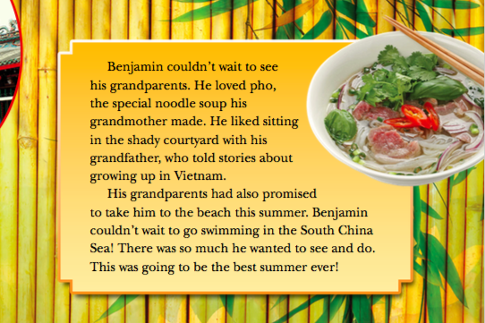
1. Gather Evidence
- How does Benjamin feel about his trip to Vietnam?
- Use text evidence to support your answer.
2. Ask Questions
- After reading this text, write three questions you have about Vietnam. Then, write an answer to your own question and indicate what resource you used to find the answers.
3. Make Your Case
- Can you relate to how Benjamin feels about his trip to Vietnam? (Do you understand how he feels and why he feels that way?) Explain your answer using at least 2-3 examples from your own experiences.

Use these sentence starters for Question 1
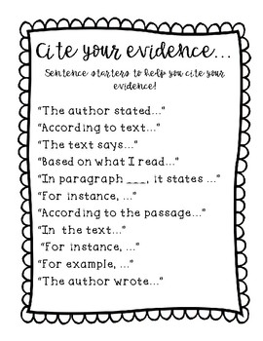
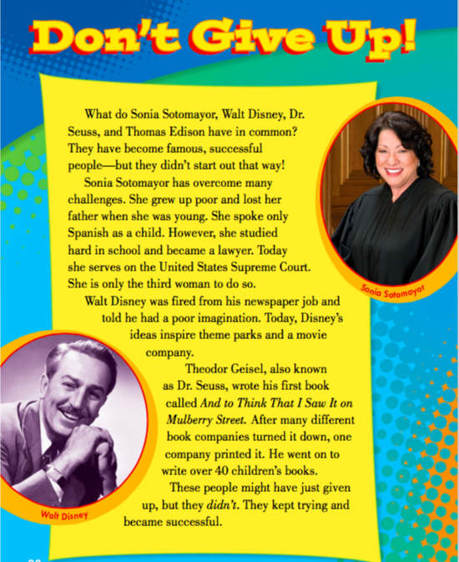

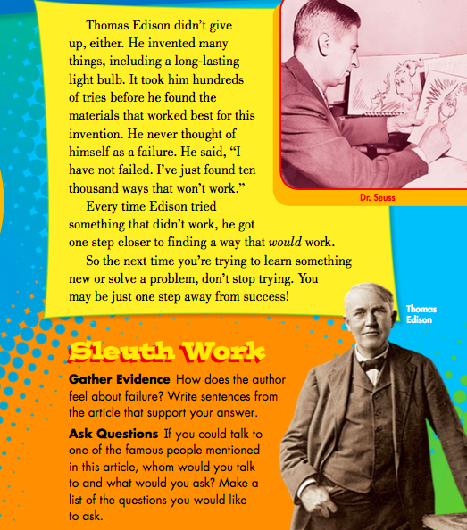

Part 1. Answer the following questions:
1) How does the author feel about failure (giving up/not trying)?
Use text evidence to support your answer (at least 2 examples)
-
-
2) How do YOU feel about failure? Use your life experiences (examples from your life) to support your answer (at least 2 examples).
-
-
3) Pick one of the famous people mentioned in the article.
Write 3 questions you would ask that person.
-
-
-
2. Choose any 5 new words from the passage. Explain each word and
make a sentence with each word in the table below:

 | New word | Explanation/Definition of the new word | Your sentence with the new word
1
2
3
4
5

Use these sentence starters for Question 1.

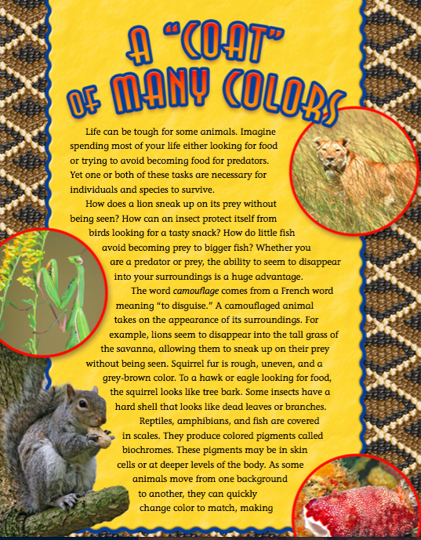

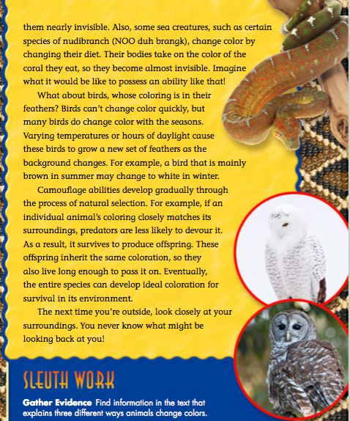
Part A. Answer the following questions:
1. Why can life be tough for some animals? Explain using text evidence.
-
2. How do lions camouflage themselves? How does their camouflage help them?
-
3. How do squirrels camouflage themselves? How does their camouflage help them?
-
4. How do insects camouflage themselves?
-
5. How do reptiles, amphibians and fish camouflage themselves?
-
6. How do some other sea creatures camouflage themselves?
-
How does their camouflage help them?
-
7. How do some birds camouflage themselves?
-
8. How do camouflage abilities of animals develop? Explain using text evidence.
-
Part B. Type the definition of each word and make a sentence with it.
 | Vocabulary word | Explanation/Definition | Make YOUR sentence with the word
1 | predators
2 | prey
3 | species
4 | camouflage
5 | surrounding
6 | gradually

Part C. Use the graphic organizer to type 3 details that support
the main idea of the passage. The main idea is already identified for you:

A Coat of Many Colors
Main Idea
Many animals camouflage to survive from predators.

Detail 1 | Detail 2 | Detail 3

Part D. Write a 3-paragraph essay about how many animals camouflage to survive from predators. Use 3 details/examples from the graphic organizer
INTRODUCTION

BODY (3 DETAILS)

CONCLUSION

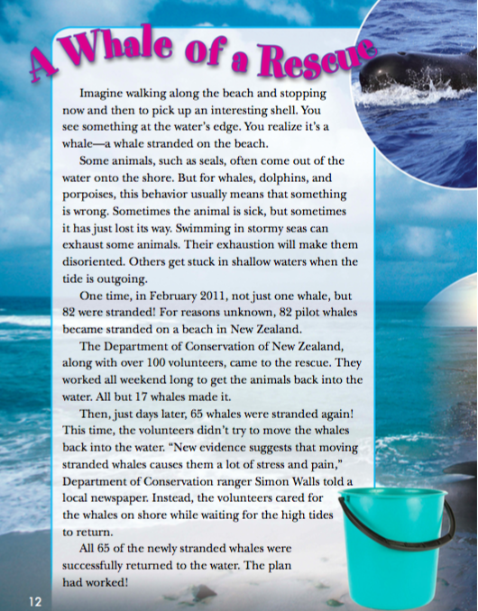

A Whale of a Rescue: Vocabulary
Vocabulary Word/Phrase | Definition
1. stuck | not being able to go back in the water
2. the shore | the land along the edge of the ocean, a sea or lake
3. lost | irregular verb- past tense of “lose”
4. stormy | when the weather is very windy with rain and thunderstorms
5. exhaust | make you very tired
6. exhaustion | a state of being very tired
7. disoriented | confused /not knowing where to go
8. shallow waters | when the water is not deep
9. tide | when the water gets high or low in the ocean
10. outgoing tide | what happens between high and low tide
11. pilot whales | a type of whales
12. volunteers | people that help others for free
13. rescue | save from danger
14. evidence | facts, information
15. suggests | says, states
16. stress | when you are nervous and upset
17. pain | when it hurts
18. successfully | when something worked well

Part A: Vocabulary Practice
- Pick any 5 words and make your own sentence with any 5 words.
- Type your word in column 1 and your sentence in column 2.
- Do not copy sentences from the passage. Make your own sentences.

Vocabulary Word/Phrase | My Sentence
1.
2.
3.
4.
5.

Part B: Vocabulary Quiz
- Read each sentence on the left.
- Choose a word from the WORD BOX that goes in the blank.
- Type that word in the column on the right, NOT in the sentence

WORD BOX
lost | the shore | successfully | disoriented | volunteer | evidence
stuck | tide | shallow water | rescue | suggest | stormy

 | Sentence | Answer
 | Example: My mom ___________ me to school. | drove
1 | I can’t find my book. I think I ___ it .
2 | When you are confused and don’t know where to go, you’re ___.
3 | The land along the edge of the ocean or a sea is called ___.
4 | According to the passage, whales sometimes get stuck in ___.
5 | When whales are ___on the shore, they can’t go back in the water.
6 | When you save an animal from danger, you ___the animal.
7 | The word we use to describe how the water gets high or low in the ocean is ___.
8 | When it rains with winds and thunderstorms, the weather is ___.
9 | When you collect facts and information about something, you collect ___ about it.
10 | According to the passage, all the stranded whales were ___ returned to the water in the end.
11 | People that offer their help for free are ___
12 | According to the passage, new ___ suggests that moving stranded whales causes them a lot of stress and pain.
Part C: Reading Comprehension Questions
- Read the questions.
- Use details from the reading passage to answer the questions.
- Write complete sentences when you answer the questions.
Example- Question: What is the passage about?
Answer: The passage is about stranded whales.

1) When whales, dolphins, and porpoises come out of the water into the shore, what does it mean?
-

2) Is swimming in stormy seas good for some animals? Why? Why not?
-

3) What happened in New Zealand in 2011?
-

4) Did the whales die?
-

5) What happened 3 days later after that incident?
-

6) What did the volunteers do about it?
-

7) Why do you think the volunteers didn’t try to move the whales back into the water?
-

8) What happened to 65 stranded whales in the end?
-

