Name:___________________________ Biology Summer Assignment PART 1 2020
Topic: Ecosystems

Directions: Biology Summer Assignment PART 1 GOOGLE Slides, click the various links provided to help you answer the questions below. Please record all answers on this answer sheet, not on the Google Slides. This assignment is worth a major grade for your biology class. All the best to you in your efforts.

Task 1

Ecosystem: Watch the video and answer the questions based on the video.

- An ecosystem is

- An example of an ecosystem is

- Another example of an ecosystem is

- The difference between biotic and abiotic components is

- An example of a biotic component is

- An example of an abiotic component is

Trophic Levels
- In your opinion, what are the three most important ideas from the video?

  - Idea #1:

  - Idea #2:

  - Idea #3:

- The amount of energy that is transferred from one energy to the next is

- This means that

Decomposers and Detritivores
- What is the difference between a decomposer and a detritivore?

- Why are decomposers and detritivores important to ecosystems?

Ecological Relationships
- What are the three types of ecological relationships? Describe each in 1-2 sentences.

  - #1

  - #2

  - #3

- What are three types of symbiosis? Describe each in 1-2 sentences.

  - #1

  - #2

  - #3

Task 2

Biodiversity
- In 1-2 sentences, explain biodiversity in your own words using the video to help you.

- Why is biodiversity important to an ecosystem?

Pollinators
- In what ways are bees important to ecosystems? Give 2-3 reasons.

- Do you think our ecosystems would survive without bees? Why or why not?

Abiotic Factors
- List 5 examples of abiotic factors

  - #1

  - #2

  - #3

  - #4

  - #5

- Choose one abiotic factor from the list. What do you predict would happen to an ecosystem if that factor was not present or its levels were too high? Explain in 2-3 sentences.

Task 3
Ecosystems
- One new thing I learned about ecosystems is

- Another thing I learned is

Levels of Organization
Put the levels of organization in order from broadest to narrowest. Then give an example of each.

broad ------------------------------> narrow

Level
Example

Word Bank: Biosphere, community, ecosystem, organism, population

Ecological Niches
- Define “niche” in your own words.

- What is the difference between fundamental and realized niches?

Limiting Factors
- Explain limiting factors in your own words.

- Explain one of the types of limiting factors in your own words.

Competitive Exclusion Principle
- Explain the competitive exclusion principle in your own words.

- An example that might happen in nature is

- How could competition be avoided? Use your example in the previous question to explain.

Name ______________________________________ Biology Summer Assignment PART 2 2020

Directions: Work through the activities on the Biology Summer Assignment PART 2 GOOGLE SLIDES 2020, click the links to view valuable resources. You will record your responses to questions and complete all directives below.

Task 1 Ecosystems, Biomes and Biosphere

1. Why do we care about the levels?

2. What level begins to include abiotic factors?

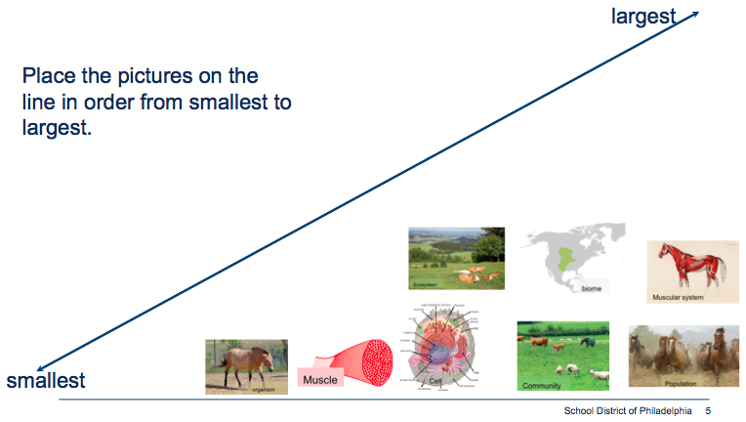
3.

Biome Overview
4. After watching the video, list two you things you wonder about Biomes in the box provided below.
a.

b.

5. Then list two you things you wonder about Biomes in the box provided below.

6. Which Biome did you choose? Why?

On the last page of your answer sheet you will collect and organize information about the biome of your choice. Be sure to scroll down to find the correct spot on your answer sheet. You will write your biome name, include apicture and a map showing the location of your biome.

Task 2 Biotic and Abiotic parts of the ecosystem
7. Sort the pictures into biotic or abiotic by dragging the pictures to the appropriate row. You may write their names.
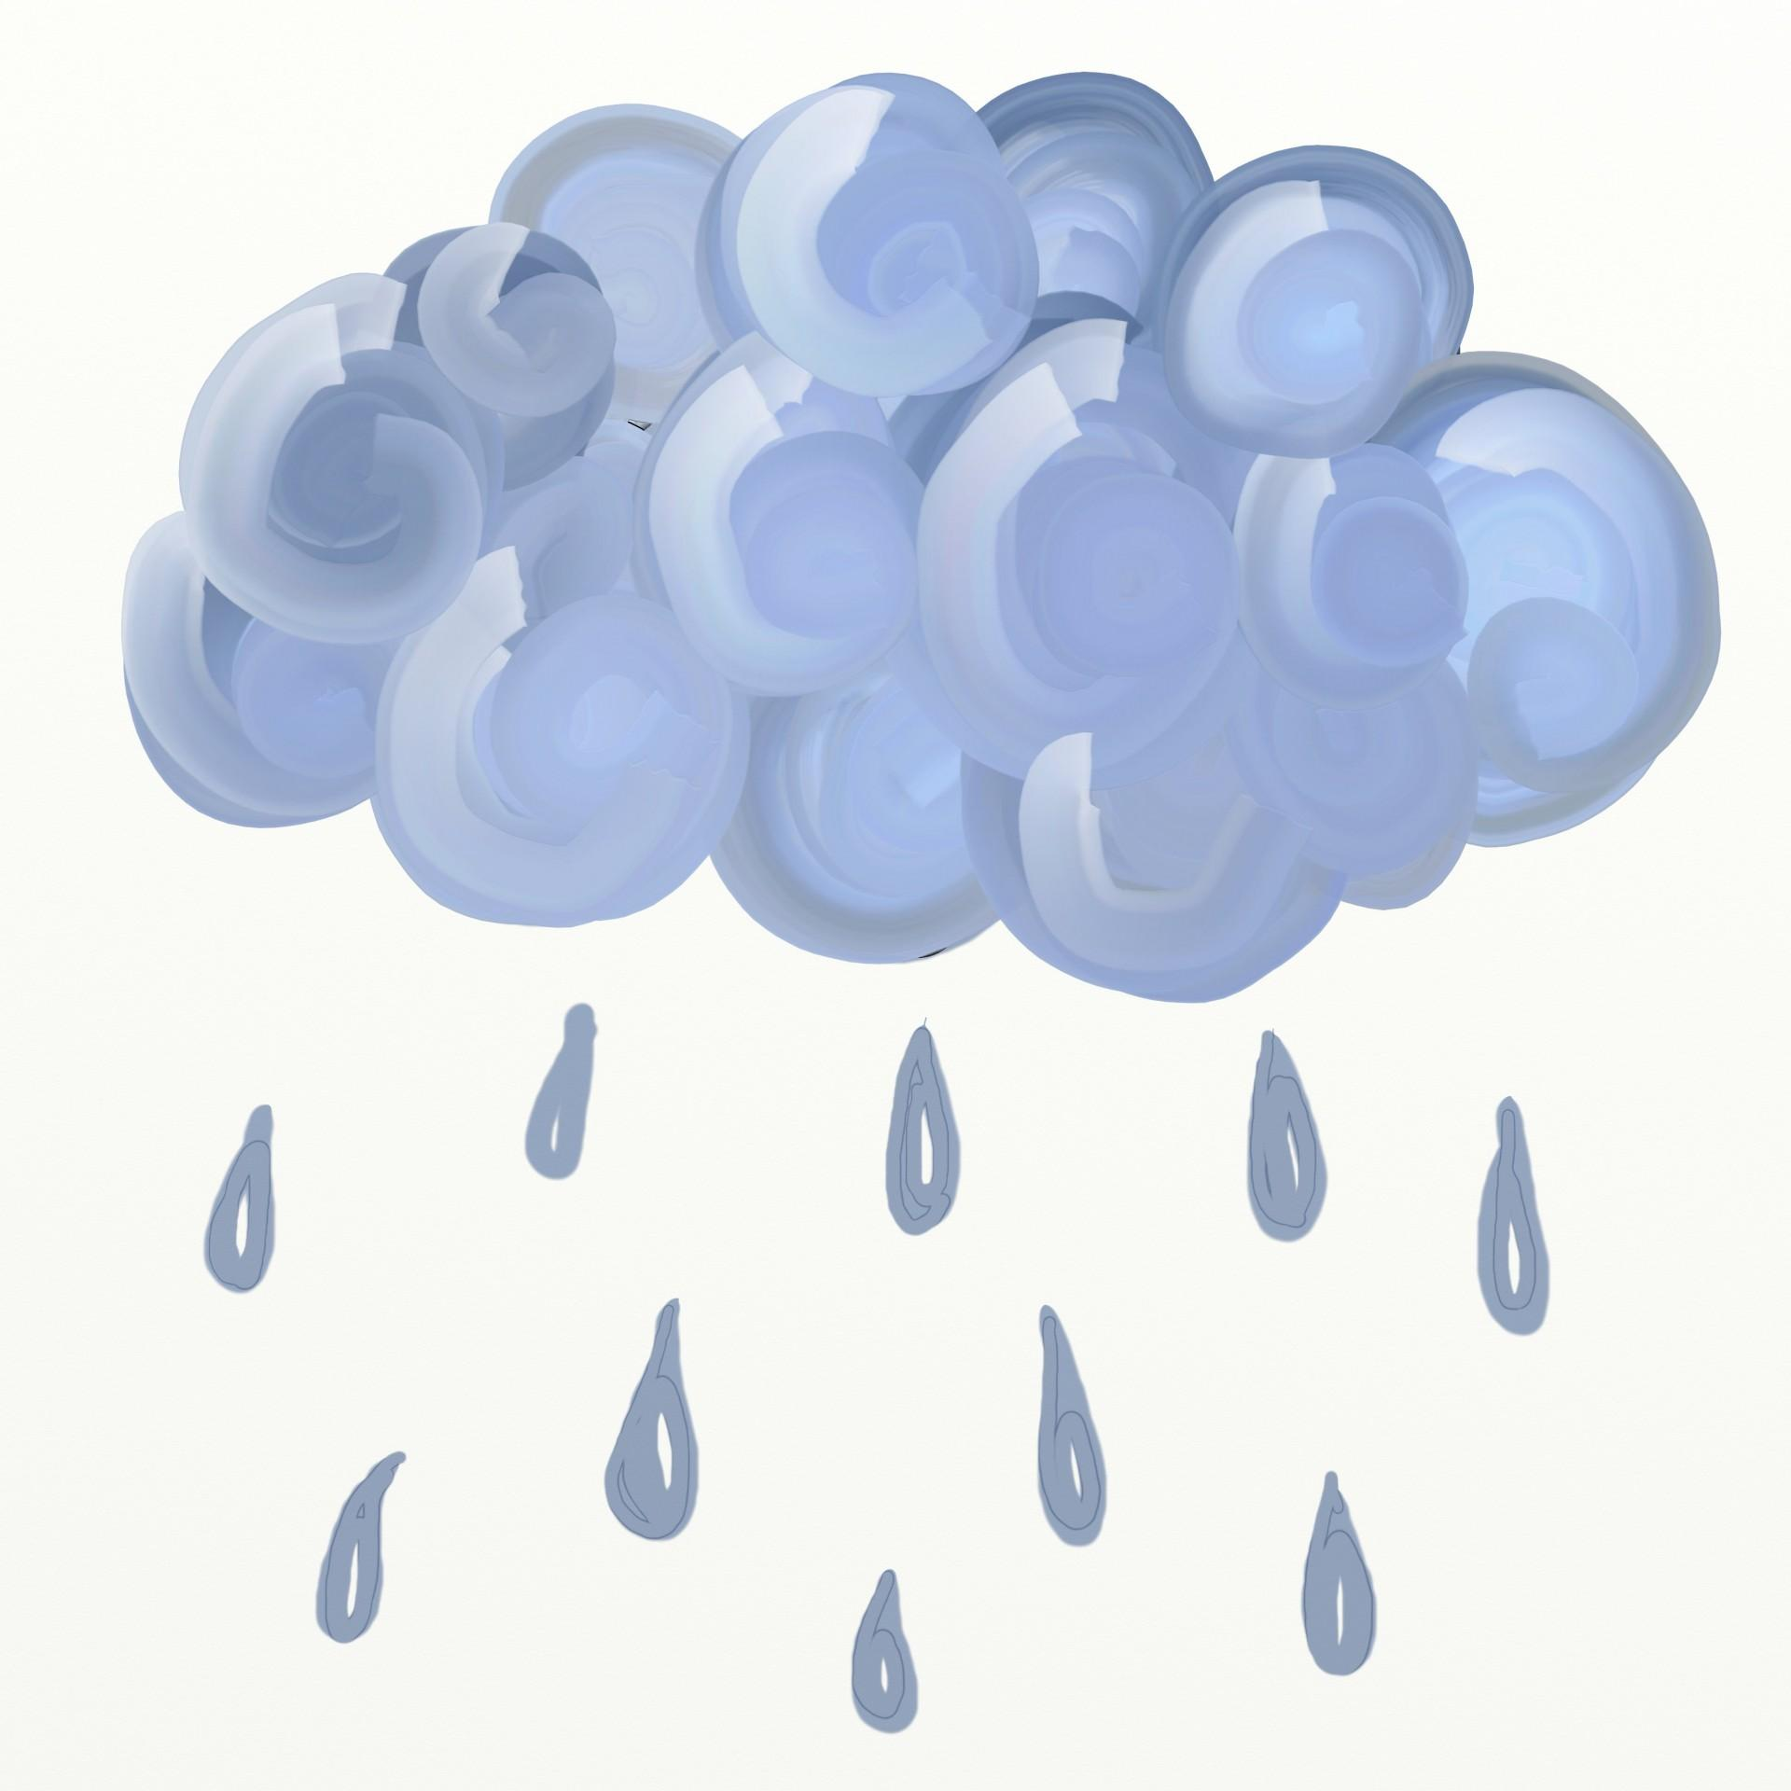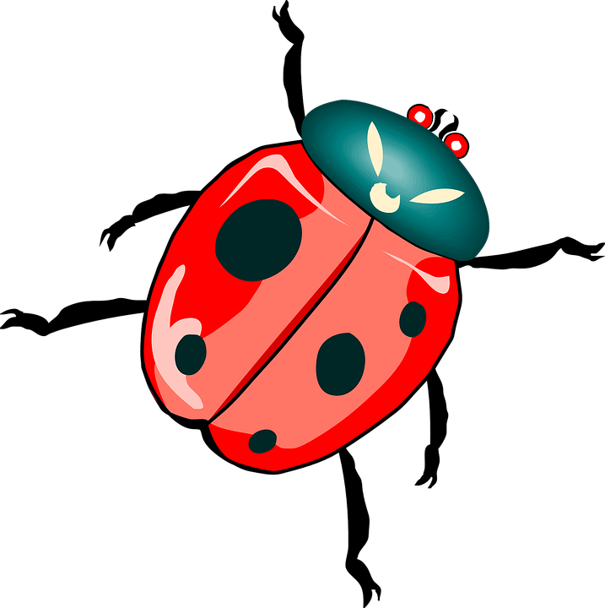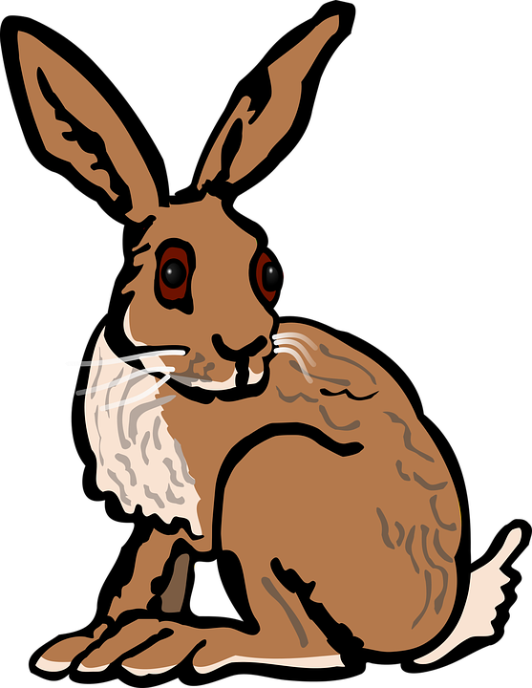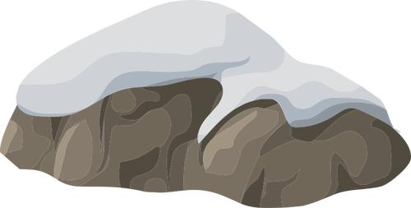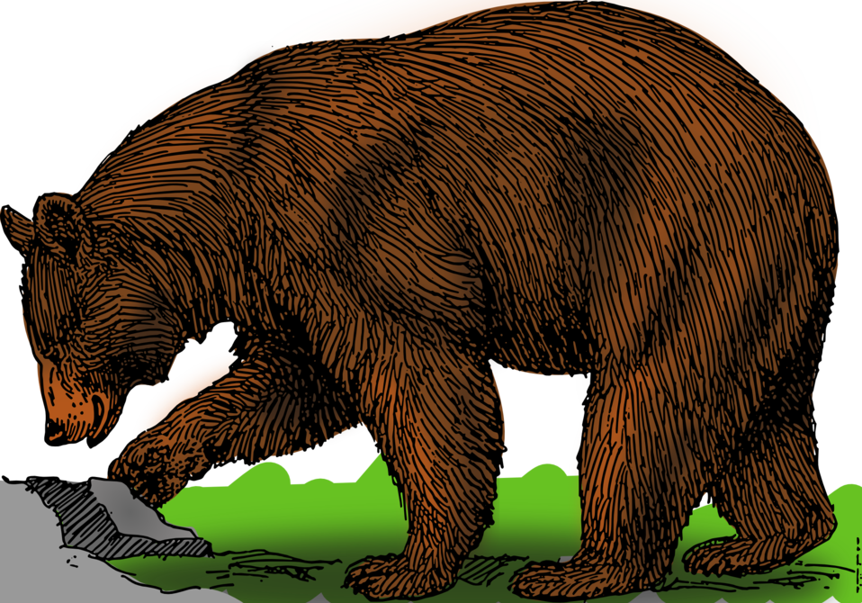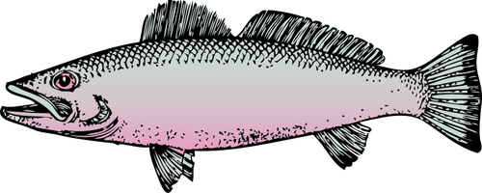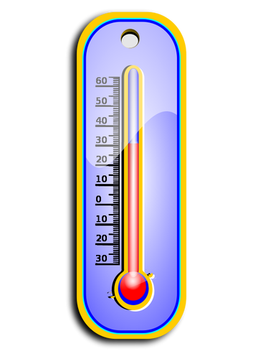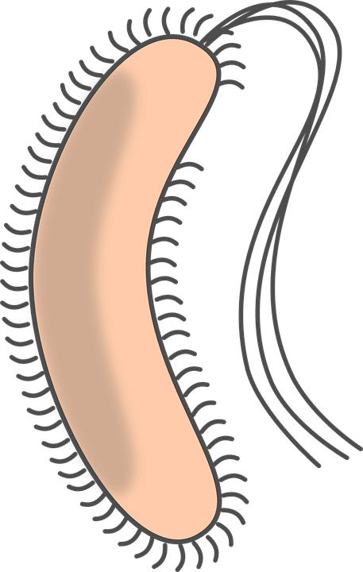

Biotic

Abiotic

8. Use the data in the graph to answer the questions below.
a. Which biome has the highest precipitation and temperature?

b. Why is the tundra also known as a cold desert?

c. What factor determines if a biome is a grassland, shrubland or forest?

9. Analyze the climatograph for Philadelphia to answer the questions.
a. Which month(s) have the lowest precipitation?

b. What is the highest average monthly temperature?

c. What is the range in precipitation between winter and summer?

Task 3 Organisms and their Adaptations
10. Animals I will be learning more about:
a. plant
b. mammal
c. bird
d. insect
e. reptile, amphibian or fish

Task 4 Energy Flow & Food Webs
11. Draw arrows to correctly show the direction of energy flow in the food chain
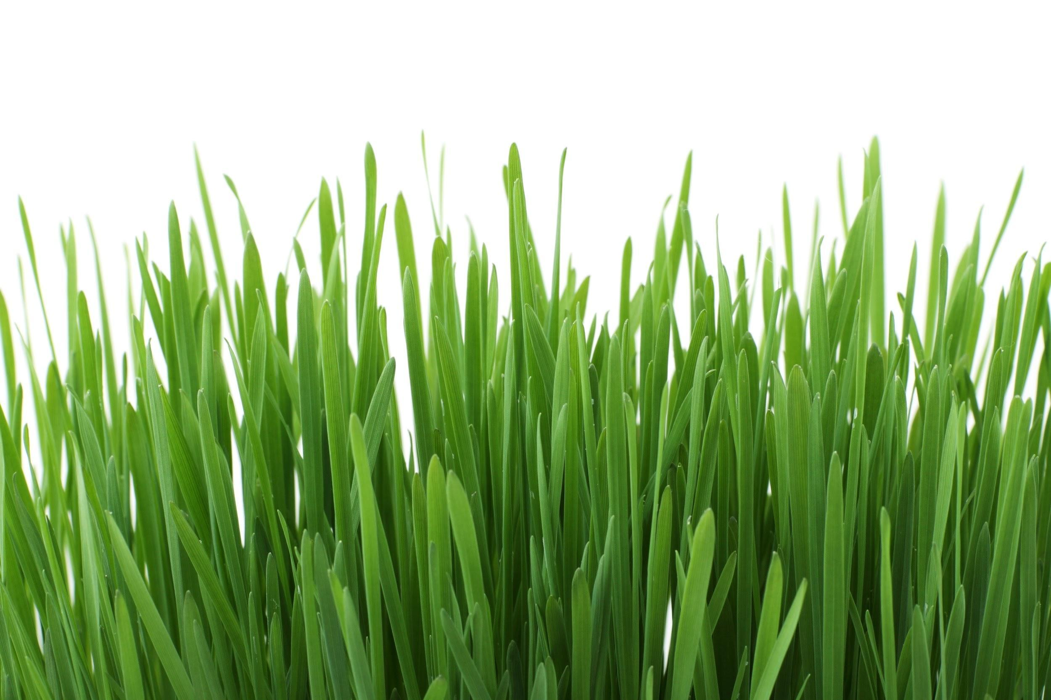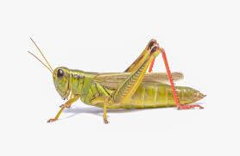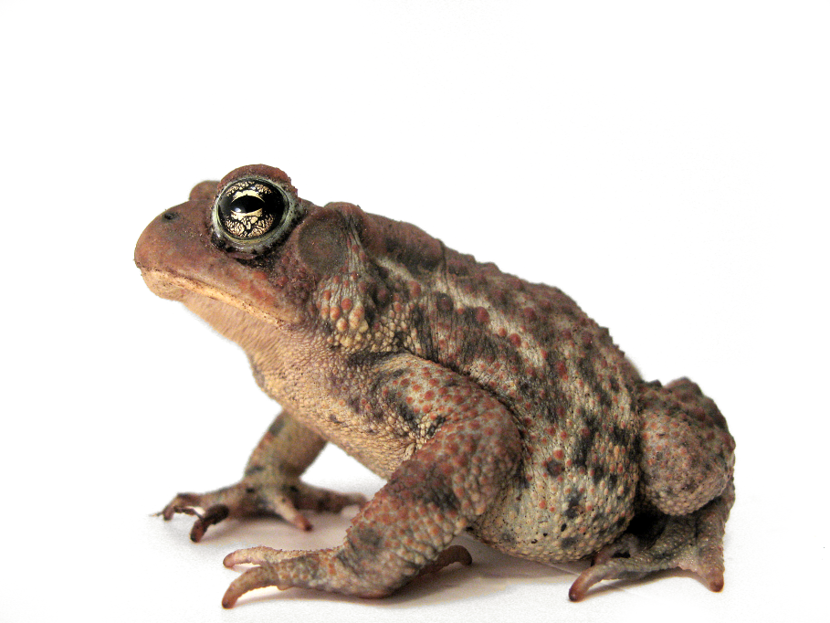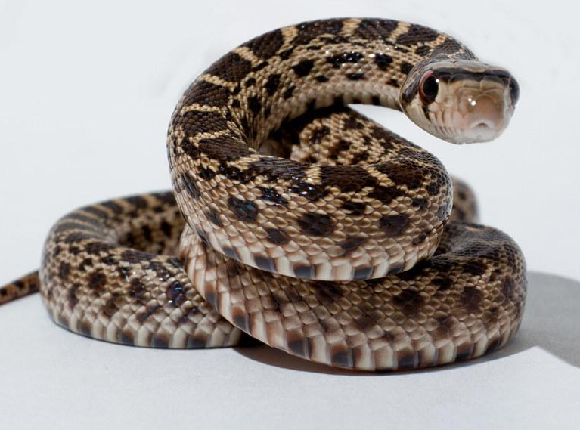

12. Order the steps to match the order of the energy flow in a food chain. First item (1) on top and last item (4) on the bottom.

________ Grasshoppers and other insects get energy from eating grass.

________ Frogs get energy from eating insects

__________Plants absorb light energy from the sun

________Plants convert light energy into chemical energy

13. The main difference between a food web and a food chain is....

Next, you will add to your biome project. Include: 6 different species from your biome (same ones that you researched earlier or different ones, Picture & common name for each organism, Arrows showing the direction of the flow of energy, Multiple arrows going to or from organisms. Add this information to the designated area of your biome project.

14. Task 5 Biotic Interactions
a. What is the difference between predation and competition?

b. Is the video you watched an example of predation or competition? Explain.

c. Complete the table

Kind of Symbiosis | Species A | Species B
Commensalism | Receives benefit
Mutualism |  | Receives benefit
Parasitism |  | Harmed

In your biome project, show one example of a symbiotic relationship in your biome. Make sure that both species live in your biome. Include the following: Common name for each organism, Picture or video showing the relationship, Type relationship (commensalism, mutualism, or parasitism) with explanation

15. Task 6 Endangered Specie
a. What is an example of an organism you know of that went extinct?

b. What are 2 examples of endangered species? Insert images of the species.

c. What are the 2 main causes of endangered species? Insert images of the species.

Add an example of an example of an endangered species in your biome to your biome project.

Task 7 Human Impact on Biome
16. Determine which of these categories is most like the biome you have been researching. Circle the correct category.

Aquatic
Forest
Tundra
Desert
Grassland

After learning more about the human impacts on your biome, discuss one of the impacts in your biome project.

BIOME PROJECT
Your name

Biome Name

A representative picture

Include: map showing the location of your biome

Climatograph

2 sentence summary of the climate of your biome

Plant
- Picture
- Common Name
- Scientific name
- Size
- Food preferences
- Adaptation for the environment
- 1 interesting fact

Mammal
- Picture
- Common Name
- Scientific name
- Size
- Food preferences
- Adaptation for the environment
- 1 interesting fact

Bird

- Picture
- Common Name
- Scientific name
- Size
- Food preferences
- Adaptation for the environment
- 1 interesting fact

Insect

- Picture
- Common Name
- Scientific name
- Size
- Food preferences
- Adaptation for the environment
- 1 interesting fact

Reptile, amphibian or fish

- Picture
- Common Name
- Scientific name
- Size
- Food preferences
- Adaptation for the environment
- 1 interesting fact

Food Web of my Biome

Symbiotic Relationship in my Biome

Endangered Species in my Biome
Picture

Common name

Scientific name

2 interesting facts

Reason for being endangered

Human Impact on your Biome
Name of impact

Picture representing impact

Explanation of the human action

Explanation of the effect on the ecosystem

One possible solution to the proble

Name ______________________________________ Biology Summer Assignment PART 3 2020

ENDANGERED AND EXTINCT SPECIES

SECTION 1: INTRODUCTORY TERMS

1. What is a species? Use this resource: https://openstax.org/books/biology-2e/pages/18-2-formation-of-new-species

2. What does it mean for a species to be extinct? Use this resource: https://www.sciencenewsforstudents.org/article/endangered-species-gives-new-meaning-single-mom

3. What does it mean for a species to be endangered? Use this resource: https://www.sciencenewsforstudents.org/article/endangered-species-gives-new-meaning-single-mom

4. Why should we care if a species is endangered? This article might help: https://www.theguardian.com/environment/2020/may/15/endangered-species-day-a-photo-essay

5. What is the difference between a food chain and a food web? Use this video: https://www.youtube.com/watch?v=-oVavgmveyY

SECTION 2: WOLVES OF YELLOWSTONE

**Begin by watching this video: https://www.nationalgeographic.org/media/wolves-yellowstone/

1. Describe a food chain from Yellowstone. Name at least 3 organisms including the gray wolf.

2. How was the food chain affected when the gray wolf population went extinct? Describe using examples of at least 2 organisms impacted.

3. What happened to the food chain when the gray wolf was reintroduced? Describe using at least 2 different organisms.

SECTION 3: ENDANGERED SPECIES RESEARCH

**Use this resource to begin the research: https://www.worldwildlife.org/species/directory?direction=desc&sort=extinction_status

1. Using the above resource, pick one endangered species. What is its common name? Species name?

**Use websites to answer the rest. Include a link to the website for each question as well as what is asked of you.

2. Insert a picture of the endangered species. Cite where you got the information from.

3. What habitat does it live in? Cite where you got the information from.

4. What are at least 2 unique features of the organism? Cite where you got the information from.

5. What are 2 reasons the organism became endangered? Cite where you got the information from.

SECTION 4: EXTINCT SPECIES RESEARCH

**Use this resource to begin the research: https://www.popularmechanics.com/science/animals/g201/recently-extinct-animals-list-470209/

1. Using the above resource, pick one extinct species. What was its common name?

**Use websites to answer the rest. Include a link to the website for each question as well as what is asked of you.

2. Insert a picture of the extinct species you picked. Cite where you got the information from.

3. What habitat did it live in? Cite where you got the information from.

4. What were at least 2 unique features of the organism? Cite where you got the information from.

5. What were 2 reasons the organism went extinct? Cite where you got the information from.

