Ideas for Mini Breaks/Resiliency Pauses
Short bursts of activity matter!
Short bursts of wellness activities can still have an impact on your wellness and help keep you in your resilient zone. They can result in a shift in the nervous system, helping people feel more relaxed or alert. Activities that are done frequently and in short bursts (30seconds to 2 minutes) create stronger neural pathways. (Bouncing back: Rewiring Your Brain for Maximum Resilience and Well-Being, by Linda Graham & Hardwiring Happiness by Rick Hanson.)
Using Invitational Language
When encouraging others to try some of these wellness activities it’s important to use invitational rather than directive language. Invitational language implies that there is no judgement if someone doesn’t wish to try one of these practices. It is respectful of their own experiences and self-determination about self-care.
Visual Exercises:
- Use the 20-20-20 rule. While on screen, every 20 minutes, look away at something 20 feet away for 20 seconds. https://www.healthline.com/health/eye-health/20-20-20-rule
- Close eyes for a few seconds and then look out the window and focus on objects at a distance.
- Expanding Perspective Exercise. See description in resource list below.
Physical care and movement:
- Quick physical bursts such as: jumping jacks, running up and down the stairs, jump rope, squats, a short walk around the block
- Eye roll, neck roll, swing arms around, flex fingers and rotate wrists, bend down and touch toes.
- One song dance break.
- Close your eyes and listen to music.
- Chair yoga. For example, the Sponge Exercise, see description in resource list below.
- Hydrate frequently.
- Progressive Muscle Relaxation. See description in resource list below.
Short mindfulness type exercises:
- Tracking: learning to read your nervous system is the foundation of helping to regulate the nervous system and can help foster resilience. See description in resources below.
- Resourcing: call to mind a resource, such as an activity, place, animal hobby that gives you joy peace or calm. See full description in resource list below.
- Grounding exercise. See descriptions in resource list below.

How-to Resource List

Sponge Exercise:
Sitting upright with head crowned to the ceiling, take an inhalation. Turn to the left and exhale. Return to center. With head crowned to the ceiling take an inhalation, turn and exhale to the right. Return to center. While doing this imagine that your belly is a sponge and when you turn you are wringing out the sponge of whatever you want to expel. Tension, worry, anger, etc. You can run through this a few times if it makes sense. Other ideas for chair yoga can be found at: https://www.verywellfit.com/chair-yoga-poses-356789

Progressive Muscle Relaxation:
Progressing through different muscle groups, starting at the head or the feet, tighten muscles for about 30 seconds and then relax and notice the difference. Most scripts for this have people going through each muscle group 2 times, but it can be adapted to fit the time frame. People can begin to notice tension in their bodies and get better at releasing it. There are numerous scripts online. Here is a 6 minute youtube video that demonstrates. Adapt as needed.
https://www.youtube.com/watch?v=utGa6rqzs3g

Expanding Perspective Exercise:
Sitting comfortably look straight ahead. Keeping your head still, shift eyes to the left and notice what you can see. Return eyes to the center point and notice your breath. Shift eyes to the right and notice what you can see. Return eyes to the center and notice your breath. Without moving your head, lift eyes to the ceiling/sky and notice what is in your line of vision. Return eyes to the center and notice breath. Move eyes downward and see what you can see. Return eyes to center and check into your breath once again. For other exercises to relieve eye stress visit: https://www.insightvisioncenter.com/6-eye-relaxation-exercises-actually-work-improve-vision/
Tracking:
Tracking refers to paying attention to sensations. (Fancy word: Interoception). Learning to read your nervous system (tracking) is the foundation of helping to stabilize the nervous system and can foster resilience. Sort of a mini body scan. When you tune in to physical sensations you may find unpleasant ones. See if you can also notice sensations that are pleasant or neutral and focus attention there for 30 seconds or more. For example, you may notice your hands resting on your lap or looseness in your shoulders. For example, if you notice your hands resting on your lap or looseness in your shoulders, hold attention there for a bit and then notice if anything happens on the inside. Eg. change in breath, or heart rate? (From the Community Resilience Model: https://www.traumaresourceinstitute.com )

Resourcing:
When we call to our mind’s eye, different resources in our lives, we may feel pleasant sensations in the moment. External Resources include positive experiences and memories and can include the people, places, activities, skills, hobbies, spiritual guides and animals that give you joy, peace or calm. Internal Resources include an individual’s personal characteristics such as kindness, compassion and humor.
Call to mind one of your resources. Try to make the image vivid in your imagination. Are there colors, sounds, sights associated with your resource? As you bring this to mind, see if you notice any pleasant or neutral sensations in your body. Hold your attention on any pleasant or neutral sensations for 30 seconds or longer. (From the Community Resilience Model: https://www.traumaresourceinstitute.com )

Grounding:
Having a sense of connectedness to where our body feels supported can calm the nervous system. Below are a few scripts for guided grounding exercises. And, here is a 2 minute youtube video that describes one type of grounding exercise. https://www.youtube.com/watch?v=8lM8pgMgjEs

Grounding

Find a comfortable position, take your time… It can be sitting in a chair, leaning against a wall, laying on the ground. Bring your attention to how your body is making contact with the chair, sofa, floor, wall,bed, etc… Bring your attention to sensations that are pleasant or neutral…
Notice which part of your body is most supported. As you do so, notice yourbreathing...heart rate...muscle tone...notice your back making contact with the chair,sofa, floor, wall bed, slowly bring your awareness to your feet and notice how your feetare making contact with the ground...notice what happens on the inside…
If you become aware of uncomfortable sensations, bring attention to places that feelneutral or better. Notice the change…
Slowly scan your body and bring your attention to all sensations that are pleasant orneutral as we get ready to end…
When you are ready bring your attention back to the room.

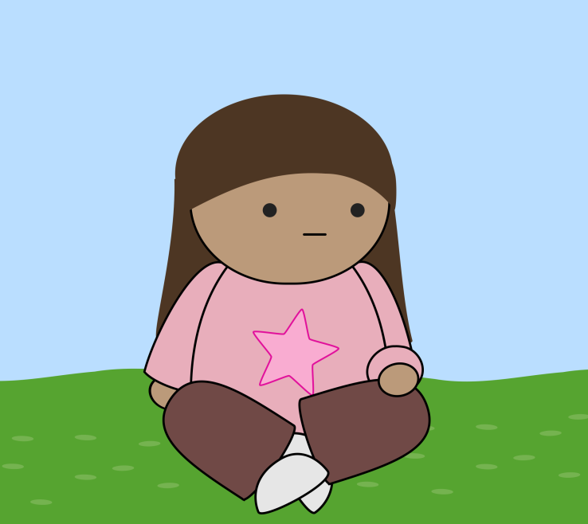
From the Community Resilience Model: traumaresourcinstitute.com

Grounding like a tree

Imagine what the strongest tree would look and feel like.
Stand tall like that tree. Imagine your strong trunk.
Now, imagine tree roots growing down into the earth fromyour strong legs and feet.
Slowly move your arms like the branches of your tree. Reachas far as you want to reach.
Pay attention to the way your body feels like that strong tree.
Wave your arms as the wind blows through the branches ofyour strong tree.
Bring attention to your feet as the wind blows your arms andnotice how your feet are solid on the ground and the rootsare holding you just right.
Notice how your whole body feels as you are strong like that tree.
(From the Community Resilience Model: traumaresourcinstitute.com)

