CLINICAL TRIAGE GUIDELINES USING THE C‐SSRS

Answers on the C‐SSRS provide the information needed in order to classify someone’s suicidal ideation and behavior, and when combined with clinical judgment, can help determine levels of risk and aid in making clinical decisions about care.

Severity of Ideation Subscale - consists of 5 questions that reflect five types of ideation of increasing severity:

- A positive answer to Question 4 or 5 indicating presence of ideation with at least some intent to die in the past one month indicates a severe risk and clear need for further evaluation and clinical management (e.g., triggers immediate referral to mental health services and patient safety precautions).

4 – Active Suicidal Ideation with Some Intent to Act, Without Specific Plan (e.g., I would hang myself [method] and I can’t guarantee that I won’t do it [intent]).

5 – Active Suicidal Ideation with Specific Plan and Intent (e.g., tomorrow at 1:00pm when I know no one will be home [plan], I am going to [intent] take a handful of Tylenol that I have in my medicine cabinet).

Suicidal Behavior Subscale - includes questions about 4 suicidal behaviors and non‐suicidal self-injurious behavior.

- Presence of ANY suicidal behavior (suicide attempt, interrupted attempt, aborted attempt and preparatory behavior) in the past 3 months indicates a severe risk and clear need for further evaluation and clinical management (e.g., triggers immediate referral to mental health services and patient safety precautions).

*Note: Endorsement of other questions on the scale could also indicate a need for further evaluation or clinical management depending on population or context, however a positive answer to Question 4 or 5 in the past month or any behavior in the past 3 months indicate the most severely emergent clinical situation.

Additional sections on the Full C-SSRS and not on the Screener version that can augment clinical judgment.

Intensity of Ideation Subscale - includes 5 questions about the Frequency, Duration, Controllability, Deterrents, and Reasons for Ideation for the most severe level of ideation endorsed on the Severity subscale (i.e., highest endorsed from 1 to 5).

- The total score ranges from 2 to 25, with a higher number indicating more intense ideation and greater risk.

Suicidal Behavior Lethality inquires about the level of actual medical damage or potential for it

- Greater lethality or potential lethality of the behavior (endorsed on the Behavior subscale) indicates increased risk.

EXAMPLES OF TRIAGE/ALERT RULES IN DIFFERENT CARE SYSTEMS

COMMUNITY CARE SETTINGS (CENTERSTONE, the largest non-profit provider of community‐based behavioral health services in the nation)

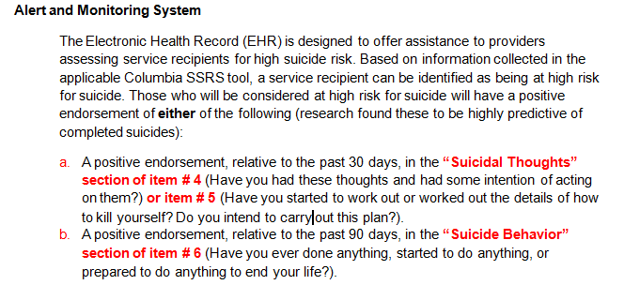

HOSPITAL SETTINGS FOR THE JOINT COMMISSION REQUIREMENT

This example is for an Emergency Department

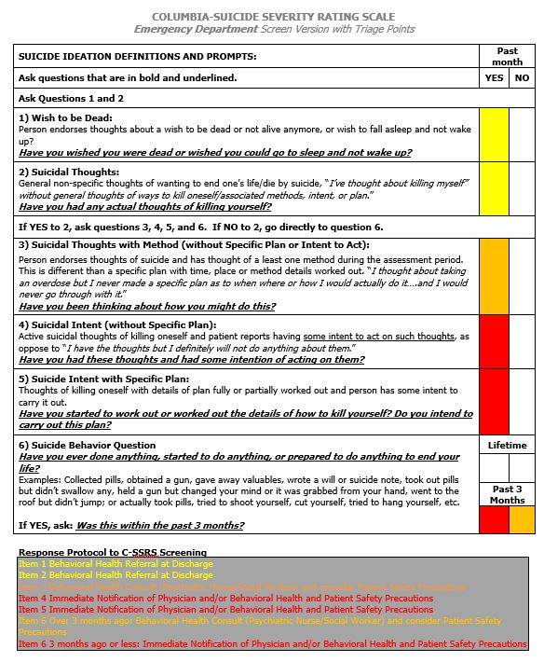

This example from the Reading Hospital policy shows types of clinical disposition corresponding to the level of ideation severity in the last month:

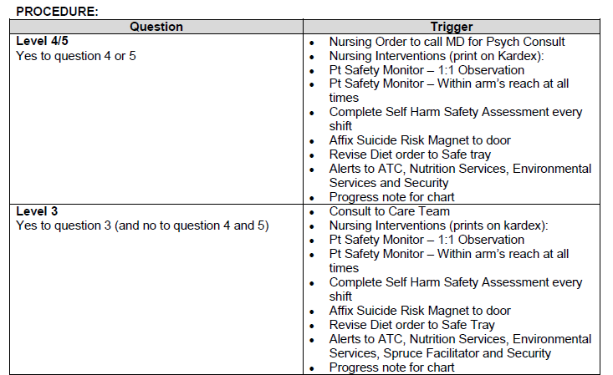

The triage plan shows that endorsing ideation of 1 or 2 results in a mental health referral at discharge, 3 results in a consult by a psychiatric nurse and 4 or 5 results in psychiatric consultation and patient safety monitoring.
Having any behavior : within the past week results in an MD consult, within the past month results in a Care Team consult, within the past year results in a mental health referral at discharge.

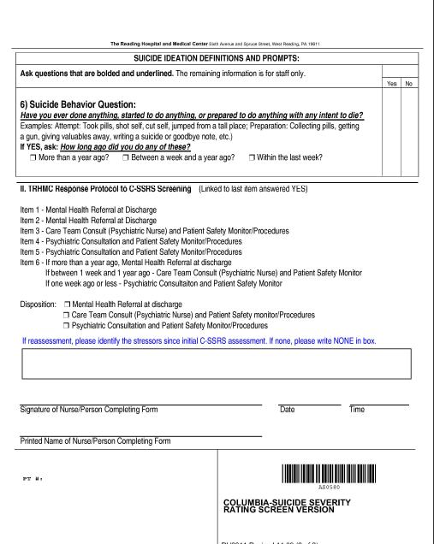

PRIMARY CARE
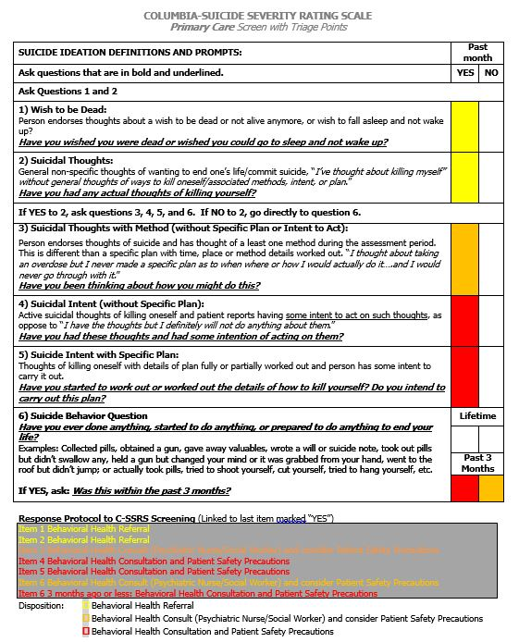
HARVARD PARTNERS HEALTHCARE/MASS GENERAL – C-SSRS WITH RISK AND PROTECTIVE FACTORS
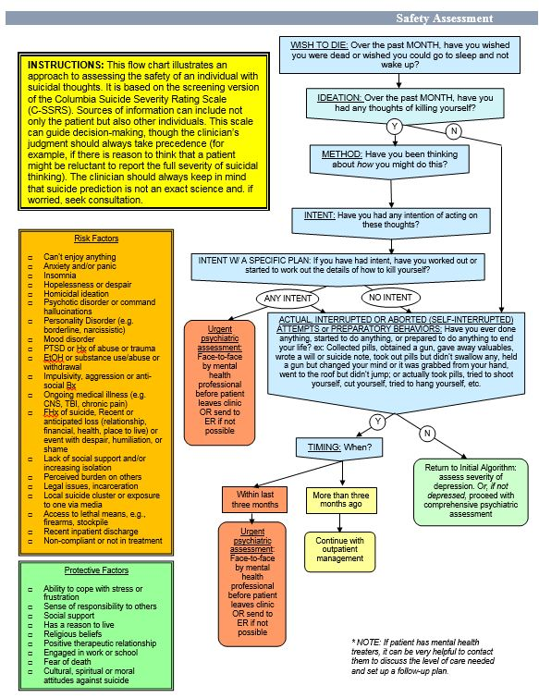

STATE‐WIDE ELECTRONIC MEDICAL RECORD SYSTEM
(used by the New York State Office of Mental Health facilities with outpatient services)

The system automatically adds a RED SUICIDE WARNING ALERT to the patient’s record for endorsing a “4 or 5” in the past month or a behavior in the past 3 months; and an ORANGE SUICIDE HISTORY ALERT if there is any lifetime history of ideation severity of ”4 or 5” or any suicidal behavior.

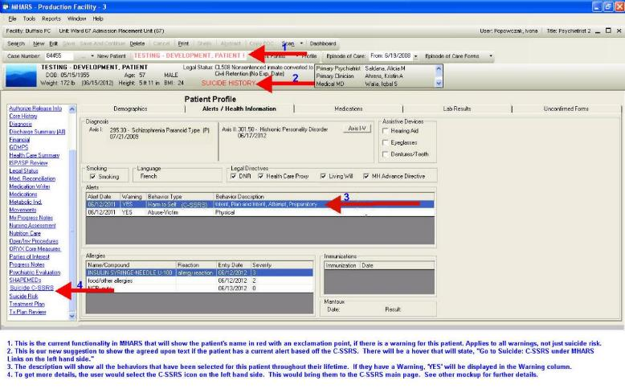
MILITARY SETTINGS – MEDCOM

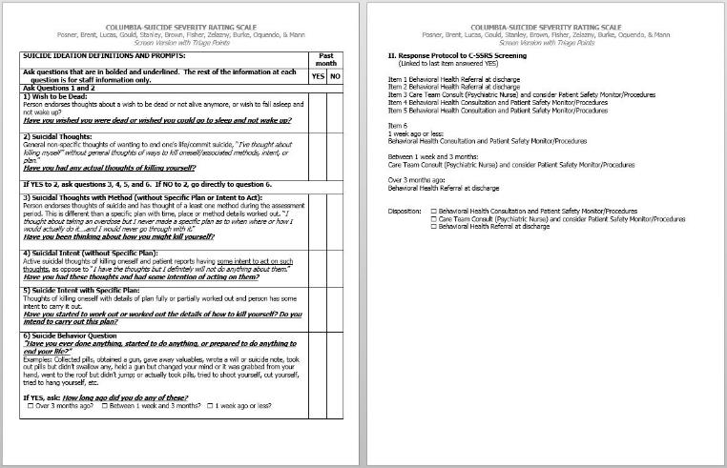

Policy specifics:

An ideation severity of:
  - 1 or 2 results in a routine behavioral health referral.
  - 3 results in a review by the care team
  - 4 or 5 results in EMERGENT ACTION – patient safety monitoring and psychiatric consult

Presence of any suicidal behavior:
  - over 3 months ago results in a routine behavioral health referral
  - within the past 3 months results in a review by the care team
  - within the past week results in EMERGENT ACTION – patient safety monitoring and psychiatric consult

PRISON MENTAL STATUS EXAM

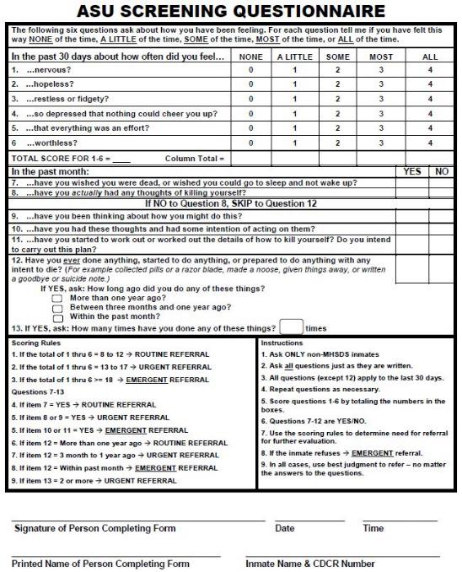

SAFE-T/C-SSRS TRIAGE TOOL FOR PSYCHIATRIC CARE/BEHAVIORAL HEALTH

