Clearance Name | Where Can I Get This? | Cost | How old can this be when submitted? | How often does it need to be renewed?
Federal Criminal History Background Check | IdentoGO  (**See detailed instructions below) | $23.85 via business check, money order, credit card, or debit card. | No more than one (1) year old | Every five (5) years
Pennsylvania State Police Criminal History Record | PATCH | $22.00 via credit or debit card only. | No more than one (1) year old | Every five (5) years
Pennsylvania Department of Public Welfare Child Abuse History Clearance | Child Welfare Portal | $14.00 via credit or debit card only. | No more than one (1) year old | Every five (5) years
Sexual Misconduct/Abuse Disclosure Form | Sexual Misconduct/Abuse Disclosure Form | N/A | Should be completed at the time of contract start | N/A
Certificate of completion of a mandatory 3-hour training on child abuse recognition | TBD | N/A | Should be completed at the time of contract start | N/A
Arrest/Conviction Report and Certification Form | Arrest/Conviction Report and Certification Form | N/A | N/A | N/A

**Using IdentoGO for fingerprinting record

This website allows you to enter your information, register for a fingerprinting appointment at a nearby location, and tells you the types of identification accepted when showing up for your appointment.

- Enter the code 1KG6XN on the homepage.
- Then click “Schedule or Manage an Appointment”

Note that if you are asked if you have an authorization code to pay for the fingerprint test, you should say “no”. Payment can be made business check, money order, credit card via when you visit the fingerprinting site. The total cost of the clearance is $23.85.

After you enter your information and schedule your appointment, you will see a screen like this:
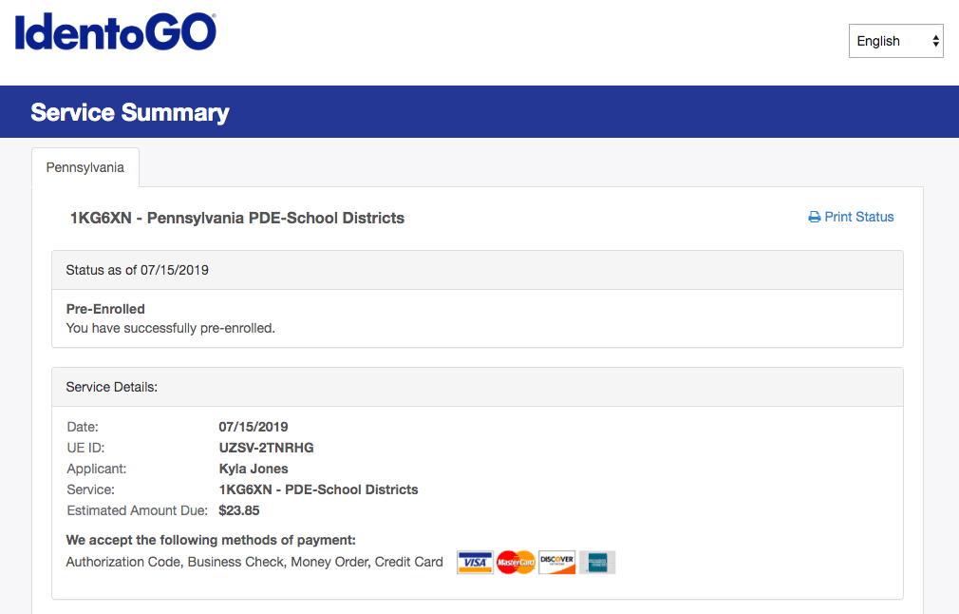

Take note of your UE ID number and bring it with you, along with your identification and method of payment.

