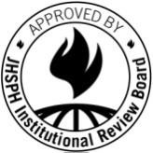
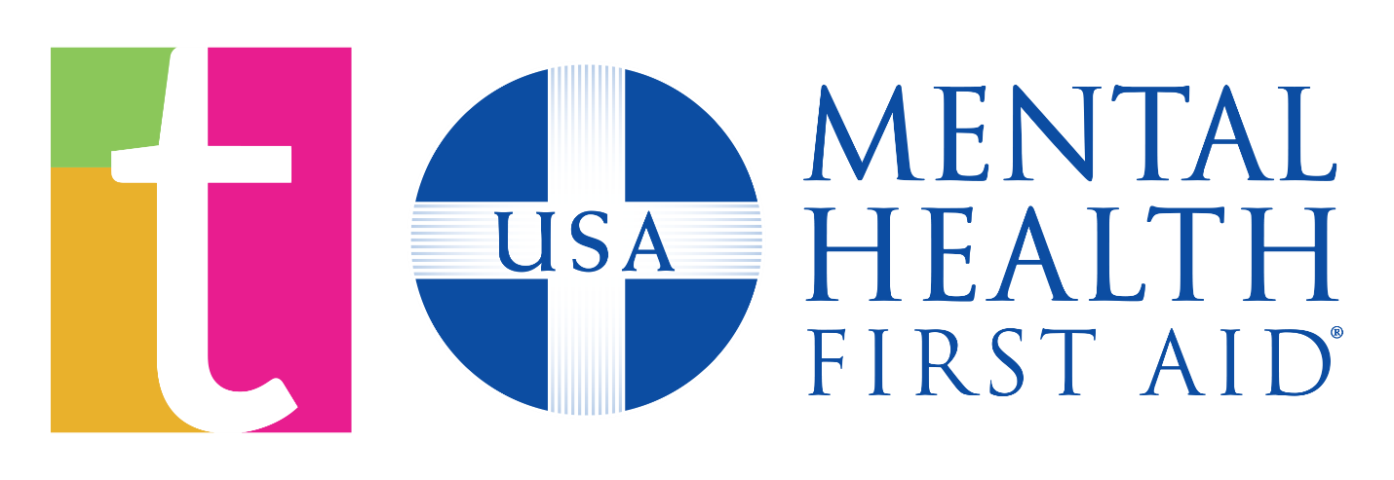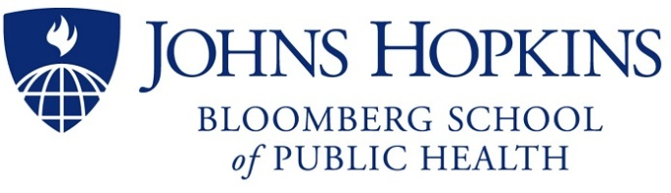

Approved:15Oct19 IRB No.: 0009325

Dear Parents,

During this semester, your child will participate in teen Mental Health First Aid (tMHFA). This program was designed to raise mental health awareness among teens and provide them with skills to assist their peers experiencing a mental health challenge. Our school is so excited to be bringing this program to our students this year.

tMHFA is currently being evaluated by a team of researchers at Johns Hopkins University. We would like to invite all students who participate in the training to take part in four anonymous online surveys to measure the effectiveness of this program.

After your permission is granted, our school will organize in-school time for students to take the online surveys. Your child will receive a link to take the online survey at the email address that you provide on the consent form.

Please review and complete the attached consent form and return to Roxborough High School with your student.

If you have any questions about the surveys, please do not hesitate to reach out to the lead researcher, Dr. Holly Wilcox, at 410-502-0629.

Sincerely,

The tMHFA Team at Johns Hopkins University

