Gilbert Spruance School
2020 - 2021
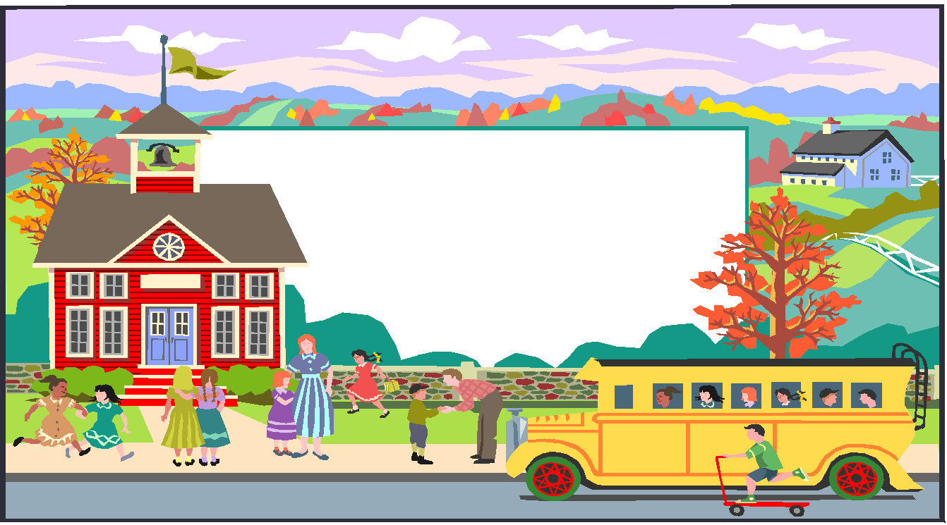
Student & Family
HANDBOOK
for
Virtual Learning

Kwand T. Lang Kenneth Christy Amy Foster
Principal Assistant Principal Assistant Principal

Message to Students and Families
re: Online Virtual Learning Model

Dear Parents/Guardians,

Welcome back! We have missed you over the summer and look forward to welcoming you to a new year of learning and growth. The 2020-2021 school year will be an unprecedented one that will challenge all of us in new ways. We’re gearing up to meet the challenge. Our teachers and other school staff have been engaged in virtual training sessions to better support students’ social-emotional needs and help them succeed in this new digital learning environment. Our staff have been learning new online systems that will continue to improve how we engage our students, to ensure we improve upon our efforts from the end of last year.

Our meeting platforms have been updated and are more robust than ever! However, Google Classroom will continue to be our primary platform for daily classroom instruction. We recognize that while most of our students have been engaged in digital learning, students have been away from what they once knew as “school” for an extended amount of time. So we are preparing to thoughtfully address both the social-emotional and academic needs of our students.

The school year will begin on Wednesday September 2, 2020 with all students learning remotely for the first marking period which ends November 17th. Our school day will run from 8:30am-3:09pm. Students will enter our School Classrooms through their Google Classroom. There is a stepper on how to join the google classroom included in this manual. So as we start the school year virtually, the goal is for students to then transition to a mix of in-person and digital learning (Hybrid Model) as long as guidance from the Philadelphia Department of Public Health and other indicators support that it is safe to do so.

As we begin the journey to return to normal, we must continue to work collaboratively to improve the academic success of each student. As educators and parents, our challenge is to help ALL students view school as an unlimited opportunity for achievement. Together, we can enable our children to reach for and to attain academic success. Spruance’s doors are always open to our families. We look forward to meeting with you to see how we can continue to partner together to support our students. We will continue to model our Core Values of being Respectful, Responsible and Safe. We believe that with your help, we can achieve our mission, vision and school motto of “Great Expectations for Every Kid, Every Day, in Every Class!”

Please continue to visit our website for important information, parent newsletters, and upcoming events.

Sincerely,
Kwand T. Lang, Sr.
Principal

Preparing for The First Days of School

Attendance Matters: Our school day will begin at 8:30 a.m. and end at 3:09 p.m. Even though we will be 100% digital, students are expected to participate in a full day of school five days a week. No doubt about it, digital learning will look and feel different than last spring. Read more about what to expect and how you can help with our Attendance and Grading Quick Guide.

Getting Ready: To help you and your child get organized and prepared for a successful new school year, we’re sharing this Family Back-to-School Checklist which contains important information about Chromebooks, internet access and much more.

Also, mark these important dates on your calendar:

- Workbook & Instructional Materials Pickup - stop by our school on September 4, 2020 between Noon and 2pm to pick up your child’s workbooks and other items. Mask wearing is required and social distancing and other protocols will be in place to ensure everyone’s safety.
- Phi Beta Sigma, Nu Sigma Chapter & Zeta Phi Beta, AAOZ Chapter Bookbag & School Supply Giveaway at Spruance - Friday, September 4, 2020, 12-2pm.
- Virtual Back-to-School Night - this is a great time to virtually meet your child’s teachers and learn more about the new school year. This will be a virtual event on Wednesday, September 16, 2020 beginning at 4:30 pm. This link to the meeting will be posted on our school’s website.
- School District of Phila. Back-to-School Drive-Thru Backpack Giveaway - this year’s event will be held on August 28 from 9 a.m. - 1 p.m. at Lincoln Financial Field, K Lot. Visit philasd.org/face/backpacks for more details and how you can schedule a walk-up appointment.

As always, please feel free to reach out to us at 215-400-3290 or email your child’s teachers with any questions. By working together, we can make this a successful year of learning and growth for every student. See you virtually on September 2nd!

Virtual Parent Drop-in Center - Parents as partners in the education of a child are vital for a student’s success. This new feature, Virtual Parent Drop-In Center, is an On-Line section of our school that uses Google Meet to address any of your concerns. A staff member will be available from 9:00am – 1:00pm.

Google Classroom:
An Introduction for Parents

If you would like to login to your child’s Google Classrooms to see and access digital learning activities, follow these directions:

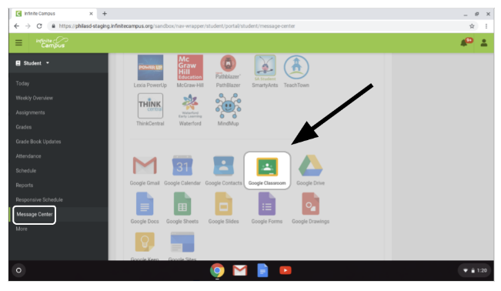
1. Turn on your child’s Chromebook and login with their school district username (student id#) and password.

2. Access Google Classroom through Infinite Campus:

○ Select the Message Center to access student
resources. Scroll until you find G Suite Applications and select Google Classroom.

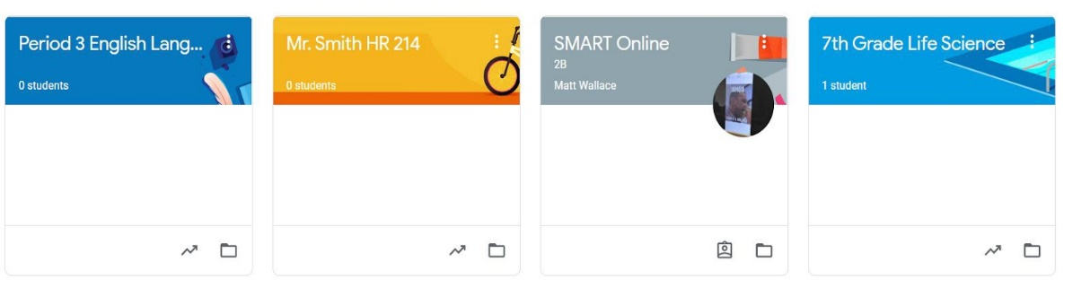
○ This will bring you to your student’s classroom dashboard, where you will see cards for each class as shown below. Select a class by clicking on the card.

3. Once you have opened up your class, you will be brought to the Classroom homepage, otherwise known as the “Stream”. See the image below to understand how to navigate and monitor this page:
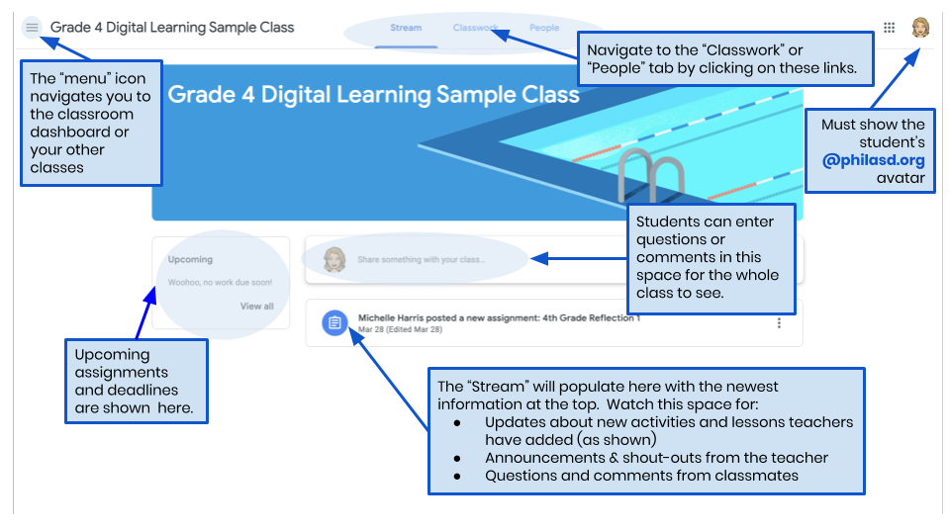

4. Each Google Classroom has three main pages: the “Stream”, “Classwork”, and “People”:
○ The Stream is your classroom home page. Watch this space for:
■ Updates about new materials and assignments
■ Announcements from your teachers
■ Questions and comments from students
○ The Classwork tab is where teachers will post assignments and share class materials for students to access.
○ The People tab lists the members of your class, including teachers and classmates, and gives you the option to email them directly.

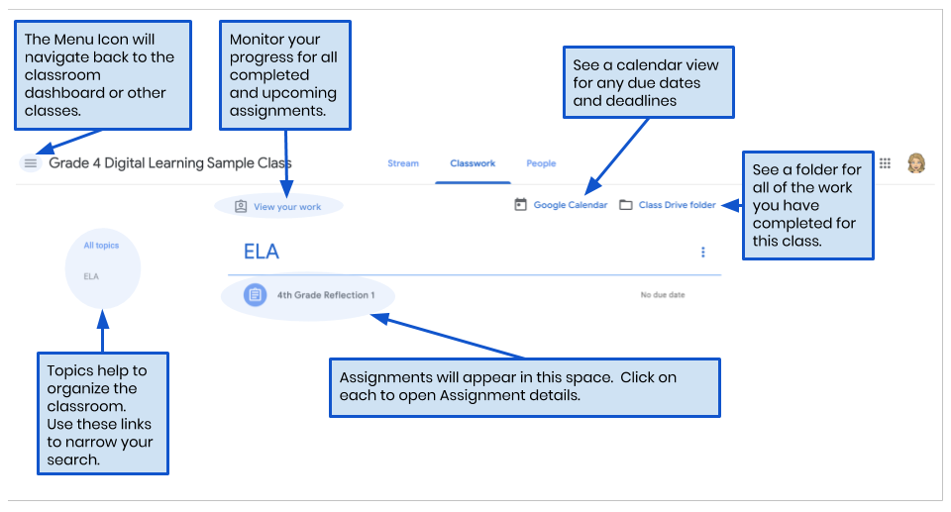
5. As you access the Classwork tab, you will see a list of assignments and materials, organized by topic.

6. Click to expand an assignment to access instructions, assignment details, and hyperlinks to the activities and resources. See the image below to better understand how to navigate the assignment windows, communicate with your classmates and teacher, and submit your work.
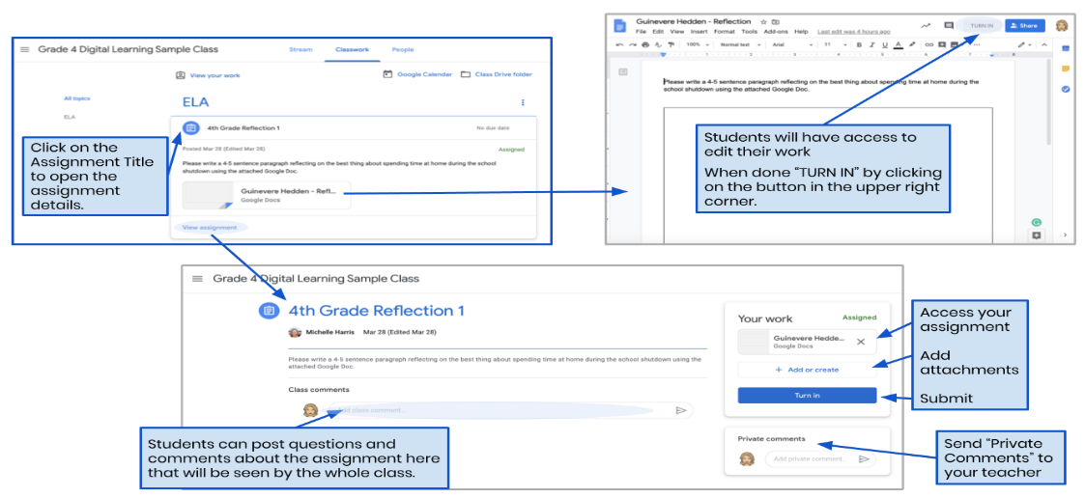

- 2020-2021 Academic Calendar here
- Student Code of Conduct 2020-21 SY here
- Staff Directory** here
- Accessing Parent & Family Portal here

Online Adaptive Programs (Blended Learning Tools)
- Lexia Reading (K-5), about the program here
- Achieve 3000 (2-8), about the program here
- Smarty Antz (K-2)
- iReady Math (K-8), about the program here

English Language Learners

The student population at Spruance is culturally and linguistically diverse. Our goal is to promote cultural recognition and respect; to celebrate the diversity of all students’ identities, cultures and abilities through shared learning experiences of students where all can engage in dialogue, challenge barriers and build collaborative relationships. All students have access to content area classes, teachers use the support of peer tutors of similar linguistic background, when feasible, to ease the academic and social transition. In addition, strategies and materials are varied in order to engage all students. English Learners (EL's) are integrated into the school community and are involved in every activity available. Every effort is made to provide information to parents in students' home languages, utilizing School District resources, paid tutors, and volunteers.

- Multilingual Family Support -School District of Philadelphia here
- Spanish Language Visualization Tips for Parents Supporting Remote Learning here
- Covid-19 Information for ELs and Multilingual Families here
- Language Line - Telephonic

Special Education

Special Education Services
Spruance School is dedicated to providing specialized services in the Least Restrictive Environment ranging from itinerant, inclusion, resource and mainstreaming to smaller classes. Students receive accommodations and adaptations as needed and required in their Individual Education Programs.

- A Parent’s Guide to Special Education for School-Aged Children here

Specialists
- Art Education
- Music
- Technology
- Science
- Writing
- Writing/Media
- Spanish
- Gym
- Health

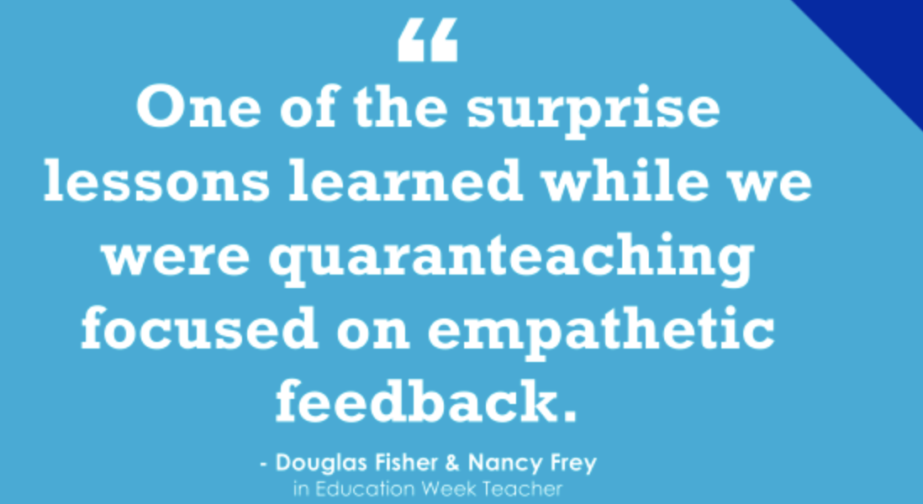
SEL (Social Emotional Learning)

- Morning Meeting will be held daily between 8:30am-9:00am
- SEL programs are part of SDP’s tiered approach to supporting positive behaviors called Positive Behavior Intervention Supports (PBIS)

PBIS/Climate and Culture at Spruance

PBIS Core Values: Be Respectful, Be Responsible, Be Safe

Here at Spruance, we need to cultivate an atmosphere that maintains a healthy climate and culture. There must be a collective effort from all members of the school community to build a place where Respect, Responsibility, and Safety are paramount to helping students succeed and achieve.

PBIS

During Remote Learning- Classes will be taught the schoolwide expectations of Respect, Responsibility and Safety with a special emphasis as it relates to “Virtual Learning”. Teachers will also receive learning about how to build community while instructing students in a virtual environment. A main component of PBIS is to use data to drive our focus, systems, and practices.
The PBIS Team will:
- Incorporate our school wide PBIS model (Virtual Bulldog Bones, Spruance Bucks, Incentives for teachers and students, into our virtual instruction model.
- Develop a virtual rewards incentive list to celebrate and recognize those students who follow school wide expectations.
- Implement virtual Bulldog Pride Matrix
Spruance Virtual Behavior Matrix
We are... | Entering and Exiting  Virtual Meetings | Teacher-Led  Instruction | Independent Learning Activities and Assignments
Respectful | - Choose a distraction-free space  - Turn video on  - Mute your microphone  - Use chat only when directed by teacher  - Keep cell phone put away | - Video on at all times  - Eyes on the speaker and/or material  - Keep your microphone muted  - Keep cell phone put away | - Choose a distraction-free space  - Focus on your work  - Maintain integrity
Responsible | - Be on time and ready to learn  - Start class charged or plugged in  - Have all materials ready  - Exit the meeting when directed by teacher  - Dress Appropriately | - Be present and stay on task  - Participate when directed  - Ask questions when you have them  - Dress Appropriately | - Complete your work independently  - Do your best work  - Ask questions when you have them  - Submit assignments on time
Safe | - Use equipment as intended  - Use kind words and faces  - Refrain from taking pictures or video  - Keep food and beverage away from computer | - Use kind words and faces  - Refrain from taking pictures or video  - Keep food and beverage away from computer | - Use school district approved websites and resources  - Report concerns to your teacher  - Keep food and beverage away from computer

Resources for Families
Supporting Families with PBIS at Home:
https://assets-global.website-files.com/5d3725188825e071f1670246/5e83b41b7df0210d47588d12_Supporting%20Families%20with%20PBIS%20at%20Home%20FINAL.pdf

PBIS at Home: http://nemtss.unl.edu/files/2018/08/PBIS-at-HOME-Binder-FINAL.pdf
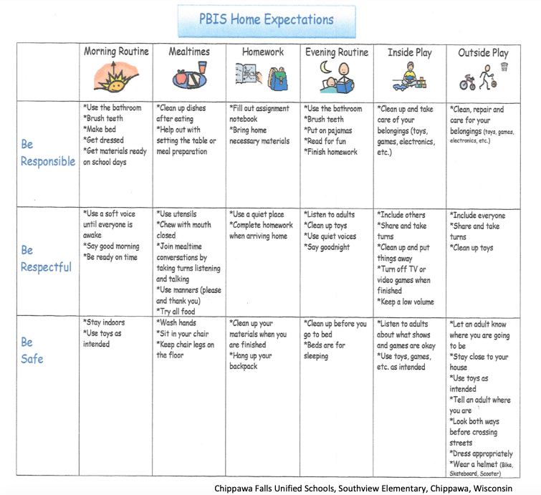

Peer Mediators will continue to support our school climate helping to resolve minor social squabbles among peers.

Restorative Justice/ Relationships First
In both virtual and in-person learning, the goal is to foster and improve relationships among all members of the school community. Training will incorporate building and using relationship/community circles in classrooms. The aim is for all members of Spruance to live and feel a culture of respect, responsibility, and safety.

Playworks
Staff will join students in a virtual setting for an opportunity for brain breaks and short games to support building healthy social relationships. During in person learning staff will interact with students to teach and engage in appropriate social play activities that will ultimately lead to improved peer to peer interactions and a reduction of disciplinary incidents in the school yard/ cafeteria.

Social Equity focusing on students will involve the following students groups:
Student Government (Bi-Monthly Meetings)
Peer Mediators (Monthly Meetings)
Playworks Student Mentors (Monthly Meetings)

Counseling Support
- Ms. Chotiner (Grades K-4)
- Ms. Green (Grades 5-8)
- Bilingual Counseling Assistants

Chromebook Technical Assistance
  - Education Center, Philadelphia School District 440 N. Broad Street, 1st Floor Lobby, Philadelphia, PA 19130
  - Fitzpatrick Annex Building (rear of Fitzpatrick Elementary School) 4101 Chalfont Drive, Philadelphia PA 19154
  - Martin Luther King High School 6100 Stenton Avenue; Philadelphia, PA 19138
- Phone Help
  - The District also now offers a dedicated telephone support line (215-400-4444) and email (FamilyTechSupport@philasd.org) exclusively for parents and students to help you get your District-issued devices up and running, and to address more basic technical issues with broken or malfunctioning computers.

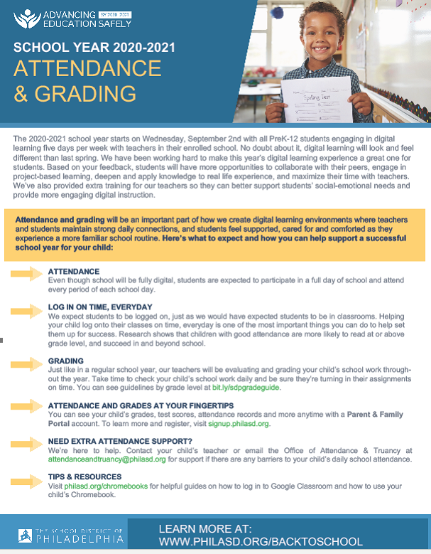

Food for Students – the list of distributions sites for food changes. Please see https://www.phila.gov/food/#/?services=Student%20Meal%20Site for the closest site to you.

Back to School Checklist and Supports
School starts on Wednesday, September 2nd, with all PreK-12 students engaging in digital learning five days per week and receiving instruction from teachers in their enrolled school.

Here’s a checklist to help you and your child prepare for a successful school year:

NEW TO THE DISTRICT? REGISTER YOUR CHILD

Register online by visiting bit.ly/phillyk12reg, by phone by calling your child’s school and speaking with a school secretary or in person by appointment only at the Education Center (440 N. Broad St.) on Tuesdays and Thursdays from 10 a.m. to 2 p.m. Email OSEP@philasd.org to make an appointment.

REGISTER FOR A PARENT AND FAMILY PORTAL ACCOUNT

A Parent & Family Portal account gives you direct access to valuable information about your child’s grades, test scores, attendance and immunization records, and much more, including the latest District updates. To learn more and register, visit signup.philasd.org.

UPDATE YOUR CONTACT INFORMATION

The contact information on file at your child’s school is used to ensure you receive important school and District updates, and can be contacted immediately in case of an emergency. Be sure to contact the school if you’ve moved, have a new phone number or your list of emergency contacts has changed.

KNOW YOUR CHILD’S SCHOOL SCHEDULE

Even though school will be 100% digital through the first marking period, students are expected to participate in a full day of learning five days a week. Start and end times for your child’s school can be found on the school’s website, or you can call the school office for more information.

SUPPORT YOUR CHILD’S DAILY PARTICIPATION IN SCHOOL

Participating in school every day is vital for your child’s continued academic growth and success. Your child’s teachers will be taking attendance for each period and coursework will be graded. Ensure your child logs into the system on time every day and reach out to the principal or your child’s teacher if you need assistance.
Also, please contact your child’s teacher or any school-based staff member for support if there are any barriers
to your child’s daily school attendance.

ENSURE YOUR CHILD HAS ACCESS TO A DIGITAL DEVICE FOR LEARNING

Our Family Tech Support Centers are open Monday - Friday from 9 a.m. to 2 p.m. (excluding holidays). You can pick up a loaner Chromebook for your child or have your current one repaired or replaced at the Education Center (440 N. Broad St., 1st floor lobby) and Fitzpatrick Annex Building (rear of Fitzpatrick Elementary at 4101
Chalfont Dr.) locations. The center at MLK High School (6100 Stenton Ave.) is for Chromebook pickup only. You can also call the hotline at 215-400-4444, email FamilyTechSupport@philasd.org or visit philasd.org/chromebooks for guides, tips and other resources. *Note: the student must be enrolled in a District- led school to receive a device.
MAKE SURE YOU HAVE INTERNET ACCESS

A list of free or low-cost Internet and WiFi access options can be found at philasd.org/technologyservices/getting- connected. The City of Philadelphia, in partnership with local service providers and civic leaders, has also launched PHLConnectED, a program to provide free internet service to students who have little to no access to reliable internet service for digital learning. Call 211 or visit phila.gov/phlconnected for more information.

REVIEW A FAMILY GUIDE TO SOCIAL-EMOTIONAL LEARNING

Your child’s teachers will be focusing on social-emotional learning this year, through daily Community Meetings in the classroom and as part of academic instruction. You can learn more about why social-emotional learning matters and how you can support it at home by visiting the Family Academy Virtual Course catalogue at philasd.org/- face/fact to review the course schedule for upcoming SEL classes that will be offered.

RECEIVE SUPPORT IF YOU HAVE CONCERNS REGARDING YOUR CHILD’S MENTAL WELL-BEING The separation that families and children have experienced by being distanced from supportive family members, teachers and friends during this pandemic may have caused feelings of sadness and anxiety. If you believe your child is currently experiencing these feelings, you can: call or text The Philly HopeLine at 1-833- PHL-HOPE (1-833-745-4673) Monday - Friday 10:00 a.m. - 8:00 p.m. to receive counseling services; share your concerns with a mental health provider with whom you have a pre-existing relationship; or, when school opens, contact your child’s school counselor who will assist in developing a plan to support your child.

PICK UP TEXTBOOKS

All schools will be contacting their families with dates and times when you can stop by to pick up textbooks and other materials to support a successful digital learning experience for your child.

KNOW WHERE YOU CAN PICK UP STUDENT MEALS FOR THE FIRST TERM

Every Thursday from 9 a.m. to noon, you can pick up a box of 5 breakfast meals, 5 lunch meals and ½ gallon of milk for each student in your household. For the latest list of school-based meal distribution sites, visit: philasd.org/grab-go-meals.

MARK YOUR CALENDARS FOR THE AUGUST 28TH BACK-TO-SCHOOL DRIVE-THRU BACKPACK EVENT AT LINCOLN FINANCIAL FIELD, 9:00 A.M. - 1:00 P.M.

The District will be providing free backpacks and supplies to assist students attending school online. Due to COVID-19, this year's event will be a drive-thru event, and the first 500 cars will be able to receive a free pair of Converse sneakers. Parents without a car may pick up backpacks for their child in person. Pre-registration is required. For more information about this event and how you can schedule a walk-up appointment, please visit philasd.org/face/backpacks or call 215-400-5300.

MAKE SURE YOUR CHILD IS UP TO DATE ON VACCINES BEFORE SCHOOL STARTS

It is important to your child’s health to be up to date on immunizations, including for the flu vaccine. This is especially important this year because we do not yet know if being sick with COVID-19 at the same time as the flu will result in more severe illness. If you are unsure which vaccines your child needs for school, visit philasd.org/studenthealth/immunizations.

FIND HELPFUL RESOURCES TO SUPPORT YOUR CHILD’S SUCCESS IN SCHOOL

We are dedicated to keeping families connected with the latest resources and information needed to support their children during digital learning. Visit the Office of Family and Community Engagement’s website, philasd.org/face and save it as a bookmark to reference throughout the year for virtual parent education
classes schedule/ descriptions/time; tools for families to use at home; and valuable online resources to engage your child during this time.

Instructional Supports

INSTRUCTIONAL LEADERS
Spruance School has four school based teacher leaders. The teacher leader is responsible for implementing and maintaining academic programs. They provide direct assistance to the staff and monitor student progress. Coordinating professional development activities and planning and implementing parent workshops are also part of their responsibility. They are available to meet with you to discuss any aspect of the instructional program.

DEAN OF STUDENTS
The Dean of Students is responsible for implementing and maintaining school climate and safety, managing the lunchroom, and coordinating the student safety squad. The Dean may assist with classroom management. Meeting with parents of student discipline referrals is also part of their responsibility.

SPECIALIST CLASSES
Art Education plays a central role in fostering creativity, developing imagination, enabling students to envision alternative possibilities by enhancing problem-solving in other areas and improving self-esteem. Our art program will explore the use of various art techniques and materials, expand student knowledge of artists and their works, correlate art projects with other subject areas, and improve students’ understanding and appreciation for their artistic creations and for the art works of others.

Music plays an active role in the instructional program at Spruance School through classroom general music, choir, and the string, woodwind and, brass instrumental programs. The music education curriculum, through its interdisciplinary approach, will help children develop good social and academic skills as they learn about other cultures. Music activities include singing, dancing, movement, speech, listening, and playing instruments. A basic introduction to music theory is incorporated in all activities. Programs include:
- Winter and Spring concerts
- Primary weekly assembly
- Choir and orchestra concerts
- Special interdisciplinary programs
- Moving up day

Technology labs at Spruance School are used by students scheduled for weekly project lab classes to enhance the classroom curriculum. Students learn research skills by using the internet extensively. Word processing in Microsoft Word and Powerpoint presentation software are utilized to complete major classroom projects.

Physical Education/Health is available for all students who are scheduled for and required to participate in physical education activities. Our physical education program provides an opportunity for students:
• to develop their strength, flexibility, gross motor coordination and eye-hand coordination through
many activities:
• to encourage students to interact in a positive way with their peers and teachers;
• to develop positive self-esteem through movement;
• to develop body and spatial awareness through movement;
• to provide students with many opportunities to develop socially, emotionally, and physically
through physical activities; and
• to stress the importance of taking care of their bodies and the importance of being in good
physical condition through physical fitness tests in the Fall and Spring.

If there is a chronic problem that indicates an exclusion from gym activities, such as asthma, a heart condition, etc., a MEH23 medical form must be filled out by a medical doctor and filed with the school nurse and the PE teacher. This form is available from the nurse and valid only for the current school year. If there is a temporary illness such as a cold or sprain, then a note from the parent or guardian is sufficient for that day only. However, all students must dress appropriately for gym, even if they have a medical excuse. This way they can receive credit for that day. Please refer to the uniform policy contained in this handbook for gym day clothing.

Other Specialist Classes: Writing, Spanish and Science.

ESOL
A point of pride is our culturally and linguistically diverse student population. English Learners (EL’’s) are integrated into the school community and are involved in every activity available. Students receive English language instruction daily within and outside of their regular classroom assignment. Collaboration between the classroom and ESOL teachers is ongoing. Every effort is made to provide information to parents in students’ home languages, utilizing School District resources, BiLingual Counseling Assistants, and tutors. Translators are available for parent meetings.

COUNSELING PROGRAM
The counseling and guidance services at Spruance are concerned with the educational, emotional and social development of all students. A sense of physical, social, emotional, and spiritual well-being is key to students’ school success. The school counselors help students to deal with issues such as life coping skills, stress management, self-esteem, interpersonal relationships, conflict resolution, and motivation to learn. Assisting families to find needed resources within the community is another important aspect of the school counseling program.

Our upper-level counselor assists our eighth graders with high school selection and applications. Seventh-grade report card marks, test scores, and good attendance are very important in the high school application process.

SPECIAL NEEDS - The Spruance Elementary School philosophy is to provide programs for all our students. We have teachers who have been trained to deliver a variety of programs designed to meet the independent needs of each student. Please contact your child’s grade level counselor for information if you believe your child is in need of special services.

JUNIOR NATIONAL HONOR SOCIETY
The National Junior Honor Society (NJHS) is the nation's premier organization established to recognize outstanding middle-level students. More than just an honor roll, NJHS serves to honor those students who have demonstrated excellence in the areas of Scholarship, Leadership, Service, and Character (and Citizenship for NJHS). Beginning in grade 7, student records are evaluated for admission to this prestigious group.

HONOR ROLL
Through hard work and attention to academics, students can earn Honor Roll status at each marking period. Honor Roll is awarded at two levels of recognition:
Distinguished: All A’s in major subjects, 1 B in a minor subject
Meritorious: All A’s and B’s, 1 C in a minor subject

Major Subjects: English/Language Arts, Math, Reading, Social Studies and Science.
Minor Subjects: Art, Gym, Health, Music, Science, Writing and Technology.

BULLYING AND HARASSMENT PROCEDURES FOR THE SCHOOL DISTRICT OF PHILADELPHIA

- “Bullying” can be exhibited by an intentional physical, psychological, verbal, nonverbal, written, or electronic act or series of acts directed at another student or students, which occurs in and/or outside a school setting, that is severe, persistent or pervasive, and has the effect of doing any of the following:
1. Substantial interference with a student’s education.
2. Creation of a threatening and hostile learning environment.
3. Substantial disruption of the orderly operation of the school.
Bullying is characterized by the following three (3) criteria:
1. It is intentional or deliberate aggressive behavior or harm doing;
2. It is carried out repeatedly over time; and
3. It occurs within an interpersonal relationship where there is an imbalance of power (e.g. one (1) person is physically larger, stronger, mentally quicker, or socially more powerful).

- “Harassment” is unwelcome verbal, written, graphic or physical conduct relating to an individual's gender, age, race, color, sexual orientation (known or perceived), gender identity expression (known or perceived), national origin, religion, disability, English language proficiency, socioeconomic status and/or political beliefs. Harassment does not have to include intent to harm, be directed at a specific target, or involve repeated incidents. A single incident of harassment may implicate more than one protected class. For example, a student may be targeted because of his race and sexual orientation.
Harassment can create a hostile environment when it:
4. Is sufficiently severe, persistent or pervasive that it affects an individual's ability to participate in or benefit from an educational program or activity or creates an intimidating, threatening or abusive educational environment;
5. Has the purpose or effect of substantially or unreasonably interfering with a student's education; or
6. Otherwise adversely affects an individual's learning opportunities, health, safety or well- being.
- “Sexual harassment” is unwelcome conduct of a sexual nature. Sexual harassment can include unwelcome sexual advances, requests for sexual favors, and other verbal, nonverbal, or physical conduct of a sexual nature.
- A student or his/her parent/guardian or third party who believes s/he has been subjected to bullying and harassment is encouraged to immediately report the incident to the building principal or designee, or to any other member of the school staff, including teachers, guidance counselors, bilingual counseling assistants (BCAs), coaches, and administrators.
- All reports will be documented using the Bullying and Harassment Reporting and Investigation Form. Reports will be promptly and appropriately investigated by the principal or principal’s designee.

- Bully Proof - Spruance School is a Bully Proof school and the Bully Policy is as follows:
• We will find peaceful ways to solve our problems with each other.
• We will report those who hurt or bully others.
• We will make an extra effort to include others.
• We will take a stand for what is right.

- Spruance is a NO PLACE FOR HATE school that is strengthened by our diversity and we do not tolerate bullying, bias, and discrimination.

Student Responsibilities
Attendance
• Be punctual and attend every class.
• Present a written excuse when absent or tardy.
• Provide proper identification when requested.
Dress and Grooming Code: Mandatory Uniform Policy
• The School District of Philadelphia has a mandatory uniform policy for all students in grades K-12. The Spruance Elementary School uniform is a red golf type shirt, tucked in, with black pants and tie shoes. Students may wear a red or black sweater or sweatshirt in cool weather. Students may not wear shirts with lettering, jewelry, large belt buckles, and head coverings unless religious in nature.
• Students who persistently fail to dress for school as required by their schools’ uniform programs may be subjected to disciplinary sanctions as described in the Student Code of Conduct.
• Students shall also observe basic standards of cleanliness, modesty, and good grooming.
• Students shall dress in a manner that neither disrupts the educational program nor poses a safety hazard.
Citizenship
• Do not take or damage the property of other students, school personnel, or the school.
• Return in the best condition possible any books, equipment, and other school materials.
• Have pride in your school.
• Be honest and courteous.
• Refrain from drug use, alcohol use, and possession, concealment, or use of illegal weapons.
• Respect the rights of fellow students, school personnel, and others, while setting a good example.
• Seek assistance from school personnel to prevent or resolve conflicts.
• Report incidents or activities that may threaten or disrupt the school environment. Tell a teacher or other staff member.
Academics
• Do your best to achieve excellence in personal conduct and academics.
• Contribute to a good learning climate.
• Improve your performance upon notice of unsatisfactory progress. See your teacher for help.
Extracurricular Activities
• Behave in an exemplary manner.
• Show good sportsmanship and play the game and participate fairly.

Specific Spruance Elementary School Rules are:
- Follow directions the first time given.
- Keep hands, feet, and other objects to yourself.
- Raise hand and wait to be called on before speaking.
- Show respect for adults, fellow students, and property.
- Come to school prepared each day, in uniform, and on time.
HOME AND SCHOOL ASSOCIATION
Spruance enjoys the support of an active Home and School Association which provides valuable resources to the educational program of the school through its various fundraising activities. Parents and teachers are invited to join by paying $5.00 in annual dues. Meetings are held monthly and all are welcome to attend. Volunteers are always needed and appreciated. Please be active members for your children! Please call the office and ask to speak with Ms. Evelyn for further information.

School Internet/Acceptable Use Policy
Internet access is available to students on computers throughout our school. The School District has adopted a formal acceptable use policy for students to allow internet privileges. This policy is outlined below. We ask you to review this, discuss it with your child, and sign the permission form that will be sent home. We share this with you so that you will understand the responsibilities and sanctions for students who violate the appropriate use of the Internet when working on computers in our school.

SCHOOL DISTRICT OF PHILADELPHIA
COMPUTING AND INTERNET ACCEPTABLE USE POLICY
Purpose

- The School District of Philadelphia is providing its employees and students ("users") with access to computing equipment, systems and local network functions such as School District e-mail and the Internet.
- This access has a limited education purpose for students and is to facilitate employees’ work productivity.

Access Rights and Privileges

- The School District has the right to place reasonable restrictions on the use of equipment, resources and material students and employees access or post through the system. Students and employees are also expected to follow the rules set forth in the District’s rules and regulations governing conduct, disciplinary code, and the law in their use of the District’s equipment and network. This access has not been established as a public access service or a public forum. All access and rights are privileges granted by the District, and users should expect no privacy rights.

- All District employees and students will have access to the Internet through the District’s private network. Parents may specifically request that their children not be provided such access by notifying the District in writing.

- No student will be given or have access to District-provided Internet e-mail.
- Students may be permitted to access an external Internet e-mail service or their personal email account for the purpose of legitimate instructional or school-based needs. This is a local decision.

- Guests/contractors are not automatically eligible for a District email account. E-mail or network access accounts may be granted if directly sponsored by a District administrator.

Unacceptable Uses

- Users may not use the District’s private network to access material that is profane or obscene (pornography of any kind), that advocates illegal acts, or that advocates violence or discrimination towards other people (hate literature).
- Users may not post personal information on the Internet about themselves or other people. Personal contact information includes address, telephone, school address, work address, pictures or video bites, clips, etc.
- Students may not agree to meet with someone they have met on the Internet without their parent's approval and participation.
- Users may not attempt to gain unauthorized access to any other computer system. This includes attempting to log in through another person's account or access another person's files. These actions are illegal, even if only for the purposes of "browsing", "snooping", or "electronic discovery".
- Users may not deliberately disrupt or harm hardware or systems, interfere with computer performance, interfere with another’s ability to use equipment and systems, or destroy data.
- Users may not use the District’s private network to engage in illegal acts, such as arranging for a drug sale or the purchase of alcohol, engaging in criminal gang activity, threatening the safety of person, etc.
- Users may not use the District’s private network to solicit information with the intent of using such information to cause personal harm or bodily injury to another or others.
- Users may not post information that could endanger an individual, cause personal damage or a danger of service disruption.
- Users may not knowingly or recklessly post false or defamatory information about a person or organization.
- Users may not intentionally seek information on, obtain copies of, or modify files, other data, or passwords belonging to other users.
- Users may not indirectly or directly make connections that create "backdoors" to the District, other organizations, community groups, etc. that allow unauthorized access to the District’s network.
- Users may not use obscene, profane, lewd, vulgar, rude, inflammatory, hateful, threatening, or disrespectful language.
- Users may not engage in personal attacks, including prejudicial or discriminatory attacks.
- Users may not harass another person. Harassment is persistently acting in a manner that distresses or annoys another person.
- Users may not re-post a message that was sent to them privately without permission of the person who sent them the message.
- Users may not forward or post chain letters or engage in "spamming". Spamming is sending an annoying or unnecessary message to a large number of people.
- Users will not install or reproduce unauthorized or unlicensed software on District resources.
- Users may not plagiarize works that they find on the Internet or other resources.
- Users may not use computer resources and Internet for private business activities or unreasonable personal use.
- Users may not use the District’s private network for political lobbying.
- Students will not download files unless approved by their teacher.

System Security Obligations

- Users are responsible for the use of their individual access account and should take all reasonable precautions to prevent others from being able to use their account. Under no conditions should a user provide his/her password to another person.
- Attempts to log on to the District’s private network or any other network as a system administrator is prohibited.
- Any user identified as a security risk or having a history of violating this or any other Acceptable Use Policy may be denied access to the District’s private network.
- Users will avoid the inadvertent spread of computer viruses by following the School District virus protection procedures if they download software of share common file directory.
- Users should immediately notify a teacher or system administrator of any possible security problem.
- Students will promptly disclose to their teacher or other appropriate school employee any message received that is inappropriate.

- Filtering

- As required by law and in recognition of the need to establish a safe and appropriate computing environment, the District will use filtering technology to prohibit access, to the degree possible, to objectionable or unsuitable content that might otherwise be accessible via the Internet.

Due Process

- The School District will cooperate fully with local, state, or federal officials in any investigation concerning or relating to any illegal activities conducted through the District’s private network.

- In the event there is an allegation that a student has violated the District's Acceptable Use Policy, the student will be provided with written notice of the alleged violation and will be provided with notice and opportunity to be heard in the manner set forth in the Student Hearing Process Policy. Disciplinary actions may be taken.

- Employee violations of the District Acceptable Use Policy will be handled in accord with the law, School Board Policy or collective bargaining agreement(s), as applicable.

Administration

- The Chief Information Officer has the responsibility and authority for the development, publication, implementation and ongoing administration and enforcement of the processes and techniques required to protect the Philadelphia School District’s computer systems from unauthorized access, loss or misuse.
- School principals have the responsibility to establish a plan to ensure adequate supervisions of students. They are also responsible for interpreting and enforcing this policy at the local level.
- Local management has the responsibility to interpret and enforce this policy.

Please note that this Handbook is intended to provide you with a reference for school and district policies, however, it may not be all-inclusive. As policies are developed or changed, you will be notified.

PBIS Core Values: Be Respectful, Be Responsible, Be Safe

Here at Spruance, we need to cultivate an atmosphere that maintains a healthy climate and culture. There must be a collective effort from all members of the school community to build a place where Respect, Responsibility, and Safety are paramount to helping students succeed and achieve.

PBIS

During Remote Learning- Classes will be taught the schoolwide expectations of Respect, Responsibility and Safety with a special emphasis as it relates to “Virtual Learning”. Teachers will also receive learning about how to build community while instructing students in a virtual environment. A main component of PBIS is to use data to drive our focus, systems, and practices.
The PBIS Team will:
- Incorporate our school wide PBIS model (Bulldog Bones, Spruance Bucks, Incentives for teachers and students, into our virtual instruction model.
- Develop a virtual rewards incentive list to celebrate and recognize those students who follow school wide expectations.
- Implement virtual Bulldog Pride Matrix
- Review of previous school year (2019-2020) data and identify current years school wide climate and culture goals

Peer Mediators will continue to support our school climate helping to resolve minor social squabbles among peers.

CICO will continue to be implemented through the guidance of our counselors and in conjunction with our conflict resolution specialist as a tier 2 / 3 intervention for students who are having sustained difficulty following our school wide expectations

Defined roles for members of the climate team to effectively help support the climate and culture of Spruance.

Restorative Justice
In both virtual and in-person learning, the goal is to foster and improve relationships among all members of the school community. Training will incorporate building and using relationship/community circles in classrooms. The aim is for all members of Spruance to live and feel a culture of respect, responsibility, and safety.
Once our in-person learning begins, we will work to implement a Youth Court Model to assist in building leadership skills, as they will facilitate other students in taking accountability for their actions and assisting them in making better choices in the future.

Playworks
Staff will join students in a virtual setting for an opportunity for brain breaks and short games to support building healthy social relationships. During in person learning staff will interact with students to teach and engage in appropriate social play activities that will ultimately lead to improved peer to peer interactions and a reduction of disciplinary incidents in the school yard/ cafeteria.
Gilbert Spruance School
2020 - 2021
Student & Family
HANDBOOK

Kwand T. Lang Kenneth Christy Amy Foster
Principal Assistant Principal Assistant Principal

MESSAGE TO STUDENTS AND PARENTS

Dear Parents/Guardians:

It is with much enthusiasm and a vision for an energized and productive school year that we welcome you to Spruance School. This year promises to be a very exciting one for our students. Many great events are planned by the staff and the Home and School Association.

As educators and parents, our challenge is to help all students view school as an unlimited opportunity for achievement. Together, we can enable our children to reach for and to attain success. Spruance’s doors are always open and we invite you to come anytime to visit, talk, and have a cup of coffee. Please accept our invitation. We look forward to meeting with you.

This student handbook will help you learn about our policies, procedures and some of the programs that will take place during the school year. Please review it carefully and maintain for easy reference throughout the year. This is one way in which we at Spruance will keep in touch with our parents as partners in the educational process.

Sincerely,

Kwand T. Lang
Principal

SCHOOL VISION
With high expectations and in a safe environment, we believe that Spruance students can achieve and become lifelong learners.

SCHOOL MISSION
Spruance School is a teaching and learning community that is dedicated to excellence. Instruction is child-centered and developmentally appropriate. All students are afforded the opportunity to achieve their full potential in order to become lifelong learners and responsible members of the community. Emphasis is placed on the involvement of staff, parents, children, and community as partners in education. Our students are prepared to be successful and productive human beings. Inherent in our mission is the development of the whole student through the utilization of instructional strategies that develop academic and social skills. This fosters self-esteem, independent thought, positive values and attitudes, self-discipline, and critical thinking. To fulfill our mission we will provide learning experiences and resources, which will educate students to become discriminating consumers and proficient users of information.

Each student understands that he/she is expected to achieve academic proficiency. The staff communicates this belief to every child. Parents and community partners are an integral part of all school events. Spruance is a community of successful learners.

Slogan: Every Kid, Every Day, in Every Classroom.

THE SCHOOL DAY
Our school day lasts from 8:30 A.M. to 3:09 P.M. Once students enter the yard in the morning, they are expected to remain in the yard and may not leave to go home, to the store or for any reason. Students line up outside in their assigned places and will enter the building with their teachers.

It is vital that all students are picked up promptly at 3:09 pm and not left at school beyond dismissal time.

All students are scheduled for a literacy block and a math block daily.

Rain or Snow Morning Entrances: Students will be allowed to enter the building at 8:05 am.

Main Building Enter the main building through the front door and report to the following areas:
Grades 7-8: Auditorium
Grades 5-6: Lunchroom
Grades 2-4: Gym
Little School House: Enter through the yard door to the All-Purpose Room.

School Closing for Snow and Inclement Weather
Please listen to Radio Station KYW-1060 AM for the official notice of school closings or check the School District of Philadelphia’s web site: www.philasd.org Call 215-400-INFO (4636)

Snow Dismissal Procedures
There may be days when due to snow accumulation, it would be hazardous to dismiss through the rear exits. On those days, children will be dismissed through the main doors of the building avoiding yard exits. Please call us if you are unsure of the exit procedure.

FOOD SERVICES
Breakfast - Breakfast for all students at Spruance is available free of charge. Breakfast is served in their classrooms starting at 8:30 am.

Lunch - Lunches are available for every student free of charge. The lunch period is a half-hour attached to a 15 minute recess. When weather permits, we will have socialized recess time.

The cleanliness and neatness of the lunchroom are the responsibility of each class, as well as of each individual student. Items containing glass (i.e., soda bottles, etc.) should NOT be a part of a student’s lunch. Please bring only food and beverages packaged in plastic or paper. In addition, students will follow these procedures:
- Students must sit in their assigned areas immediately upon entering the lunchroom. Aides will call each class for those who get lunches.
- Lunch lines must be orderly. Lines must not be broken into.
- Students will stay seated during lunch except while engaging in
approved activities.
- All food will be consumed in the lunchroom.
- Talking is to be done in conversational tones.
- There must be immediate silence when a whistle is blown.
- Each student is responsible for putting his/her debris in the receptacles provided.
- Students from each class will be assigned weekly to be responsible for cleaning table tops and floor areas.
- Students will not be allowed to leave the lunchroom until their assigned areas have been cleaned.
- Students must have an appropriate pass to leave the lunchroom for designated areas.
- Permission will not be given to leave the lunchroom during the first or last ten minutes of the lunch period.

ACADEMIC AND SOCIAL SERVICES
INSTRUCTIONAL LEADERS
Spruance School has two school based teacher leaders. The teacher leader is responsible for implementing and maintaining academic programs. They provide direct assistance to the staff and monitor student progress. Coordinating professional development activities and planning and implementing parent workshops are also part of their responsibility. They are available to meet with you to discuss any aspect of the instructional program.

DEAN OF STUDENTS
The Dean of Students is responsible for implementing and maintaining school climate and safety, managing the lunchroom, and coordinating the student safety squad. The Dean may assist with classroom management. Meeting with parents of student discipline referrals is also part of their responsibility.

MEDICINES IN SCHOOL
In order for any medication, prescription or over the counter, to be administered in school, written doctor’s orders on the MED-1 form (see attached) must be received with the medication. Medication cannot be administered, nor can it be stored in school without these orders. This is in accordance with The Pennsylvania Department of Health policies:
“The CSN must ensure that, for each medication to be administered there is a
medication order from a licensed prescriber. A prescription provides instruction to
the pharmacist for dispensing the medication, while a medication order provides
instruction to the nurse for administration of the medication. Medication orders are
required for both prescription as well as over-the-counter medications and herbal
remedies. Regulations promulgated pursuant to the Professional Nursing Law permit
a licensed RN to ―administer a drug ordered for a patient in the dosage and manner
prescribed.‖ 49 Pa Code 21.14(a).”

Additionally, all medications must be brought to school by the parent or guardian. The medication must be in the original pharmacy labeled package. This is also in accordance with The Pennsylvania Department of Health policies:
“A parent/guardian or a responsible adult designated by the parent/guardian should deliver all medications to the school. The medication must be in the original pharmacy labeled container. (See II, B, 1, Pharmacy Act.) According to 49 Pa Code §27.18(d) (1).”

SPECIALIST CLASSES
Art Education plays a central role in fostering creativity, developing imagination, enabling students to envision alternative possibilities by enhancing problem-solving in other areas and improving self-esteem. Our art program will explore the use of various art techniques and materials, expand student knowledge of artists and their works, correlate art projects with other subject areas, and improve students’ understanding and appreciation for their artistic creations and for the art works of others.

Music plays an active role in the instructional program at Spruance School through classroom general music, choir, and the string, woodwind and, brass instrumental programs. The music education curriculum, through its interdisciplinary approach, will help children develop good social and academic skills as they learn about other cultures. Music activities include singing, dancing, movement, speech, listening, and playing instruments. A basic introduction to music theory is incorporated in all activities. Programs include:
- Winter and Spring concerts
- Primary weekly assembly
- Choir and orchestra concerts
- Special interdisciplinary programs
- Moving up day

Technology labs at Spruance School are used by students scheduled for weekly project lab classes to enhance the classroom curriculum. Students learn research skills by using the internet extensively. Word processing in Microsoft Word and Powerpoint presentation software are utilized to complete major classroom projects.

Physical Education/Health is available for all students who are scheduled for and required to participate in physical education activities. Our physical education program provides an opportunity for students:
• to develop their strength, flexibility, gross motor coordination and eye-hand coordination through
many activities:
• to encourage students to interact in a positive way with their peers and teachers;
• to develop positive self-esteem through movement;
• to develop body and spatial awareness through movement;
• to provide students with many opportunities to develop socially, emotionally, and physically
through physical activities; and
• to stress the importance of taking care of their bodies and the importance of being in good
physical condition through physical fitness tests in the Fall and Spring.

If there is a chronic problem that indicates an exclusion from gym activities, such as asthma, a heart condition, etc., a MEH23 medical form must be filled out by a medical doctor and filed with the school nurse and the PE teacher. This form is available from the nurse and valid only for the current school year. If there is a temporary illness such as a cold or sprain, then a note from the parent or guardian is sufficient for that day only. However, all students must dress appropriately for gym, even if they have a medical excuse. This way they can receive credit for that day. Please refer to the uniform policy contained in this handbook for gym day clothing.

Other Specialist Classes: Writing and Science.
ESOL
A point of pride is our culturally and linguistically diverse student population. English Learners (EL’’s) are integrated into the school community and are involved in every activity available. Students receive English language instruction daily within and outside of their regular classroom assignment. Collaboration between the classroom and ESOL teachers is ongoing. Every effort is made to provide information to parents in students’ home languages, utilizing School District resources, BiLingual Counseling Assistants, and tutors. Translators are available for parent meetings.

COUNSELING PROGRAM
The counseling and guidance services at Spruance are concerned with the educational, emotional and social development of all students. A sense of physical, social, emotional, and spiritual well-being is key to students’ school success. The school counselors help students to deal with issues such as life coping skills, stress management, self-esteem, interpersonal relationships, conflict resolution, and motivation to learn. Assisting families to find needed resources within the community is another important aspect of the school counseling program.

Our upper-level counselor assists our eighth graders with high school selection and applications. Seventh-grade report card marks, test scores, and good attendance are very important in the high school application process.

SPECIAL NEEDS - The Spruance Elementary School philosophy is to provide programs for all our students. We have teachers who have been trained to deliver a variety of programs designed to meet the independent needs of each student. Please contact your child’s grade level counselor for information if you believe your child is in need of special services.

HEALTH SERVICES
Health room office hours are observed at Spruance Elementary School. Students are expected to adhere to these times. During these times students can be seen for minor injuries and illnesses. Examples are abrasions, cuts, contusions, headaches, and general type needs. The school nurse is responsible for caring for injuries that occur during school hours. If a child sustains injuries at home, it is the parent’s responsibility to provide the care needed. All Tylenol distributed through the health office is adult strength and will not be given to a child without either verbal or written consent from the parent/guardian. Parents/guardians should provide feminine products for their daughters, as the nurse’s supply is only for emergency use.

Health office hours allow time for mandatory screening programs, student referrals and follow-ups, parental contacts, student conferences, and care to our special needs students. A written pass, signed by the teacher, is required for entry to the health office. Emergencies -- severe bleeding, head or eye injuries, asthma attacks -- will be seen anytime!

Medications and Medical Conditions - Any student requiring either medication or medical treatments during the school day must have a Med-1 form completed by their private physician. Another medical form, S865, must be completed by the parent/guardian and returned to the nurse. All forms may be obtained from the Nurse.

Students may not bring any kind of medication, including Tylenol and cough drops, to school without a written note from their parent/guardian. All medications brought to school must be in labeled pharmacy containers and given to the nurse at the start of the school day. If these rules are not followed, the medication will be taken from the child and will not be given. Parents/guardians will be contacted by the school nurse.

Children who have fevers or other contagious illnesses should not be sent to school. They should be kept home for 24 hours after a fever subsides, so as not to spread the infection to others. If the nurse calls a parent/guardian because the child is sick, it is the parent or guardian’s responsibility to take the child home. The child may not stay at school. 911 will be called for emergencies and the child will be taken to the nearest hospital.

School personnel will contact parents of students who become ill during the day. Many ill students are reporting to school and asking to see the nurse. Students who are ill should stay home until they are recovered. A sick child who is sent home first thing in the morning will be charged with a full day of absence.

Immunizations - Every student must have all of the State required immunizations for school entry. Parents must contact the nurse whenever their child receives any vaccinations to update our records. Students who have not received the required immunizations will be excluded from school. Absences, for this reason, are coded unexcused (1) - “Parent Neglect”.

Health Insurance - Please contact the Health Office for information on free or low-cost health insurance, or for any changes to your health insurance.

Homebound Services - Homebound services are available for students with medically documented, certified medical reasons. Please contact the school nurse with requests.

EXTRACURRICULAR ACTIVITIES
Students at Spruance have various opportunities to enhance their interests and personal growth through participation in numerous extracurricular activities. Students are encouraged to become active participants. Our clubs will offer students an opportunity to extend the academic day.

All after school extracurricular activities end by 4:15 P.M. unless otherwise noted. Note that crossing guards are not on duty when clubs end. Parents are responsible for timely pickups of children involved in after school activities. Failure to do so may result in the student not being allowed to stay for the after school activity.

STUDENT COUNCIL
The Spruance Student Council is a community service group. We try to enhance our students’ leadership qualities. Student Council is open to students in grades 6 - 8. Past activities of the Spruance Student Council include: Collecting food from the whole school for Thanksgiving food baskets to churches, synagogues and neighborhood senior citizen centers, collecting new and almost new toys for unfortunate children at Christmas, collecting new, small, personal sundry items for homeless children in shelters, making a large school banner for the stage, sponsoring school activities, and giving a gift to the school on graduation day. Student Council has its election of officers, which are patterned after government election procedures, in November of each year.

JUNIOR NATIONAL HONOR SOCIETY
The National Junior Honor Society (NJHS) is the nation's premier organization established to recognize outstanding middle-level students. More than just an honor roll, NJHS serves to honor those students who have demonstrated excellence in the areas of Scholarship, Leadership, Service, and Character (and Citizenship for NJHS). Beginning in grade 7, student records are evaluated for admission to this prestigious group.

HONOR ROLL
Through hard work and attention to academics, students can earn Honor Roll status at each marking period. Honor Roll is awarded at two levels of recognition:
Distinguished: All A’s in major subjects, 1 B in a minor subject
Meritorious: All A’s and B’s, 1 C in a minor subject

Major Subjects: English/Language Arts, Math, Reading, Social Studies and Science.
Minor Subjects: Art, Gym, Health, Music, Science, Writing and Technology.

LOST AND FOUND
Articles found in the school are kept outside the gym for a period of time. You are free to inspect the table during school hours to search for any articles you have lost. If possible, mark your belongings with your name and room number. Students are responsible for taking care of their own property. Valuable items (iPods, phones, electronics, etc), jewelry and large sums of money should not be brought to school - the school will not be responsible for lost personal items.

SCHOOL NOTICES
One way of keeping all parents informed is through notices sent home with our pupils. These notices may be from the school, teacher, the Home and School Association or community agency. Please impress upon your child the importance of taking all notices home. Make frequent checks of your child’s belongings for notices.

PARENT-TEACHER CONFERENCES
Parents may request a conference at any time during the school year by sending a note to the teacher or calling. Conferences will also be held at the issuance of the first, second and third report cards. Parents will be advised of report card conference dates during the school year. Report cards will either be sent home the last day of school or distributed to students on the 1st day of the following year. In order for you to receive this important document, it is important that we have your correct address. Please report address changes to the office as soon as they change.
SCHOOL SUPPLIES
A letter will be sent home on the last day of school, and again in September, listing the school supplies needed for each classroom. Students will not be required to, and should not bring scissors or compasses to school.

POLICIES
Attendance - State law requires school attendance for every child under the age of 17. If absent from school, the student must bring a note from a parent or guardian to the homeroom or advisory teacher on the day of return, The note must include your name and telephone number, the dates and reasons for the absence, and parent/guardian signature. Students who fail to bring in such notes on the day of return will be coded with unexcused absences. All school work missed by students must be made up as soon as possible after returning to school. Excessive absence, without makeup of work, may result in lowered academic achievement.

Regular attendance, except in case of serious illness (where homebound instruction may be required), is a requirement at Spruance. Parents will be notified by the teacher following the first day of absence. Three absences require a referral to our attendance officers. A doctor’s note is required if the child is absent for three days or more. The parent will be contacted by our attendance officers if there is a problem with your child’s attendance record. There is also a central calling system in place that calls your home each day in the event of your child’s absence.

Once 8 days of absence is attained, MTSS is required, where we will work together to develop strategies to improve attendance. If attendance does not improve, a meeting will be scheduled with school personnel to discuss your child’s attendance and to develop an attendance contract. If absences do not cease, referrals to Truancy Court may occur. Removing a child from school to babysit a younger sibling, go shopping, or take care of family business is an unexcused absence and will be coded as such. Students who go on vacation during the school year will also be coded as an unexcused absence. The School District requires a doctor’s note every time the child is absent after 8 occurrences. If a doctors note is note provided the child will be marked (F01) Parental neglect

Lateness
Students are expected to arrive promptly each morning and must be in line in the yard to begin the day by 8:30 A.M. In the event of lateness, a note should be sent from home explaining the reason for the lateness. Parents/Guardians may not take late arrivals to class. Learning is in progress and interruptions must be kept to a minimum. Cooperation with this policy is needed in order to allow the educational program to proceed without the interruption of students arriving late. After three latenesses, a warning notice will be sent to the home. After the 5th lateness, the teacher will refer the student to the Community Liaison. A consequence will be assigned. If there is no improvement, MTSS, a parental conference and administrative intervention will be necessary. Major problems with transportation or weather and excused latenesses due to doctor appointments that cannot be scheduled at other times will not be included in this total.

Student Code of Conduct - Spruance students are expected to exhibit the highest level of positive behavior. All students will be held accountable to the School District’s Student Code of Conduct. The School District of Philadelphia has adopted this Code of Student Conduct in order to inform students, parents, and school personnel of the behavior that is expected from all students to ensure a safe and focused learning environment. This code is strictly enforced at Spruance. The School District expects each student to work to the best of his/her ability and to cooperate with other students and school staff in maintaining a safe, healthy and orderly learning environment. A proper learning environment must be free from disruptive, threatening and dangerous behavior that interferes with the excitement and challenges of teaching and learning. The rules are intended to promote self-respect, respect for others and respect for property. No student may engage in any conduct or encourage any other person to engage in conduct that jeopardizes the health, safety or welfare of any member of the school community, or in any conduct that disrupts or undermines the basic educational mission of the School District. A printed Code of Conduct will be sent home at the beginning of the school year. Some highlights are noted below.

- Alcohol, smoking, drugs, and fighting are prohibited in the school, on school grounds and, to and from school.

- Students may not chew gum.

- Students may not leave school grounds unless they have been signed out by a parent and are accompanied by the parent.

- Computers - Students are not permitted to send or receive inappropriate or offensive e-mail. They are not permitted to use the internet to access material deemed inappropriate or offensive.

- Graffiti – of any type is forbidden and will be considered the desecration of school property. Students may not be in possession of indelible ink markers.

- Cell Phones/Electronic Games and Equipment - Cell phones, personal radios, MP3 Players, CD players, and electronic games and equipment are prohibited. The use of cell phones by students on school premises is prohibited by the School District of Philadelphia. Regulations to prohibit the use of cell phones and texting devices include confiscation of prohibited items. The principal retains the right not to return cell phones, texting devices that are deemed disruptive to the school environment.
Cell Phone & Electronics Policy
• Turned off and put away during class time & transitions
• 1 st occurrence, the teacher will take the phone.
• 2 nd occurrence, Dean of Students will confiscate the phone and release to parent only.
• 3 rd occurrence, the device will ONLY be released on the last day of the marking quarter.

- Act 26 - Pennsylvania Law (Act 26 of 1995) requires the arrest and expulsion from school, for at least one year, of any student found in possession of a weapon on school property, in a school program, while traveling to or from school or school program, including time on public transportation.

The term weapon includes and, is not limited to any knife, cutting instrument, cutting tool, nunchaku, firearm, shotgun, stun gun, B.B. gun, starter pistol, an explosive device which may cause a fire and any other tool, instrument or implement capable of causing serious bodily injury. There is no requirement that the student uses or try to use the weapon. Possession for self-protection is not a defense. Violations will become a part of a student’s permanent disciplinary record, and will be available to any school in which he/she may later enroll. Further, you will have to disclose the existence of any weapons violations or other serious violations to any new school in which your child enrolls.

Tools or supplies, such as metal or pointed scissors and compasses, should not be sent to school with your child unless you receive a written request from the instructor on the school’s official letterhead.

- Hallways and Stair Movement - All students must remain in classrooms for maximum instruction and may not be present in the hallways or stairwells unaccompanied by an adult unless in the possession of a hall pass issued by a staff member for emergency reasons or bathroom use. Students must sign out in the class logbook prior to leaving the room. Students who do not return to class following lunch, prep, recess or class change may be considered cutting and subject to disciplinary action. There are four requirements for moving through the halls.
• Walk quietly in the hallway
• Go directly to your assigned area
• Eat only in the lunchroom or classroom during designated times (no chewing gum)
• Put all trash in trash cans

- Respect - AT SPRUANCE SCHOOL WE CARE! Students are expected to demonstrate respect for themselves and others. Students are expected to respond promptly and respectfully to the adult direction. If a student believes that a staff member has erred in his/her direction or request, then the student is advised to comply with the direction and bring the concern to the attention of his teacher or an administrator.

BULLYING AND HARASSMENT PROCEDURES FOR THE SCHOOL DISTRICT OF PHILADELPHIA

- “Bullying” can be exhibited by an intentional physical, psychological, verbal, nonverbal, written, or electronic act or series of acts directed at another student or students, which occurs in and/or outside a school setting, that is severe, persistent or pervasive, and has the effect of doing any of the following:
1. Substantial interference with a student’s education.
2. Creation of a threatening and hostile learning environment.
3. Substantial disruption of the orderly operation of the school.
Bullying is characterized by the following three (3) criteria:
1. It is intentional or deliberate aggressive behavior or harm doing;
2. It is carried out repeatedly over time; and
3. It occurs within an interpersonal relationship where there is an imbalance of power (e.g. one (1) person is physically larger, stronger, mentally quicker, or socially more powerful).

- “Harassment” is unwelcome verbal, written, graphic or physical conduct relating to an individual's gender, age, race, color, sexual orientation (known or perceived), gender identity expression (known or perceived), national origin, religion, disability, English language proficiency, socioeconomic status and/or political beliefs. Harassment does not have to include intent to harm, be directed at a specific target, or involve repeated incidents. A single incident of harassment may implicate more than one protected class. For example, a student may be targeted because of his race and sexual orientation.
Harassment can create a hostile environment when it:
4. Is sufficiently severe, persistent or pervasive that it affects an individual's ability to participate in or benefit from an educational program or activity or creates an intimidating, threatening or abusive educational environment;
5. Has the purpose or effect of substantially or unreasonably interfering with a student's education; or
6. Otherwise adversely affects an individual's learning opportunities, health, safety or well- being.
- “Sexual harassment” is unwelcome conduct of a sexual nature. Sexual harassment can include unwelcome sexual advances, requests for sexual favors, and other verbal, nonverbal, or physical conduct of a sexual nature.
- A student or his/her parent/guardian or third party who believes s/he has been subjected to bullying and harassment is encouraged to immediately report the incident to the building principal or designee, or to any other member of the school staff, including teachers, guidance counselors, bilingual counseling assistants (BCAs), coaches, and administrators.
- All reports will be documented using the Bullying and Harassment Reporting and Investigation Form. Reports will be promptly and appropriately investigated by the principal or principal’s designee.

- Bully Proof - Spruance School is a Bully Proof school and the Bully Policy is as follows:
• We will find peaceful ways to solve our problems with each other.
• We will report those who hurt or bully others.
• We will make an extra effort to include others.
• We will take a stand for what is right.

- Spruance is a NO PLACE FOR HATE school that is strengthened by our diversity and we do not tolerate bullying, bias, and discrimination.

Student Responsibilities
Attendance
• Be punctual and attend every class.
• Present a written excuse when absent or tardy.
• Provide proper identification when requested.
Dress and Grooming Code: Mandatory Uniform Policy
• The School District of Philadelphia has a mandatory uniform policy for all students in grades K-12. The Spruance Elementary School uniform is a red golf type shirt, tucked in, with black pants and tie shoes. Students may wear a red or black sweater or sweatshirt in cool weather. Students may not wear shirts with lettering, jewelry, large belt buckles, and head coverings unless religious in nature.
• Students who persistently fail to dress for school as required by their schools’ uniform programs may be subjected to disciplinary sanctions as described in the Student Code of Conduct.
• Students shall also observe basic standards of cleanliness, modesty, and good grooming.
• Students shall dress in a manner that neither disrupts the educational program nor poses a safety hazard.
Citizenship
• Do not take or damage the property of other students, school personnel, or the school.
• Return in the best condition possible any books, equipment, and other school materials.
• Have pride in your school.
• Be honest and courteous.
• Refrain from drug use, alcohol use, and possession, concealment, or use of illegal weapons.
• Respect the rights of fellow students, school personnel, and others, while setting a good example.
• Seek assistance from school personnel to prevent or resolve conflicts.
• Report incidents or activities that may threaten or disrupt the school environment. Tell a teacher or other staff member.
Academics
• Do your best to achieve excellence in personal conduct and academics.
• Contribute to a good learning climate.
• Improve your performance upon notice of unsatisfactory progress. See your teacher for help.
Extracurricular Activities
• Behave in an exemplary manner.
• Show good sportsmanship and play the game and participate fairly.

Specific Spruance Elementary School Rules are:
- Follow directions the first time given.
- Keep hands, feet, and other objects to yourself.
- Raise hand and wait to be called on before speaking.
- Show respect for adults, fellow students, and property.
- Come to school prepared each day, in uniform, and on time.

Time Out Room (ALC- Alternative Learning Center) - The Time Out Room serves as an alternative disciplinary intervention to avoid out of school suspensions. Students are assigned for a specific period of time and work on curriculum and behavior improvement. All student referrals are made by the principal or assistant principal. This is a progressive discipline policy which includes communication, mediation, and various levels of corrective actions. We seek to maintain an instructional atmosphere which will support students’ entry back into the classroom.

Zero Tolerance - Respect is the cornerstone of all our interactions and behaviors. We acknowledge the dignity and worth of one another and strive never to diminish another by our conduct or attitudes. Spruance is a community which dedicates itself to the safety and well-being of its citizens and which recognizes that human dignity is the basis for all our relationships and growth.

In accordance with the School District of Philadelphia’s Policies 102 and 103, we have established a zero-tolerance policy towards the language and behavior of intolerance. This includes verbal as well as physical harassment. Unacceptable conduct, for example, could include inappropriate comments regarding ethnicity or sexual orientation, offhanded discriminatory remarks, offensive jokes, and overt harassment of any kind. It also includes spoken and written acts of abuse, violence, harassment, intimidation, extortion, the use of vulgarity, cursing, making remarks of a personally destructive nature toward another person, and any restriction or prevention of free movement of an individual. No student or staff member should be demeaned on the basis of race, language, national origin, ethnic origin, religion, gender, sexual orientation, or ability. Any infractions of this nondiscrimination policy may result in immediate disciplinary action.

Early Dismissals - No child will be given an early dismissal from school unless the parent/guardian, noted in school records, comes to school to escort the child out of the building. Parents/guardians requesting early dismissals must present a photo ID. Parents/guardians may not designate another person to pick up their child either by phone or in writing as we are unable to accept your request. Please do not ask for exceptions to this policy as the policy has been made for the safety of your child. Parents are asked not to schedule doctor’s appointments during school hours. Doctor and dental appointments should be scheduled after school when at all possible.

In the event your child is ill and the nurse is unable to reach the parent/guardian of record, the principal may release the child to the person listed as an emergency contact on the Parent Location form that you have provided at the beginning of the year. That person must also present a photo ID and may not designate another person to pick up your child. In the event, a child is seriously injured or ill and a parent cannot come to the building, the school will call 911 to take the child to a nearby hospital for medical care.

Any child who leaves school prior to 10:00 A.M. will be charged with an entire day of absence. Students who come to school after 10:00 am and before 1:00 pm will be a marker for a half-day absence. We strongly discourage parents from coming into the office to request a child’s dismissal after 2:30 P.M. Parents will be asked to record the reason for the early dismissal. Notes will be required for doctor’s visits, if a child is absent all day for a routine appointment the child will be coded (F01), parental neglect. Children should come to school after the appointment. On scheduled early dismissal days there will be no early dismissal given, except for emergencies.

Parents of Students in the Little School House must report to the Main building to request an early dismissal.

*Important Note About Custody - If you are separated or divorced, we need to have a copy of your custody papers on file in the event there are specific visitation rights that impact upon the school day. If at any time you feel that a problem of abduction may occur, we need to have knowledge of this in the school office. This is the only way we can assist in preventing this from happening at school.

Birthday Policy: Parents must check with the homeroom teacher, before bringing in cupcakes. Parents must give the homeroom teacher 24 hours notice before sending in birthday party items. We accept cupcakes only. We do not accept pizza, knives, candles, balloons, cakes, presents or parents.

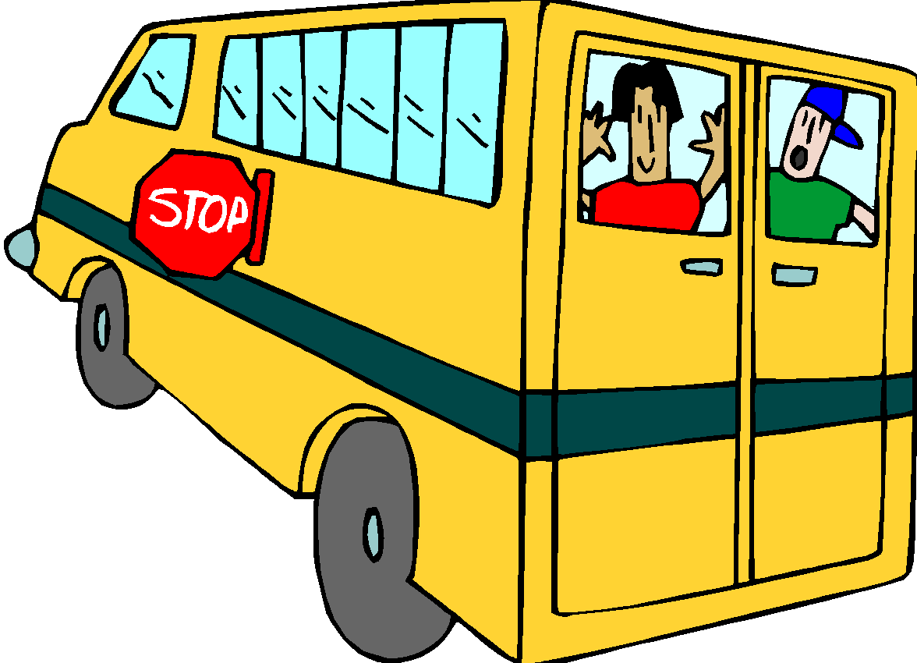
Educational Trips - Many educational trips are planned for our students. Class trips are an extension of the instructional program. Only students in the participating class and designated adult chaperones may attend the trip. For reasons of security and curriculum, students in other classes and children of chaperones may not attend.

On these trips, the students represent themselves and Spruance Elementary School. We are concerned with proper behavior and safety at all times. All pupils must have a permission slip signed by a parent in order to attend. A pupil who exhibits serious behavioral problems may not be permitted to go with the class unless accompanied by a parent chaperone. Students may be denied participation in a school trip due to behavioral issues, however, not due to inability to pay. Students not attending trips should report to school for attendance in another appropriate grade level class.

Homework - Through homework, classroom instruction is reinforced, high expectations are supported, students are motivated toward self-direction, and the relationship between school and home is strengthened. It may be daily or given over a longer period of time as a project or a report. It provides an opportunity for our pupils to strengthen basic skills, reinforce study skills, and encourages independent thinking and creativity. Homework is an important part of every student’s instructional program. Parents are encouraged to take an active interest in their children’s assignments. It is required that homework be signed by a parent.

Every elementary classroom teacher will require regularly assigned homework based upon classroom instruction no less than four times a week, Monday through Thursday. Because homework is an important part of the instructional program, failure to submit homework will be reflected in the student’s grade.

Purpose: Homework may be assigned in order to:
• strengthen basic skills;
• reinforce study habits;
• extend classroom learning;
• develop initiative, responsibility and self direction;
• stimulate independent thinking;
• increase range and scope of interests; and
• foster the worthwhile use of leisure time.

While the student should assume the major responsibility for completing the homework assignment, parents are encouraged to take an active interest in homework by:
• asking about homework every day;
• providing a definite time and a suitable place for study or home activities;
• making resource materials available;
• checking for neatness and completeness; and
• arranging with the teacher for limited homework assignments when the student’s physical condition necessitates it.

In addition to monitoring and helping children with homework, we ask that parents include a half-hour reading and computer time in your child’s evening activities. This time may include reading to your child, listening to your child read aloud, or a silent reading time. Books may be purchased through classroom subscriptions to reading clubs and our book fairs. In addition, parents who attend our monthly meetings receive books for their children’s home libraries. It also should include time for www.firstinmath.com and www.studyisland.com

You can help at home by providing paper, crayons, markers, and pencils for pre-writing activities. Help your child to illustrate an event, story, etc. They can label the picture in beginning writing (phonetic) or by dictating to you. Read and discuss nursery rhymes, poems, and stories with your child to stimulate a love of books. Let your child share in home responsibilities, conversations, and activities. Help develop independence by allowing your child to do simple activities independently, such as hanging up his/her coat, washing hands, etc. Remember that a parent is the child’s first and most important teacher.

Parent’s Right to Know
Parents/guardians have the right to inspect and review the contents of their child’s educational records. Parents/guardians may request access to review these records by phoning the principal or assistant principal. When the records are shown to the parent/guardian, he/she must sign an official request form. We request 24 hours notice to make copies of requested records.

Street Safety and Parking Near the School
There is no parking on the school side of any bordering street. Parking on the school side of the street during school hours is not permitted. This law safeguards all of the children. Police will ticket illegally parked cars.

Parents who drive their children to school are asked to discharge pupils who are going to the Main Building on the Horrocks or Hellerman Street side of the building. When children are discharged from cars, they should be dropped off at the school sidewalk. Children must exit the car on the sidewalk side. The discharging car should then leave immediately. When children are being picked up, they should go to the corner to cross the street and enter your car on the sidewalk side.

Do not discharge your child on Levick Street as it is hazardous because of heavy traffic. Eastwood Street is reserved for parking by our yellow school buses. Parking regulations must be respected whenever children are transported to school by parents.

Textbooks
The Board of Education charges each student with responsibility for the proper care of school property and the school textbooks, supplies, and equipment entrusted to his/her use. Students are responsible for the care, maintenance, and timely return of all textbooks. Schools shall require students and/or parents to sign a compact acknowledging their responsibility for the care and prompt return of textbooks loaned to them by the school. Students and/or their parents will be assessed penalties for lost or damaged textbooks. Imposition of one or more of the following penalties is permitted: a charge for replacement of the textbook; requiring the student to perform a prescribed number of hours of school service; withholding of a report card; and/or loss of privileges such as participation in sports or other extracurricular activities, proms, and other special events or moving up related activities.

Theft
The school is a community and theft of school or personal property is an injury to all members of the school community. Deliberate theft of school or personal property will result in suspension from school, restitution, and notification to the police of such incidents.

Uniform Policy
The Board of Education has adopted a mandatory school uniform policy for all students. Spruance students are required to wear the following:

GIRLS: Girls will wear either a long or short-sleeved red golf shirt that has a collar with either black pants or skirt. Skirts must be no shorter than two inches above the knee. No jumpers! No handbags – bookbags only!

BOYS: Boys will wear black pants with either a long or short-sleeved red golf shirt which has a collar.

No: Students may not wear large dangling earrings, jewelry, large belts, tights without a skirt or pants, tutus, sandals, flip flops, and high heels. Students may not wear any hats, hoods, scarves or other headgear unless for religious reasons.
Shoes must be sturdy such as sneakers with ties or shoes with buckles.
Over-sized clothing is not permitted and pants must be belted at the waist. Undergarments should not be visible. If a child chooses to wear a long sleeve shirt under a short sleeve uniform shirt, it must be red.
Students should not wear expensive jewelry and the school will not take responsibility for the loss.

In cool weather, students may wear red/black sweaters or sweatshirts.

Uniforms are available for sale at school – See Mrs. Evelyn Reamer-Benitez in the main office.

All students are expected to adhere to this uniform policy. Failure to wear the school uniform will result in appropriate disciplinary action in accordance with the Student Code of Conduct.

Gym Uniforms:
In order to implement our physical education program, proper attire is necessary. Preparation for a class is part of the student’s overall subject grade. We require the following clothing to meet the needs of personal cleanliness and maximum safety:
- All-purpose black athletic shorts (no cutoffs or playsuits) and a separate red t-shirt to be worn only during PE class.
- Students may wear black sweatpants (no stripes) during the winter months.
- White athletic socks that cover the ankle.
- Athletic shoes that are designed for activity (no Docksiders)
and that is laced and tied properly.
- No jewelry is to be worn during class in order to provide safety for the student and the rest of the class. Watches, earrings, chains, rings, etc., should be left at home.

Vandalism
Any vandalism to the property of the School District of Philadelphia should be reported to school authorities immediately. This includes the destruction of bulletin boards, displays, etc. Incidents will be dealt with according to Section 3307 of the Pennsylvania Crime Code. Any student vandalizing school property will be suspended and required to make full restitution for any damages incurred and may be referred to the police. Students who engage in horseplay which results in accidental damage to school property will be held financially responsible for such damage.

Violence
With the recent events of school violence in other school districts, we urge you to be as alert as possible to warning signs that may indicate children are at risk for acting out in aggressive and violent ways. The United States Department of Education has identified several early warning signs of violence. They include such things as:

• excessive feelings of isolation and rejection;
• significantly less interest in school;
• expressions of violence in writings and drawings; and
• uncontrolled anger and making serious threats of violence.

Any significant changes in a child’s daily routine in eating, sleeping, or studying may be possible early warning signs. Remember that all children at times exhibit these signs and that this is normal. Nevertheless, if you believe that the changes in a child’s behavior are significant, please talk to the child’s teacher, counselor, doctor, or spiritual advisor. If there is a firearm in your house, make sure that it is locked up with the key in a safe place. Please remember never to touch or play with guns and that if children see or find a gun, they should report it to an adult immediately.

Visitors (including Spruance Families)
Each person wishing to enter the building must use the buzzer/camera system at the front doors of each building. Once the secretary has released the door, each person must come to the office to obtain a visitor’s badge. This badge must be visible at all times. The visitor’s badge is to be returned to the office at the end of the visit. Your cooperation with this policy will assist us in providing a safe learning environment for our school community.

No visitor will be permitted to go to a classroom during school hours. If you have an appointment with a staff member, they will come to the main office to escort you to your destination.

Yard Behavior
Students are expected to abide by Spruance school rules and the Student Code of Conduct while in the schoolyard. Rough play such as chasing, wrestling and tackling is not permitted. Footballs are not permitted. Students may bring basketballs and jump ropes, however, if rough play is observed, the equipment will be confiscated and returned only after conference with parents/guardians.

HOME AND SCHOOL ASSOCIATION
Spruance enjoys the support of an active Home and School Association which provides valuable resources to the educational program of the school through its various fundraising activities. Parents and teachers are invited to join by paying $5.00 in annual dues. Meetings are held monthly and all are welcome to attend. Volunteers are always needed and appreciated. Please be active members for your children! Please call the office and ask to speak with Ms. Evelyn for further information.

School Internet/Acceptable Use Policy
Internet access is available to students on computers throughout our school. The School District has adopted a formal acceptable use policy for students to allow internet privileges. This policy is outlined below. We ask you to review this, discuss it with your child, and sign the permission form that will be sent home. We share this with you so that you will understand the responsibilities and sanctions for students who violate the appropriate use of the Internet when working on computers in our school.

SCHOOL DISTRICT OF PHILADELPHIA
COMPUTING AND INTERNET ACCEPTABLE USE POLICY
Purpose

- The School District of Philadelphia is providing its employees and students ("users") with access to computing equipment, systems and local network functions such as School District e-mail and the Internet.
- This access has a limited education purpose for students and is to facilitate employees’ work productivity.

Access Rights and Privileges

- The School District has the right to place reasonable restrictions on the use of equipment, resources and material students and employees access or post through the system. Students and employees are also expected to follow the rules set forth in the District’s rules and regulations governing conduct, disciplinary code, and the law in their use of the District’s equipment and network. This access has not been established as a public access service or a public forum. All access and rights are privileges granted by the District, and users should expect no privacy rights.

- All District employees and students will have access to the Internet through the District’s private network. Parents may specifically request that their children not be provided such access by notifying the District in writing.

- No student will be given or have access to District-provided Internet e-mail.
- Students may be permitted to access an external Internet e-mail service or their personal email account for the purpose of legitimate instructional or school-based needs. This is a local decision.

- Guests/contractors are not automatically eligible for a District email account. E-mail or network access accounts may be granted if directly sponsored by a District administrator.

Unacceptable Uses

- Users may not use the District’s private network to access material that is profane or obscene (pornography of any kind), that advocates illegal acts, or that advocates violence or discrimination towards other people (hate literature).
- Users may not post personal information on the Internet about themselves or other people. Personal contact information includes address, telephone, school address, work address, pictures or video bites, clips, etc.
- Students may not agree to meet with someone they have met on the Internet without their parent's approval and participation.
- Users may not attempt to gain unauthorized access to any other computer system. This includes attempting to log in through another person's account or access another person's files. These actions are illegal, even if only for the purposes of "browsing", "snooping", or "electronic discovery".
- Users may not deliberately disrupt or harm hardware or systems, interfere with computer performance, interfere with another’s ability to use equipment and systems, or destroy data.
- Users may not use the District’s private network to engage in illegal acts, such as arranging for a drug sale or the purchase of alcohol, engaging in criminal gang activity, threatening the safety of person, etc.
- Users may not use the District’s private network to solicit information with the intent of using such information to cause personal harm or bodily injury to another or others.
- Users may not post information that could endanger an individual, cause personal damage or a danger of service disruption.
- Users may not knowingly or recklessly post false or defamatory information about a person or organization.
- Users may not intentionally seek information on, obtain copies of, or modify files, other data, or passwords belonging to other users.
- Users may not indirectly or directly make connections that create "backdoors" to the District, other organizations, community groups, etc. that allow unauthorized access to the District’s network.
- Users may not use obscene, profane, lewd, vulgar, rude, inflammatory, hateful, threatening, or disrespectful language.
- Users may not engage in personal attacks, including prejudicial or discriminatory attacks.
- Users may not harass another person. Harassment is persistently acting in a manner that distresses or annoys another person.
- Users may not re-post a message that was sent to them privately without permission of the person who sent them the message.
- Users may not forward or post chain letters or engage in "spamming". Spamming is sending an annoying or unnecessary message to a large number of people.
- Users will not install or reproduce unauthorized or unlicensed software on District resources.
- Users may not plagiarize works that they find on the Internet or other resources.
- Users may not use computer resources and Internet for private business activities or unreasonable personal use.
- Users may not use the District’s private network for political lobbying.
- Students will not download files unless approved by their teacher.

System Security Obligations

- Users are responsible for the use of their individual access account and should take all reasonable precautions to prevent others from being able to use their account. Under no conditions should a user provide his/her password to another person.
- Attempts to log on to the District’s private network or any other network as a system administrator is prohibited.
- Any user identified as a security risk or having a history of violating this or any other Acceptable Use Policy may be denied access to the District’s private network.
- Users will avoid the inadvertent spread of computer viruses by following the School District virus protection procedures if they download software of share common file directory.
- Users should immediately notify a teacher or system administrator of any possible security problem.
- Students will promptly disclose to their teacher or other appropriate school employee any message received that is inappropriate.

- Filtering

- As required by law and in recognition of the need to establish a safe and appropriate computing environment, the District will use filtering technology to prohibit access, to the degree possible, to objectionable or unsuitable content that might otherwise be accessible via the Internet.

Due Process

- The School District will cooperate fully with local, state, or federal officials in any investigation concerning or relating to any illegal activities conducted through the District’s private network.

- In the event there is an allegation that a student has violated the District's Acceptable Use Policy, the student will be provided with written notice of the alleged violation and will be provided with notice and opportunity to be heard in the manner set forth in the Student Hearing Process Policy. Disciplinary actions may be taken.

- Employee violations of the District Acceptable Use Policy will be handled in accord with the law, School Board Policy or collective bargaining agreement(s), as applicable.

Administration

- The Chief Information Officer has the responsibility and authority for the development, publication, implementation and ongoing administration and enforcement of the processes and techniques required to protect the Philadelphia School District’s computer systems from unauthorized access, loss or misuse.
- School principals have the responsibility to establish a plan to ensure adequate supervisions of students. They are also responsible for interpreting and enforcing this policy at the local level.
- Local management has the responsibility to interpret and enforce this policy.

Please note that this Handbook is intended to provide you with a reference for school and district policies, however, it may not be all-inclusive. As policies are developed or changed, you will be notified.

