THE SCHOOL DISTRICT OF PHILADELPHIA
OFFICE OF STUDENT ENROLLMENT AND PLACEMENT
2019-2020 School Selection Process- Overview

The School District of Philadelphia will be accepting online applications for the School Selection Process from September 20th – November 1st at 5:00 PM. The School Selection Process is for students and families who wish to apply to a school outside of their neighborhood boundaries for admission into grades K-12 for September 2020. Please follow the steps below to submit an application.


STEP 1- Go to schoolselect.philasd.org

STEP 2- Select the button that says APPLY HERE!

STEP 3- Click on the green button that reads “I am a current School Distirct of Philadelphia Student. You will be taken to another page with additional instuctions. Once you are ready, click on the green button again.
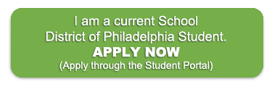

STEP 4- CURRENT DISTRICT STUDENT
An application can be submitted in two ways.

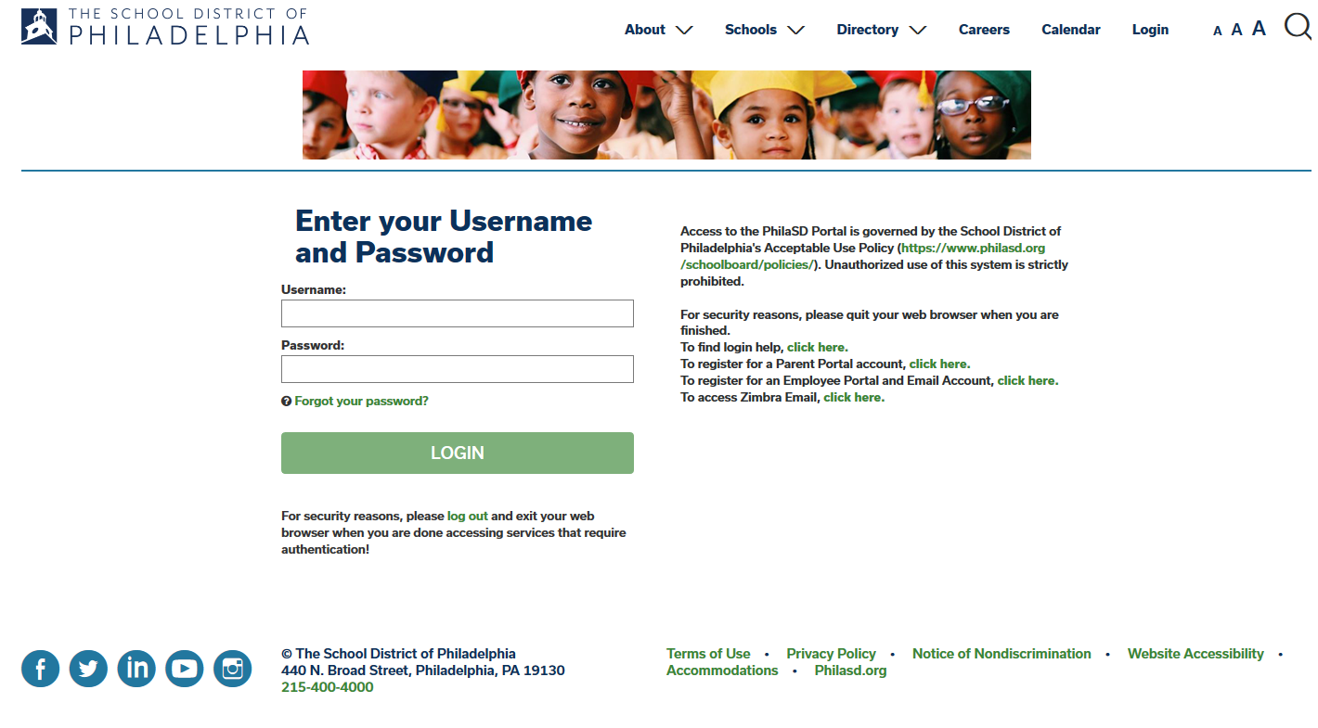 | - Through the Student Portal - You will need the student’s ID number and password.
 | - Through the Parent & Family Portal - Parents will need to register for a portal account in order to be able to access the school selection application.
Students and families will be able to make changes to the application until 5:00 PM on November 1st. PLEASE NOTE: The School District will use the last modification made to a student’s application.

All notifications will be displayed through the Student and Parent Portals, including school determinations (Approval, Disapproval, and Waitlist statuses).

The School Selection website, schoolselect.philasd.org, will also contain the following resources:
- The School District’s High School Directory
- PSSA Conversion Chart
- List of eligible neighborhood Elementary and Middle Schools

??Questions??- (email) schoolselect@philasd.org or (telephone) 215-400-4290

