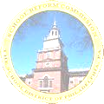
The School District of Philadelphia
440 N. Broad Street
Philadelphia, PA 19130
Philadelphia Federation of Teachers
1816 Chestnut Street
Philadelphia, PA 19103

Professional Development Plan – End of Year Review

- What goals have I accomplished?

- What have I learned?

- What new strategies have I used? What practices have I changed? What worked? What did not work?

- How did your plan impact your classroom practice? Please explain.

Teacher’s Signature: | Date:

Administrator’s Signature: | Date:

