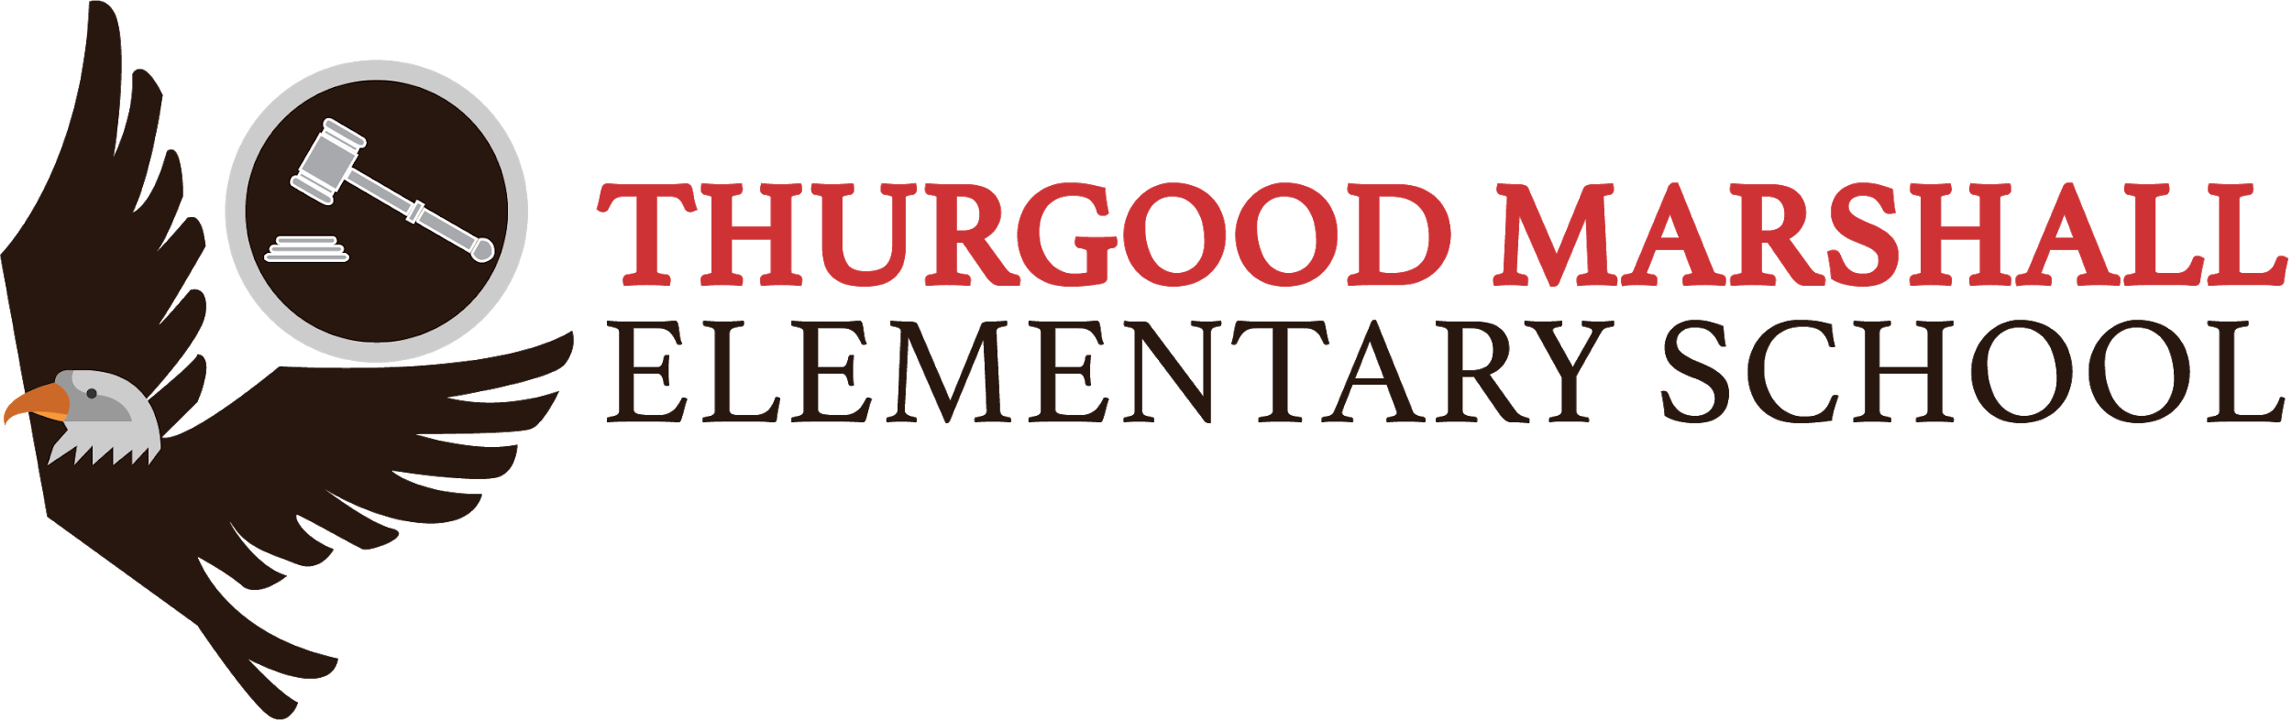
Marshall FamGram
Week of May 17, 2021

ALERTS
May 17, 2021 | ACCESS testing continues for grades 6-8
May 17, 2021 | PSSA testing begins for grades 6-8
May 17, 2021 | AimsWebPlus testing continues for grades 3-5
May 18, 2021 | SCHOOLS CLOSED
May 10, 2021 | ACCESS testing begins for grades 6-8

Reminders and Announcements
Grab & Go Meals
Below are a few food service links
● Please visit this website to find the closest distribution site near you: https://www.phila.gov/food/
● Each box contains seven breakfasts and seven lunches. Check out sample boxes on our website: https://www.philasd.org/foodservices/ or here: https://ytps://youtu.be/NbnAMU
-----------------------------------------
Use the Parent & Family Portal to Monitor Grades
Access portal using this link!!!!
Register Your Child for Kindergarten Today!

Kindergarten registration for the 2021-2022 school year is now open. If you have a child who will be five years old on or before September 1st, please register them by May 28th, 2021 to give them an opportunity to Thrive at Five!

Be advised. THIS EDUCATIONAL INSTITUTION ADHERES TO THE COViD-19 PROTOCOLS
ESTA INSTITUCIÓN EDUCATIVA SE ADHIERE A LOS PROTOCOLOS COViD-19

Online Attendance Matters! At Thurgood Marshall no more than 13% of scholars will attend 85% of days or less. no más del 13% de los becarios asistirán al 85% de los días o menos.
April Incentive
Escape Room (grades 3-4)
Virtual Amusement Park (grades K-2)

SCHOOL GOALS for ACADEMICS:
- Early Literacy Measurable Goal: At least 50% of scholars in grades K-3 will score at target by Spring AIMSweb Plus, as evidenced by the grade level composite score
- Early Literacy Measurable Goal: No more than 30% of scholars in grade 3 will score at Below Basic on the ELA PSSA (includes PASA). AIMSweb plus will be used to monitor bi-weekly
- English Language Arts Measurable Goal: (1) At least 12% of EL scholars in grades 4-8 will score Proficient or Advanced on the ELA PSSA (including PASA), using STAR to monitor. (2) At least 33% of SPED scholars in grades 4-8 will score at Proficient or Advanced on the ELA PSSA (including PASA), using STAR to monitor. (3) At least 31% of scholars in grades 4-8 will score at Proficient or Advanced on the ELA PSSA (including PASA), using STAR to monitor.
- Mathematics Measurable Goal: At least 5% of EL scholars in grades 4-8 will score at Proficient or Advanced on the Math PSSA (including PASA), using STAR to monitor ● At least 22% of SPED scholars in grades 4-8 will score at Proficient or Advanced on the MAth PSSA (including PASA), using STAR to monitor ● At least 17% of scholars in grades 4-8 will score at Proficient or Advanced on the Math PSSA (including PASA), using STAR to monitor

On the week of April 26, 2021, we will recognize our TOP honor scholars for their excellence in academic achievement; having earned grades of A/B in both 1st and 2nd quarters. You can look for their names to be posted in their google classroom.

SCHOOL GOALS for CLIMATE:
- School Climate and Culture Measurable Goal: At least 97% of scholars will have zero out-of-school suspensions (100% of K-2 will have zero out-of-school suspensions)

In April/May, we will celebrate our TOP scholars for their excellence in "scholarship, responsibility, leadership, and service on live streaming. Stay tuned...

OUR MANTRA: BE RESPECTFUL, BE RESPONSIBLE, BE READY TO LEARN AND BE PATIENT!!!!!!
*The house is now your child’s learning environment. Please be mindful to ensure that there is minimal noise and that the background set up is conducive for learning. Thank you!!!!

- Parents/guardians of students who have selected to remain fully virtual/remote do not have to submit requests to opt-out of testing. If families of students who have selected hybrid instruction want to opt-out of the federal tests, they are allowed to do so. They should submit their request in writing to the school.
Click link to view: Assessment Letter for Parents - April 2021

Click here to view parent letter for ACCESS testing: ACCESS for ELL notification letter

8th Grade:
Social Event: Wednesday, June 2, 2021 @ 10:00 a.m.
Promotion Ceremony: Wednesday, June 9, 2021@ 10:30 a.m. Two tickets per scholar.

From Ms. Smink:
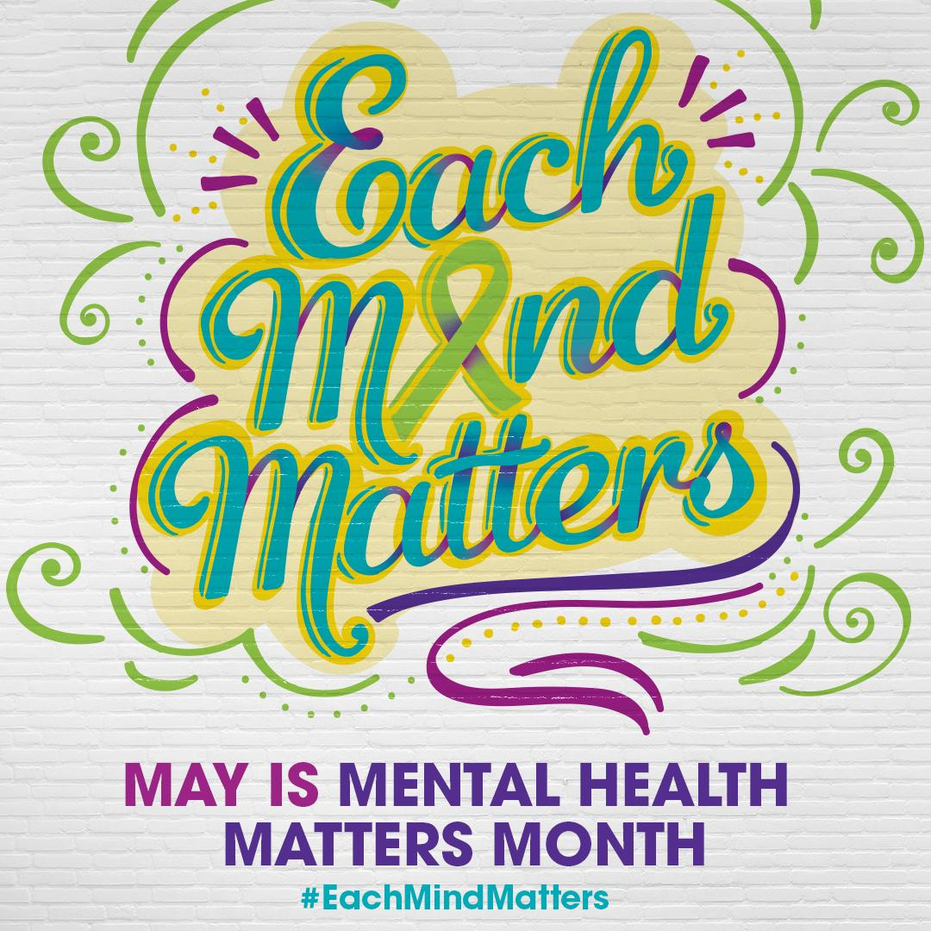

Mental Heath Resources: https://www.mhanational.org/31-tips-boost-your-mental-health
https://uhs.umich.edu/tenthings

Mediation videos:
https://www.youtube.com/watch?v=F7PxEy5IyV4
https://www.youtube.com/watch?v=8Xdwr4cRTVA

