April 23, 2020

Dear Parents and Guardians,

I hope this communication finds you and your family healthy. The School District of Philadelphia will be closed for the remainder of the school year. Although school buildings remain closed at this time, please know that teaching and learning will continue for students. Review and enrichment with teachers began on Monday, April 20. Planned instruction for the District will resume on May 4th and end June 12th. As we move to digital learning, we know parents and guardians are being asked to engage in new roles in their student’s learning. To help ease you into this work, below is guidance and suggestions:

- Planned Instruction - Beginning May 4, teachers will provide 3 hours/day of planned instruction via Google Classroom. Students in grades K-12 will use their District-issued Chromebooks to participate. Planned Instruction will cover content in Math, English, Science, Social Studies, World Language, Health/P.E., Postsecondary Readiness, CTE, as well as special education and related services. Lessons are intended to reinforce prior learning, provide enrichment activities, and introduce new learning to all students.
- Google Classroom - Google Classroom is the primary platform where teachers will post assignments, conduct lessons, and communicate with students. Some schools may continue to use other approved online platforms such as Edgenuity or Canvas.
- Participation - Each student, by the method available, is expected to login to their student portal each school day, Monday through Friday. If navigating to online adaptive programs or Google Classroom, students should login through their Student Portal.
  - Students enrolled in grades 9-12, a true middle school (i.e., a 5-8 or 6-8 school), Engineering & Sciences HS, Penn Treaty HS, Hill Freedman Academy, GAMP and Masterman should log into the Student Portal each school day and navigate to “Assignments Due Today” to mark as one indication of their participation in each attendance bearing course scheduled for that day. Students, please see this link for instructions on how to submit your participation through the Portal.
  - Another indication of participation is the completion and submission of assignments to teachers.
- Grading - The District is shifting from four marking terms to three. Students’ final grades will be an average of the three terms. Students may receive grades for new assignments, missed assignments, and make-up assignments on or after May 4th. All students in grades K-12 will be promoted based on the current marking guidelines. If you have questions, please contact your child’s teacher or counselor.
- Communicating with Teachers - All teachers will have scheduled office hours to provide instructional support for students and answer questions for families. Your child’s teacher will reach out to you as well via email or phone. Please check your email on a regular basis, if possible, so you don’t miss important messages.
- Expectations for Families:
  - Communicate with their child's teacher and/or principals if they have questions.
  - Establish a place for learning at home that minimizes distractions and work to establish a routine for learning at home while also being flexible when needed
  - Set realistic goals for themselves and their child(ren).
  - Remind their child to check in with their teacher if they have concerns or need support and encourage them to take breaks for snacks, exercise, and play.

Who to Contact When You Need Help

- General Questions: call (215) 400-5300 or email covid19info@philasd.org.
- Grades, Credit, Assignments and Feedback: reach out to your child’s counselor or teacher. Visit the school’s website to receive contact information.
- Frequently Asked Questions: check out answers and other updates at https://www.philasd.org/coronavirus/.
- Technology-related Problem or Issue: Visit the remote learning resource center on the district website at https://www.philasd.org/coronavirus/chromebooks/ or call the Parent & Family Technology Support Hotline at (215) 400-4444 or email FamilyTechSupport@philasd.org.
- Social-emotional or Health Concern: reach out to your child’s counselor or nurse. Visit the school’s website to receive contact information.
- Receive Updates: Join me @PhillySchools Facebook live events every Wednesday at 3:00pm where I share updates on our Continuity of Education plan.

We look forward to when we can all come back together in person, in our schools and offices. The School District of Philadelphia remains committed to working together and teaming with our partners to support you and your children. Please stay home as much as possible and please take good care of yourselves and your loved ones.

Sincerely,
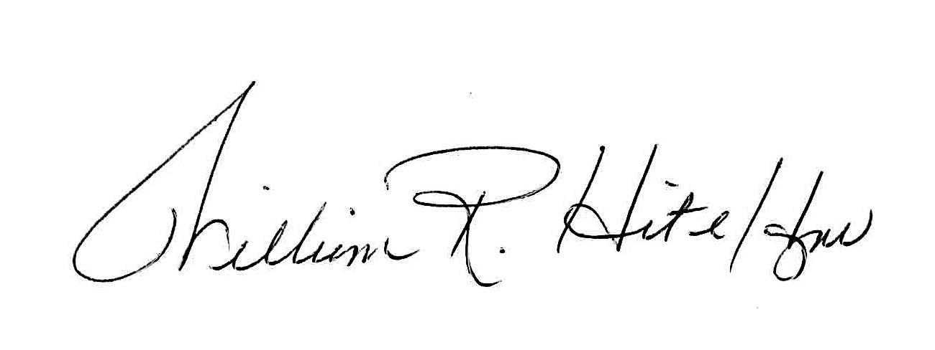
William R. Hite Jr., Ed.D.
Superintendent
The School District of Philadelphia

