Supply List 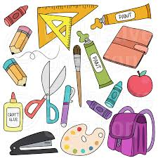

1 large book bag

5 two-pocket folders

1 spiral notebook with graph paper

1 graphing calculator TI-73 or TI-83 (optional)

1 5-subject notebook

12 pencils

4 pens (black or blue ink)

4 notebooks (spiral or composition)

1 12-inch ruler

1 combination lock

2 highlighters

1 box of tissues

1 ream of copy paper

1 box of Clorox wipes

1 mini stapler

2 erasers

